Preface :

Well, this project was born during the spring vacation of 2026, when I was a second-year preparatory (CP2) student at the National Higher School of Artificial Intelligence (ENSIA) in Algiers. During that break, I decided to dive into the world of Machine Learning by taking a course on GeeksforGeeks—the kind of place where geeks like me genuinely enjoy spending their time when nothing else seems right.
After two years at ENSIA, I had already built solid foundations in mathematics, including linear algebra, probability, statistics, and calculus. Alongside that, I had developed strong programming skills in Python, Java, and C++, gained experience in data manipulation, and learned to build modern full-stack web applications using HTML, CSS, JavaScript, Figma, and the MERN stack through my web development coursework. At that point, I finally felt ready to combine everything I had learned into one meaningful project.
After completing the course, I wanted to apply everything I had learned to a real and concrete project that would add value to my CV. Like any beginner, my first instinct was to search the Internet for interesting machine learning projects to work on. Unsurprisingly, most of the suggestions revolved around the classic beginner projects: house price prediction, stock price prediction, Iris classification, and many others. Although these projects are excellent for learning the fundamentals of machine learning, they are also the ones that almost everyone builds by following online tutorials. I wanted something different—something more ambitious, more meaningful, and capable of solving a real-world problem.
Around that time, I noticed that many ENSIA students had dedicated their Instagram accounts to creating educational content for Baccalaureate students. Watching them share advice, study tips, and motivation inspired me to think about how I could contribute using the skills I had just acquired. That was when the idea came to me: why not build an intelligent platform capable of predicting and analyzing the Algerian Baccalaureate?
In Algeria, the Baccalaureate is far more than a national examination; it is a decisive milestone that greatly influences a student's academic and professional future. It is also surrounded by countless assumptions and stereotypes. Do Brevet results really influence Baccalaureate performance? Are students' trimester grades reliable indicators of their final results? Does the chosen stream (filière) significantly affect academic performance? Do students within the same stream naturally form distinct clusters based on their academic profiles? Furthermore, many students struggle throughout the BAC year to evaluate their current level, identify their strengths and weaknesses, and make informed decisions about their future orientation after graduation.
These questions immediately convinced me that this was the right project to pursue. Not only did it address a real problem faced by thousands of Algerian students every year, but it also provided an opportunity to apply machine learning to a local context while working with educational data that I could collect and understand myself.

Moreover, educational data was considerably easier to collect than many other types of datasets, which made it an ideal starting point for the project. More importantly, I wanted to build my own dataset instead of relying on Kaggle or publicly available international datasets. Since this was my first real project involving data science, I wanted to experience the entire pipeline—from data collection and generation to preprocessing, analysis, model training, and deployment—rather than simply starting from an already prepared dataset.
I spent nearly eight weeks working on this project. My productivity was not always consistent, as I was simultaneously trying to successfully complete my academic semester while preparing my visa application. Despite these challenges, I remained committed to bringing the project to completion.
From the very beginning, my goal was to transform the powerful tools that Machine Learning offers into something that any Baccalaureate student—with absolutely no knowledge of computer science—could easily use and understand. For me, this project was about discovering meaningful patterns hidden within Algerian Baccalaureate data, teaching those patterns to machines, and ultimately transforming them into an interactive application that users could explore, enjoy, and benefit from.
This philosophy extended beyond the machine learning models themselves. Every user interface component, color palette, and page layout was carefully designed with a specific audience in mind: a 17-year-old student experiencing the Baccalaureate journey. My objective was not only to build an intelligent system, but also to create an interface that felt modern, intuitive, engaging, and welcoming for the students who would eventually use it.
I would also like to emphasize that I do not claim this platform to be perfect. As this is my first experience developing a complete end-to-end machine learning application, there are undoubtedly areas that could be improved, along with potential limitations and biases that future work may address. Nevertheless, I firmly believe that the platform can provide Baccalaureate students with valuable insights into their academic journey and help them make more informed decisions through a unique and innovative approach.
The overall design of the application follows a strategic approach by dividing the Baccalaureate journey into three major decision-making phases that every Algerian student experiences: Pre-BAC, BAC Year, and Post-BAC. Rather than treating the Baccalaureate as a single event, I chose to model it as a complete journey, where each phase presents its own challenges, questions, and decisions.
Each of these phases was designed with a specific objective in mind and was inspired by observations, experiences, and questions that I had throughout my own journey as a Baccalaureate student. In the following sections, I will explain the motivation and inspiration behind each phase.

Pre-BAC
At first glance, many people might consider this phase unnecessary. After all, it is common to hear stories of students who dramatically improve their Baccalaureate results compared to their previous academic performance, sometimes by as many as five points. The opposite is also true. Since the Algerian Baccalaureate consists of a single examination for each subject, completed within one week, many believe that previous grades are not reliable indicators of the final outcome. In addition, the examination itself is often perceived as emphasizing pattern recognition and mastery of familiar exercise types rather than purely measuring creativity or problem-solving abilities.
These observations naturally raise several questions. Do a student's Brevet results—the official national examination preceding high school—and their grades during the first and second years of secondary education actually correlate with their Baccalaureate performance? How consistent is a student's academic performance throughout the years? How much do grades fluctuate from one stage to another? One of the primary objectives of this phase was to investigate these relationships using statistical analysis and machine learning rather than relying solely on common beliefs and personal opinions.
Another motivation behind this phase was the noticeable difference between the various academic streams (filières). During my own years in high school, I observed that each stream seemed to have its own academic characteristics. For example, the Scientific stream often contains students with highly diverse academic profiles, ranging from exceptional performers to students facing considerable difficulties, while other streams may exhibit different patterns altogether. These observations remained personal impressions for years, and this project finally gave me the opportunity to transform those impressions into measurable data and objective analysis.
For this reason, I decided to perform clustering separately within each academic stream. This was, in many ways, an attempt to answer a question that had been in my mind since I was a student at Fatma Nsoumer High School. Was I simply noticing patterns that did not truly exist, or did the data have its own story to tell? Beyond its technical value, this analysis was also a way of satisfying a long-standing curiosity that I had carried since my teenage years.
This phase also includes a student matching system designed to identify the most similar student within the dataset based on the available academic information ,this will eventually allow you to position yourself in your stream . If I may add a small cultural observation, Algerians naturally enjoy comparing themselves with others—sometimes perhaps a little too much. Instead of leaving this tendency to informal comparisons, I wanted to transform it into a meaningful feature that allows students to understand where they stand among their peers and to better position themselves within their own academic stream.

BAC Year
The BAC Year phase represents the core of the application. In this stage, I chose to study each subject independently rather than predicting only the overall Baccalaureate average. To achieve this, I relied on the official syllabuses available on the Ency-Education and DZ-Exams websites. These well-known Algerian educational platforms provide a comprehensive collection of resources related to the national education system, including official syllabuses, examination papers, statistics from previous national examinations, and official documents published by the Ministry of Education. These resources played a fundamental role in selecting the most relevant features and in collecting and generating the datasets used throughout this project. I would also like to express my sincere gratitude to these platforms, as they were invaluable sources of information during the development process.
As with any machine learning project, this phase involved the complete data science pipeline, including Exploratory Data Analysis (EDA), feature engineering, model training, and model evaluation. The primary objective was to predict the student's grade in each subject individually based on factors such as the student's academic stream (filière), trimester grades, and other relevant features identified during the analysis. After evaluating several possibilities, the Random Forest Regressor was selected as the final predictive model and was trained separately for each of the fifteen subjects included in the application.
However, building accurate predictive models was only part of the objective. My goal was to transform these models into an interactive and intuitive experience for the end user. The frontend was therefore designed to provide a dedicated page for each subject through a set of clickable subject cards. Once a subject is selected, the student is presented with the examination structure, an input form for the required features, and an interface that guides them through the entire prediction process.
After generating the prediction, the application performs a detailed interpretation of the result using SHAP values to identify the student's strengths and weaknesses and to explain how each feature influenced the predicted grade. Additional derived features are then computed and presented through rule-based explanations to make the results easier to understand.
The application then enters a simulation phase. Using the relationships and correlations discovered during the Exploratory Data Analysis, students can simulate improvements in specific features and immediately observe how these changes may influence their predicted subject average. Finally, the application generates a detailed report summarizing the prediction, the explanation of the model, the identified strengths and weaknesses, the simulation results, and all the analyses performed throughout the process.
In addition to the prediction system, this section also includes several complementary tools designed to support students throughout the academic year:
- A Baccalaureate average calculator, accompanied by detailed documentation describing subject coefficients, weekly teaching hours, and the examination structure for every academic stream. The application automatically adapts the displayed information according to the selected stream.
- A personalized resource recommender, which suggests learning materials based on the student's predicted grade and identified weaknesses. Some of these resources were personally useful during my own Baccalaureate preparation, while others have been collected from various educational platforms. This module is intended to evolve continuously as new educational resources become available.
- A budget allocation tool, designed to help students better organize and manage their study-related expenses.
- A personalized to-do list generator, which creates study tasks based on the student's weaknesses and predicted performance.
- A timetable generator, which automatically builds a personalized study schedule using Genetic Algorithms. The inspiration for this module came from one of the projects completed during our Introduction to Artificial Intelligence course at ENSIA, where we applied search techniques such as Constraint Satisfaction Problems (CSP), Hill Climbing, and Simulated Annealing to generate valid academic timetables.
Both the generated to-do list and the timetable remain fully customizable, allowing students to adapt them according to their personal preferences and study habits. After all, user comfort and flexibility were among the main design priorities of the application.

Post-BAC
The final phase of the application focuses on one of the most important decisions every Algerian Baccalaureate student has to make: choosing a higher education pathway.
To support this decision, I first built a comprehensive JSON database containing the eleven major academic domains available in the Algerian higher education system, including Mathematics and Computer Science, Science and Technology, Languages, Literature, and others. For each domain, I collected detailed information about the available study programs, including Engineering Schools (Écoles Supérieures), State Engineering programs, LMD degrees, Higher Schools of Teachers (ENS), admission thresholds from previous years, and additional information describing each program.
Using this information together with the student's predicted academic performance, the Random Forest model predicts the three academic domains that best match the student's profile and preferences. The application also generates a ranked list of all the programs that the student is likely to be eligible for based on their predicted Baccalaureate average. Rather than simply displaying recommendations, the system also explains the reasoning behind each suggestion, allowing students to better understand why a particular orientation may suit their academic profile.
From a technical perspective, the application was developed using the MERN stack and is supported by a lightweight MongoDB database responsible for storing the application's data and ensuring smooth interaction between the frontend and the backend.
The design of the interface was intentionally inspired by the culture surrounding the Algerian Baccalaureate. Since the target audience consists primarily of teenagers and young adults, I wanted the application to feel modern, familiar, and engaging rather than purely academic. Every design choice—from the color palette and page layouts to the visual identity of the platform—was made with this audience in mind.
Even the landing page was designed with careful attention to detail. Every visual element carries a meaning that an Algerian Baccalaureate student can immediately recognize and relate to, making the platform feel familiar from the very first interaction.

Front Matter:
- Cover Page
- Acknowledgements
- Preface (the one we just wrote)
- Abstract
- Table of Contents
- List of Figures
- List of Tables

Chapter 1 — Introduction:
The Algerian Baccalaureate (BAC) represents one of the most significant milestones in the academic journey of Algerian students. Beyond being a national examination, it serves as the primary gateway to higher education and largely determines the academic and professional opportunities available to students after secondary school. Every year, hundreds of thousands of candidates prepare for this examination while facing considerable academic pressure, societal expectations, and uncertainty regarding their future.
Despite the abundance of educational resources available today, students often struggle to answer fundamental questions throughout their Baccalaureate journey. Before entering the final year of high school, many wonder whether their previous academic performance is truly representative of their future potential. During the Baccalaureate year, students frequently seek to identify their strengths and weaknesses, estimate their expected performance, prioritize their revision efforts, and manage their time effectively. Finally, once the examination is over, they face another critical challenge: choosing the higher education pathway that best matches their academic profile, interests, and predicted results.
While machine learning has demonstrated remarkable capabilities in discovering hidden patterns within data and supporting decision-making across numerous domains, its application to the Algerian educational context remains relatively limited. Existing educational applications often focus on isolated tasks such as grade prediction or simple orientation tools without considering the complete academic journey experienced by students. Moreover, many available machine learning projects rely on publicly available international datasets, making them less representative of the realities and specific characteristics of the Algerian educational system.
This project aims to address these limitations by proposing bacAidz, an end-to-end machine learning platform specifically designed for Algerian Baccalaureate students. Rather than treating the Baccalaureate as a single prediction problem, the platform models it as a complete journey composed of three successive phases: Pre-BAC, BAC Year, and Post-BAC. Each phase addresses a different set of challenges through the integration of data analysis, machine learning, explainable artificial intelligence, rule-based systems, and modern web technologies.
The objectives of this project can be summarized as follows:
- Collect, generate, and organize representative datasets related to the Algerian Baccalaureate.
- Explore and analyze these datasets to identify meaningful academic patterns and relationships.
- Develop machine learning models capable of assisting students in predicting academic performance and supporting educational decision-making.
- Integrate explainability techniques to improve the transparency and interpretability of model predictions.
- Design and implement an intuitive web platform that transforms complex machine learning models into accessible tools for students with no prior knowledge of artificial intelligence.
- Provide additional intelligent services, including personalized recommendations, study planning tools, and higher education orientation assistance.
The main contributions of this project extend beyond the development of predictive models. They include the construction of original datasets tailored to the Algerian educational system, the design of an end-to-end intelligent platform combining multiple artificial intelligence techniques, and the development of a user-centered interface specifically adapted to the needs and expectations of Algerian Baccalaureate students.
The remainder of this report is organized as follows. Chapter 2 presents the overall architecture of the system, including the project organization, technologies, database design, and user interface philosophy. Chapters 3, 4, and 5 describe the three main phases of the application: Pre-BAC, BAC Year, and Post-BAC, respectively, detailing the datasets, exploratory analyses, machine learning models, evaluation procedures, and user interfaces developed for each module. Chapter 6 discusses the backend architecture and software engineering aspects of the application. Chapter 7 presents the experimental results and demonstrates the platform through representative use cases. Finally, Chapters 8 and 9 discuss the limitations of the current system, potential future improvements, and concluding remarks.

Chapter 2 — Project Analysis and Global Design
The development of this project followed a complete end-to-end engineering workflow, beginning with data collection and ending with the deployment of a fully functional web application. Before discussing each module in detail, this chapter provides a global overview of the different stages involved in the project's development.
The first stage consisted of identifying the most relevant features and collecting representative data describing the academic journey of Algerian Baccalaureate students. To achieve this, several data collection forms were designed and distributed among students. Additional information was gathered from reliable educational resources and official publications, including Ency-Education, DZ-Exams, official social media pages, national examination statistics, and official journals published by the Algerian educational authorities.
Although these sources provided valuable and generally reliable information, the collected data inevitably contained missing fields, inconsistencies, noise, and occasional inaccuracies. Furthermore, some information required by the machine learning models was simply unavailable. For this reason, a data generation phase was introduced to reconstruct the missing information as realistically as possible while preserving the characteristics of the Algerian educational system. The objective was not to artificially inflate the datasets but rather to build representative datasets that accurately reflect the reality experienced by Algerian students.
Once the data collection and generation processes were completed, all datasets were converted into structured CSV files. A comprehensive preprocessing stage was then carried out, including data cleaning, handling missing values, removing duplicate records, detecting and treating outliers, reducing noise, and validating the consistency of the collected information. The final datasets contained approximately 1,500 to 2,000 representative student records, depending on the module.
The project was then organized into three independent modules corresponding to the three major phases of the Algerian Baccalaureate journey: Pre-BAC, BAC Year, and Post-BAC. For each module, dedicated Jupyter notebooks were developed to conduct Exploratory Data Analysis (EDA), investigate meaningful patterns within the data, answer the educational questions identified at the beginning of the project, engineer relevant features, compare different machine learning algorithms, train and evaluate the selected models, and validate their predictions using multiple representative student profiles.
After completing the machine learning pipeline, the focus shifted toward software development. The objective was to transform the trained models into an interactive platform that could be easily used by students with no background in artificial intelligence. The application was therefore developed using the MERN stack, providing a modern, responsive, and scalable architecture.
The graphical user interface was first designed using Figma to establish a consistent visual identity and user experience. During implementation, some complex interface components were generated with the assistance of Claude in order to accelerate the frontend development process and dedicate more time to higher-level engineering tasks such as backend development, database design, API integration, model deployment, and system testing.
Finally, the different components of the application—including the frontend, backend, database, and machine learning models—were integrated into a unified platform. Extensive testing was conducted to verify the correctness of predictions, the reliability of the application, and the overall user experience before the platform reached its final deployment stage.
The following sections of this chapter describe the overall architecture of the system, the organization of the project, the selected technologies, the database design, and the user interface philosophy that guided the development of the platform.

2.1 Global Architecture:
One diagram.
User
↓
React Frontend
↓
Express API
↓
Machine Learning Models
↓
MongoDB

2.2 Folder Structure:

frontend/ (contains react components and pages )
backend/(data csv files ,trained ml models ,ml python scripts for using the models,config for the database ,models for the database schemas ,controllers ,routers services ,utils )
notebooks/ the starting point where everything was crafted from the EDA to model training and evaluation
Explain why each folder exists.

2.3 Technologies:

The project combines several technologies from the fields of data science, artificial intelligence, web development, and database management. Each technology was selected according to its strengths and its role within the overall architecture.
Technology | Purpose | Justification
Python | Machine learning and data analysis | Chosen for its simplicity and its rich ecosystem of AI and data science libraries.
Pandas | Data manipulation and preprocessing | Provides powerful tools for cleaning, transforming, and organizing datasets.
NumPy | Numerical computing | Enables efficient mathematical operations on large datasets.
Scikit-learn | Machine learning | Offers reliable implementations of preprocessing techniques, algorithms, and evaluation metrics.
SHAP | Model explainability | Explains the contribution of each feature to the prediction, improving model transparency.
Matplotlib | Data visualization | Used to generate statistical plots during the Exploratory Data Analysis phase.
Seaborn | Statistical visualization | Simplifies the creation of informative and aesthetically pleasing visualizations.
Jupyter Notebook | Experimentation environment | Facilitates iterative data exploration, model development, and documentation in a single workspace.
CSV Files | Dataset storage | Lightweight, portable, and directly compatible with most data science libraries.
React.js | Frontend development | Component-based architecture simplifies the creation of interactive and reusable user interfaces.
JavaScript | Frontend and backend programming | Allows the same language to be used across the entire web application.
HTML5 | Page structure | Provides the structural foundation of the user interface.
CSS3 | Styling | Responsible for the application's visual appearance and responsive design.
Tailwind CSS (if used) | UI styling | Accelerates interface development through utility-first CSS classes.
Node.js | Backend runtime | Executes server-side JavaScript efficiently using a non-blocking architecture.
Express.js | REST API | Simplifies backend development through lightweight routing and middleware management.
MongoDB | Database | A flexible NoSQL database well suited for storing user profiles and application data.
Mongoose | MongoDB Object Modeling | Simplifies database interactions through schemas and data validation.
REST API | Communication | Enables structured communication between the frontend and backend.
JSON | Data exchange | Lightweight format for transferring data between different application layers.
Figma | UI/UX design | Used to prototype and design the application's interface before implementation.
Visual Studio Code | Development environment | Provides an efficient IDE with extensive extensions for web and Python development.
Git | Version control | Tracks code modifications and facilitates project management.
GitHub | Source code hosting | Stores the project's source code and enables version control and portfolio presentation.
MongoDB Compass (if used) | Database management | Provides a graphical interface for exploring and managing MongoDB collections.
Postman (if used) | API testing | Used to test and debug backend endpoints before frontend integration.

2.4 Database Design:
The application uses MongoDB as its primary database management system. A NoSQL document-oriented database was preferred over a traditional relational database because most of the application's data naturally fits a hierarchical JSON structure. This choice also integrates seamlessly with the MERN stack and provides the flexibility required to store prediction results, user information, and dynamically generated reports.
The database is composed of four main collections, each corresponding to a different stage of the application.

Users Collection
The Users collection stores the information required for user authentication and personalization.
Each document contains the student's identity, login credentials, academic stream (filière), and Baccalaureate session. Passwords are never stored in plain text; instead, they are automatically hashed using the BCrypt algorithm before being saved, ensuring secure authentication and protecting users against credential leakage.
The collection also serves as the central entity of the database, as every prediction generated by the application is associated with a specific user.

Pre-BAC Results Collection
The Pre-BAC Results collection stores the outputs generated during the first phase of the platform.
Each user owns a single Pre-BAC prediction containing:
- the predicted Baccalaureate average,
- the cluster assigned by the clustering algorithm,
- the identified student archetype,
- the most similar student in the dataset,
- similarity score,
- and the derived features computed during feature engineering.
These results allow the application to preserve the student's historical analysis while avoiding repeated model execution.

BAC Year Results Collection
The BAC Year Results collection is the largest and most detailed collection in the database.
Instead of storing only the final average, each document contains a complete academic profile covering every predicted subject.
For each subject, the application stores:
- the predicted grade,
- success probability,
- improvement potential,
- identified strengths,
- detected weaknesses,
- SHAP-based explanations,
- subject-specific derived features,
- and the original input values used during prediction.
The collection also maintains global statistics summarizing the student's overall academic performance, including weighted average, strongest and weakest subjects, overall risk level, and cross-subject indicators generated by the machine learning pipeline.

Post-BAC Results Collection
The Post-BAC Results collection stores the personalized higher education recommendations generated by the orientation module.
Each document contains the student's Top-10 recommended university programs, together with their ranking, predicted compatibility score, university information, domain, and a short description of each specialization.
These recommendations are generated by combining the machine learning predictions with a rule-based filtering system that considers admission thresholds and user preferences.

Relationships Between Collections
Although MongoDB is a non-relational database, logical relationships are maintained using document references.
The User collection acts as the central entity of the database. Each prediction generated during the three phases references the corresponding user through the user_id field.
This organization establishes a one-to-one relationship between a student and his or her Pre-BAC analysis, while allowing one user to accumulate multiple BAC Year predictions and Post-BAC recommendation sessions throughout the application's lifetime.
Such a design ensures data consistency while maintaining the flexibility offered by a document-oriented database.
+----------------+
| User |
+----------------+
| _id |
| fullname |
| username |
| password_hash |
| filiere |
| bac_year |
+-------+--------+
|
+-------------------+-------------------+
| | |
| | |
▼ ▼ ▼

+----------------+ +--------------------+ +------------------+
| PreBAC Result | | BAC Year Result | | PostBAC Top 10 |
+----------------+ +--------------------+ +------------------+
| user_id | | user_id | | user_id |
| prediction | | subjects[] | | top_10[] |
| cluster | | summary | | score |
| archetype | | derived_features | | university |
+----------------+ +--------------------+ +------------------+
Note :

One thing I really like
I noticed you didn't create 15 different collections for the BAC subjects.
Instead, you embedded them inside a subjects array.
That was a good design decision.
I would even mention it in the report:
"Instead of creating one collection for each academic subject, all subject predictions are embedded within a single BAC Year document. This approach reduces the number of database queries, simplifies data retrieval, and naturally groups all subject predictions belonging to the same prediction session."
That's the kind of sentence that shows you're thinking like a software engineer, not just writing code. It demonstrates that your database structure was chosen deliberately to balance organization, performance, and maintainability.

2.5 UI/UX Philosophy:
The design of the application goes beyond aesthetics. Every visual element, interaction, and navigation decision was made with one objective in mind: creating an interface that naturally resonates with Algerian Baccalaureate students. Since the target users are primarily teenagers between the ages of 16 and 19, the platform was designed to be modern, engaging, intuitive, and motivating throughout the entire academic journey.

Simplicity and Clarity
The interface follows a minimalist design philosophy where unnecessary visual clutter is avoided. Information is presented progressively, allowing students to focus on the most important tasks without feeling overwhelmed.
Simple layouts, clear typography, and well-defined sections improve readability and make the platform accessible even to users with little technological experience.

Modern Color Palette
The application adopts a dark theme based primarily on shades of blue, violet, and white.
This palette was selected because it offers several advantages:
- modern and professional appearance;
- reduced eye strain during long study sessions;
- strong visual contrast for improved readability;
- a technological identity consistent with an AI-powered platform.

Arabic-First Experience
Although the application was developed using international technologies, the user interface primarily employs the Arabic language, since it is the language most familiar to Algerian Baccalaureate students and the language in which the official examinations are conducted.
This choice reduces the learning curve and makes the application feel immediately familiar to its target audience.

Motivational Slogans
Short motivational slogans are integrated throughout the platform.
Besides creating a more dynamic interface, these messages reflect an important aspect of Algerian student culture, where motivational phrases are widely shared during the Baccalaureate preparation period. Their objective is to maintain user engagement and create a more encouraging learning environment.

SVG Illustrations
The interface primarily relies on SVG illustrations rather than traditional photographs.
SVG graphics offer several advantages:
- lightweight files and faster loading times;
- infinite scalability without loss of quality;
- consistent visual style;
- easy customization to match the application's color palette.

Meaningful Icons and Terminology
Icons, labels, and technical terms were carefully selected to remain understandable for students unfamiliar with artificial intelligence or machine learning.
Whenever possible, technical concepts are translated into simple educational language, allowing users to focus on the insights rather than the underlying algorithms.

Roadmaps and Progress Visualization
Several sections of the application present information as visual roadmaps.
This design choice helps students better understand their current academic position, the objectives they should achieve, and the different stages of their Baccalaureate journey.

Countdown Timer
The landing page includes a live countdown displaying the remaining days, hours, minutes, and seconds before the next Algerian Baccalaureate examination.
Besides providing useful information, this element creates a constant sense of progression and reminds students of the approaching deadline, reinforcing motivation and planning.

Timelines
Whenever chronological information is presented—such as academic progression or orientation procedures—the application uses visual timelines.
Timelines improve comprehension by presenting information in a logical sequence and allow students to quickly identify the different stages of their educational journey.

User-Centered Design
Throughout the development process, every interface component was designed with one central question in mind:
"Would an Algerian Baccalaureate student immediately understand and enjoy using this feature?"
This philosophy guided not only the visual appearance of the application but also the organization of information, navigation flow, and interaction mechanisms, resulting in a platform that is both functional and engaging.

One thing I would add
Knowing your project, I'd add another subsection:

Gamification
You have several features that motivate students:
- prediction reports,
- strengths and weaknesses,
- progress simulations,
- personalized recommendations,
- study plans,
- timetable generation.
These aren't just ML outputs—they encourage users to engage with the platform and improve over time. Mentioning this shows that you considered user motivation as part of the design.

Chapter 3 — Pre-BAC Module

3.1 Objective
The Pre-BAC module was designed to investigate a series of recurring questions and widely shared beliefs surrounding the Algerian Baccalaureate. Every year, students, parents, teachers, and social media communities debate the factors that truly influence success in the BAC. While many opinions exist, very few are supported by objective data.
The objective of this module was therefore to explore whether these commonly accepted ideas are merely part of the collective imagination or whether they can be observed through statistical analysis and machine learning.
The main questions addressed by this module are summarized below.

1. Do previous academic results influence the Baccalaureate average?
One of the most frequently asked questions by Algerian students concerns the relationship between previous academic performance and BAC success. More specifically:
- Does the average obtained in the Brevet (the official national examination preceding high school) influence the final BAC average?
- Do the grades obtained during the first and second years of secondary school (1AS and 2AS) correlate with BAC performance?
- Can students who performed poorly during these years still achieve a significant improvement ("remontada") during the BAC?
- Conversely, do consistently high grades before the BAC guarantee success?
This analysis aims to quantify these relationships rather than relying solely on anecdotal evidence.

2. Does the academic stream (filière) influence students' grades?
Another common belief is that some academic streams systematically obtain higher or lower BAC averages than others.
The objective was to determine whether the chosen filière represents a significant explanatory factor for students' academic performance and whether noticeable differences exist between streams.

3. Do students naturally form distinct academic profiles?
Beyond simple averages, this study investigates whether students within the same filière naturally group into clusters sharing similar academic characteristics.
By applying clustering algorithms, the project seeks to identify common student profiles and determine whether meaningful patterns emerge from the data without predefined labels.

4. What is the influence of study habits and personal behavior?
Academic success is often associated not only with grades but also with behavioral factors such as study habits, time management, sleep, stress, consistency, and family support.
This module explores the relationship between these behavioral variables and students' predicted academic performance to better understand their relative importance.

5. Can data help evaluate popular educational beliefs?
Finally, the project investigates several popular beliefs frequently discussed among Algerian students and on social media.
One example concerns the widespread claim that students from the Kabylie region consistently achieve higher BAC success rates because of the so-called "Saboura Sihria" ("magic blackboard"), a popular expression referring to the alleged practice of teachers writing answers on classroom boards during examinations.
Rather than accepting or rejecting such claims beforehand, the objective is to examine whether the collected data provides any evidence supporting these beliefs or whether they remain unsupported by the available observations.
Overall, the Pre-BAC module illustrates how data science can be used not only to make predictions but also to explore educational phenomena, challenge assumptions, and provide objective insights into the reality of the Algerian Baccalaureate system.

3.2 Dataset
Features:
The Pre-BAC prediction model was built using a combination of demographic information, previous academic performance, study habits, behavioral characteristics, and engineered features. The objective was to capture as many factors as possible that may influence a student's final Baccalaureate performance.
The features are grouped into the following categories.

1. Student Information
Feature | Description
student_id | Unique identifier assigned to each student.
gender | Student's gender.
region | Geographic region of residence. (to study the legend of saboura sihriya )
filiere | Academic stream followed by the student.
reason_for_choice | Main reason for choosing the academic stream. (parents,academic_guidance,grade_pressure,friends ,interest)
is_repeater | Indicates whether the student is repeating the BAC year.

2. Brevet Examination Results
These variables describe the student's performance in the Brevet, the national examination preceding secondary education.
Feature
brevet_avg,
brevet_math
brevet_physics
brevet_science
brevet_arabic
brevet_langues
brevet_hfada

3. First-Year Secondary School (1AS)
These variables represent the student's academic performance during the first year of secondary school.
Feature
as1_avg_global
as1_math
as1_physics
as1_science
as1_arabic
as1_langues
as1_language_avg
as1_hfada

4. Second-Year Secondary School (2AS)
These variables represent the student's academic performance during the second year of secondary school.
Feature
as2_avg_global
as2_math
as2_physics
as2_science
as2_arabic
as2_langues
as2_language_avg
as2_hfada

5. Study Habits and Lifestyle
These variables characterize the student's learning behavior and daily habits.
Feature | Description
weekly_study_hours | Average study hours per week.
study_consistency | Regularity of study sessions.(from 0 to 1)
time_essential_subjects | Time allocated to core BAC subjects.
time_non_essential_subjects | Time allocated to secondary subjects.
private_tutoring_hours | Weekly hours of private tutoring.
exam_anxiety | Self-reported examination anxiety level.
health_state | General health condition.
family_support_score | Perceived family support.
learning_style | Preferred learning strategy.
comprehension_speed | Speed of understanding new concepts.
focus_level | Ability to maintain

Collection:
Since no public dataset exists that accurately represents the academic journey of Algerian Baccalaureate students while containing all the variables required for this study, a custom dataset had to be constructed.
The data collection process relied on several complementary sources.

Student Surveys
Google Forms were designed and distributed among Algerian high school students. These questionnaires collected information related to:
- demographic characteristics;
- previous academic performance;
- study habits;
- lifestyle and behavioral factors;
- perceived strengths and weaknesses;
- family support;
- learning preferences.
The responses provided the majority of the behavioral and academic variables used throughout the project.

Official Educational Resources
To ensure that the generated datasets reflected the reality of the Algerian educational system, several official and widely recognized educational resources were consulted, including:
- official Baccalaureate statistics;
- Ministry of Education publications;
- Ency-Education;
- DZ-Exams;
- official examination reports;
- publicly available educational statistics.
These resources were mainly used to understand examination structures, grading distributions, admission thresholds, subject coefficients, and historical educational trends.

Literature and Domain Knowledge
Some variables were selected based on findings commonly reported in educational research, particularly those describing factors known to influence academic performance, such as study consistency, sleep habits, examination anxiety, and family support.
Combining these different information sources allowed the construction of a richer and more representative dataset than relying on a single source alone.

Generation:
Although the collected data formed a solid foundation for the project, it was not sufficient to train robust machine learning models. Some variables were missing entirely, while others contained incomplete observations or were represented by only a limited number of samples.
To address these limitations, a controlled data generation process was carried out.
The objective was not to fabricate unrealistic information, but rather to generate additional observations that remained statistically coherent with the characteristics of Algerian Baccalaureate students observed during the collection phase.
Several constraints were respected during this process:
- generated grades remained within realistic educational ranges;
- relationships between previous and future academic performance were preserved;
- distributions remained consistent across the different filières;
- behavioral variables followed plausible combinations;
- impossible or contradictory profiles were avoided.
After generation, every dataset underwent an additional validation phase to ensure that the synthetic observations remained coherent with the original data before proceeding to model training.
The final datasets contained approximately 1,500–2,000 student profiles, providing sufficient diversity for the different machine learning tasks developed throughout the project.

Cleaning:
Before performing any statistical analysis or training machine learning models, the collected and generated datasets underwent a comprehensive data cleaning and preprocessing phase. The objective of this stage was to improve data quality, eliminate inconsistencies, and ensure that the datasets accurately represented the academic profiles of Algerian Baccalaureate students.
The main preprocessing operations are summarized below.

Missing Values
Some records contained incomplete information due to unanswered survey questions or unavailable data. Missing values were handled using appropriate strategies depending on the nature of each variable. In cases where reliable estimation was not possible, incomplete records were removed to preserve the integrity of the dataset.

Duplicate Records
Duplicate student entries were identified and removed to ensure that each observation represented a unique student and to prevent certain profiles from having an unintended influence on the machine learning models.

Inconsistent Data
The dataset was examined for logically inconsistent values, such as impossible grade combinations, invalid categorical values, or contradictory information. These records were corrected whenever possible or removed if they could not be reliably validated.

Outlier Detection
Extreme observations were carefully analyzed to distinguish between genuine exceptional performances and erroneous data entries. Obvious errors were removed, while legitimate high- or low-performing students were retained to preserve the natural diversity of the dataset.

Data Type Verification
All variables were converted to their appropriate data types. Numerical features were stored as numeric values, while categorical variables were encoded consistently to facilitate subsequent preprocessing and model training.

Feature Encoding
Categorical variables, including the student's filière, learning style, gender, and region, were transformed into numerical representations suitable for machine learning algorithms using appropriate encoding techniques.

Data Validation
A final validation stage was performed to verify that every feature respected its expected range and that the relationships between variables remained coherent after preprocessing.
After completing these preprocessing steps, the datasets were considered sufficiently clean, consistent, and representative for Exploratory Data Analysis (EDA), feature engineering, and machine learning model development.

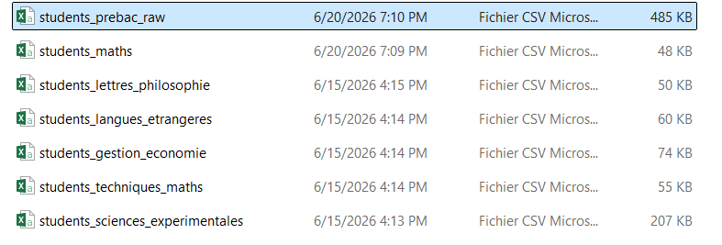

3.3 Exploratory Data Analysis
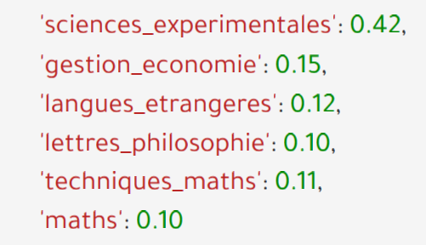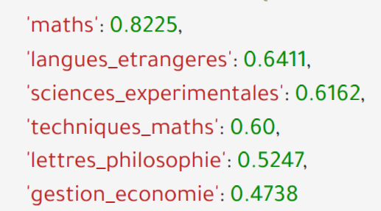

The dataset used in this study contains a representative sample of approximately 1,500 Algerian Baccalaureate students. The two figures above illustrate the distribution of students across the six academic streams (filières) as well as the corresponding success rate observed within each stream.
As shown in the first figure, the Sciences Expérimentales stream is by far the most represented in the dataset. This popularity can be explained by its balanced curriculum, which combines scientific subjects with relatively well-distributed coefficients while offering students a wide range of higher education opportunities after obtaining the Baccalaureate. In contrast, the other streams generally lead to a more specialized set of university programs and career paths, making them less attractive to a large proportion of students.
The second figure highlights the success rate for each filière. It can be observed that the Mathematics stream achieves the highest success rate, exceeding 80%. A possible explanation is that this stream is highly selective, attracting students with particularly strong mathematical and scientific backgrounds. As a result, although it contains fewer students than the Sciences Expérimentales stream, its population tends to exhibit a higher overall academic performance. This observation supports the common perception that the Mathematics stream prioritizes academic selectivity and quality over quantity.
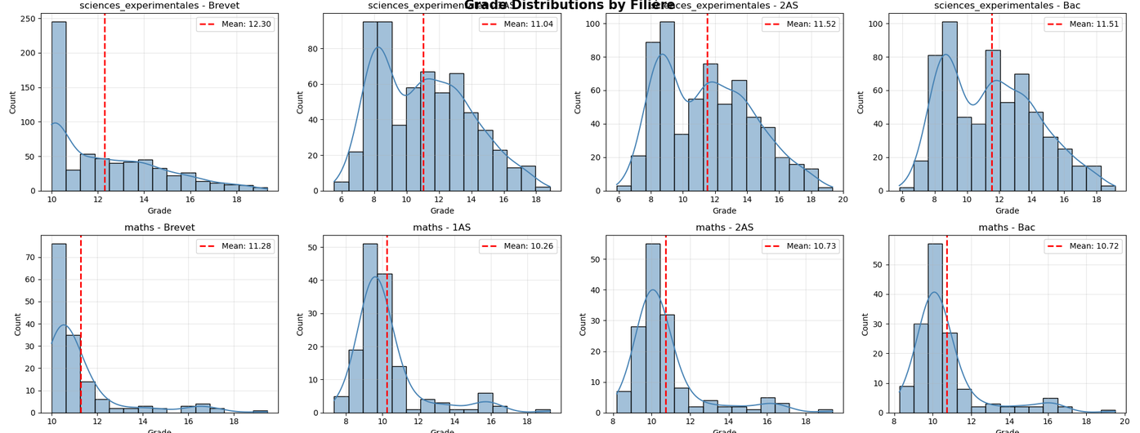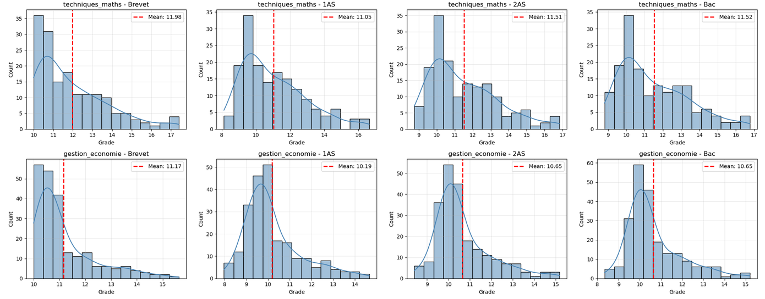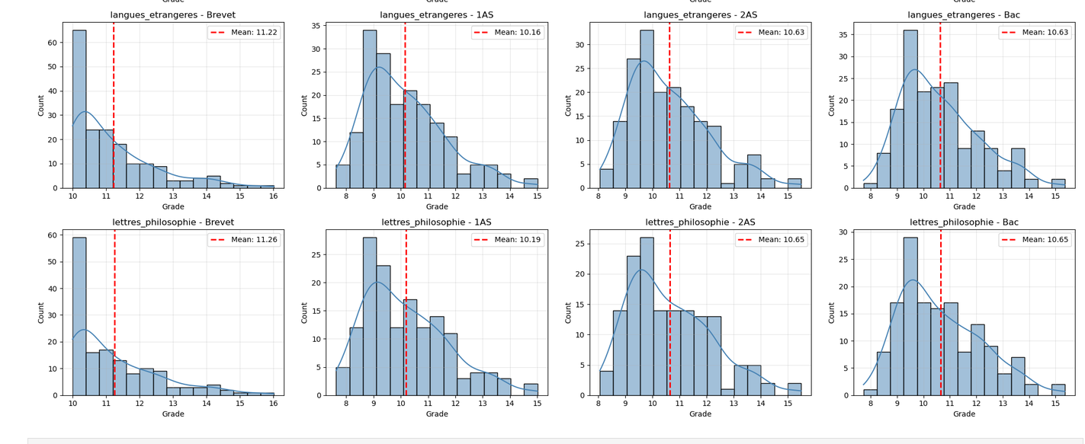
The figure above illustrates the distribution of Brevet, 1AS, 2AS, and Baccalaureate average grades across the different filières. It can be observed that the distribution of Baccalaureate averages is approximately normal, centered around an average score of 10/20, while still containing a number of high- and low-performing outliers.
In contrast, the distributions of the Brevet, 1AS, and 2AS averages exhibit a slight left skew, indicating a higher concentration of students with relatively good grades during the years preceding the Baccalaureate.
Comparing these distributions suggests that the Baccalaureate examination introduces greater variability in student performance. This observation may indicate that a considerable number of students experience significant changes in their academic results during the BAC year, whether positive or negative. In particular, it provides evidence that strong improvements—commonly referred to by Algerian students as "remontadas"—are indeed possible. Consequently, previous academic performance should not be considered the sole determinant of success in the Baccalaureate, offering an encouraging perspective for students aiming to improve their final results.

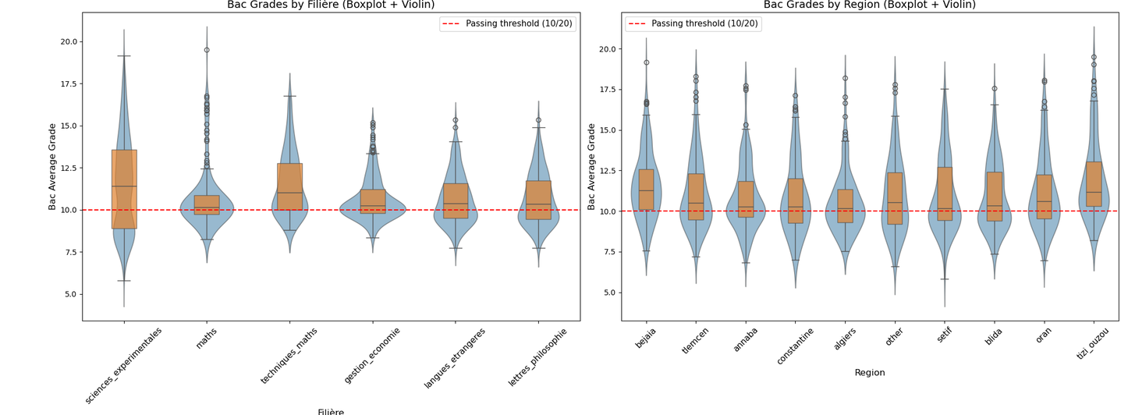

Distribution of Baccalaureate Grades by Filière and Region
The figure above presents the distribution of Baccalaureate average grades according to both the students' academic stream (filière) and their geographic region (wilaya). The combination of violin plots and boxplots provides information about the overall grade distribution, central tendency, variability, and the presence of exceptional observations.

Performance Across Academic Streams
The results reveal noticeable differences in grade distributions between the six filières.
The Sciences Expérimentales and Techniques Mathématiques streams exhibit the largest variability, as reflected by their wider distributions and larger interquartile ranges. This indicates a more heterogeneous student population, with both high- and low-performing students represented within the same stream.
The Mathematics stream displays a different pattern. Most students are concentrated within a relatively narrow range around the passing threshold, resulting in a more compact distribution. However, this stream also contains numerous high-performing outliers, with several students achieving averages approaching 20/20. This observation is consistent with the selective nature of the Mathematics stream, which generally attracts students with strong academic backgrounds.
The remaining streams—Gestion et Économie, Langues Étrangères, and Lettres et Philosophie—show relatively symmetric distributions centered around the passing threshold. Their median grades remain close to 10/20, suggesting that a large proportion of students achieve results near the minimum score required for success.

Performance Across Regions
Unlike the differences observed between academic streams, the distributions across the different wilayas are remarkably similar.
For almost every region, the median Baccalaureate average lies between 10 and 11 out of 20, while the overall distribution follows a comparable bell-shaped pattern. The majority of students obtain grades between approximately 9 and 12.5, with only moderate differences in variability across regions.
Furthermore, every region contains a number of high-achieving students whose averages exceed 16/20, demonstrating that excellent academic performance is not concentrated within a particular geographic area.

Discussion
Overall, these results suggest that the academic stream (filière) has a much greater influence on the distribution of Baccalaureate grades than the student's geographic region. While students from different wilayas exhibit broadly similar performance patterns, each filière possesses its own distinctive distribution, reflecting differences in student selection, curriculum structure, and academic requirements.
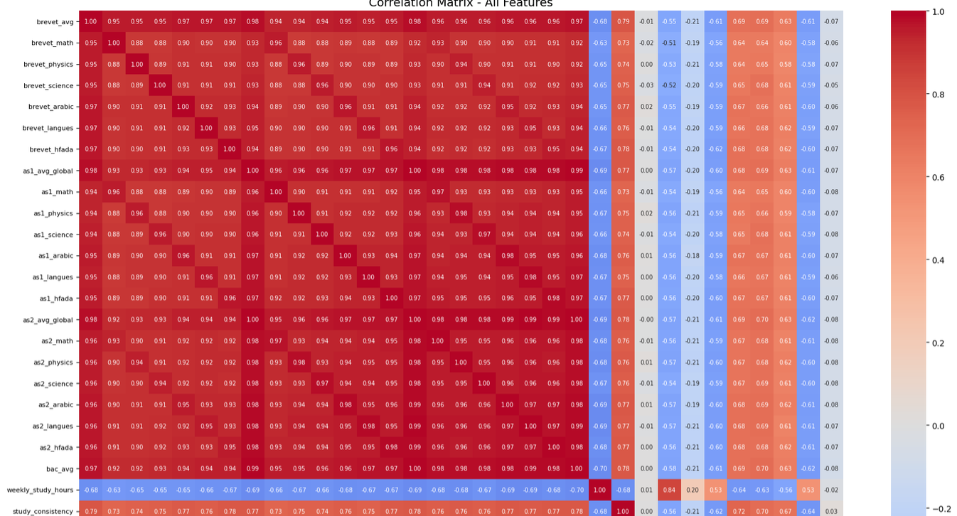
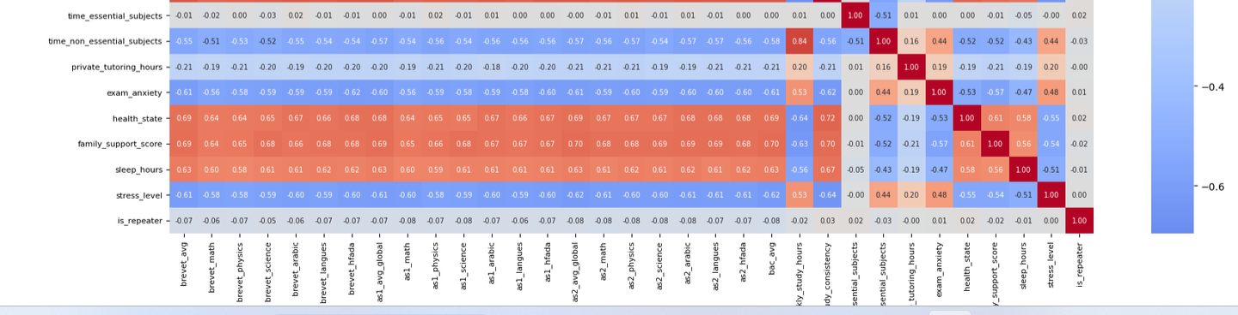

Correlation Analysis
The correlation heatmap provides an overview of the linear relationships between the different features and the final Baccalaureate average.
As can be immediately observed, the Second-Year Secondary School (2AS) average exhibits the strongest positive correlation with the Baccalaureate average, reaching a correlation coefficient of approximately 0.86. This indicates that a student's academic performance during the year immediately preceding the BAC is the best predictor of their final examination result.
The First-Year Secondary School (1AS) average and the Brevet average also show significant positive correlations, both with coefficients close to 0.67. Although these variables remain important predictors, their influence is noticeably weaker than that of the 2AS average, suggesting that more recent academic performance carries greater predictive power.
In contrast, most behavioral variables exhibit relatively weak linear correlations with the Baccalaureate average. Variables related to study habits, stress, family support, and lifestyle generally present low correlation coefficients when considered individually. However, this should not be interpreted as evidence that these factors are unimportant. Their effects are often indirect or involve complex nonlinear interactions that cannot be fully captured by simple pairwise correlation analysis. Such relationships are better modeled by machine learning algorithms capable of learning nonlinear patterns, such as the Random Forest Regressor used in this project.
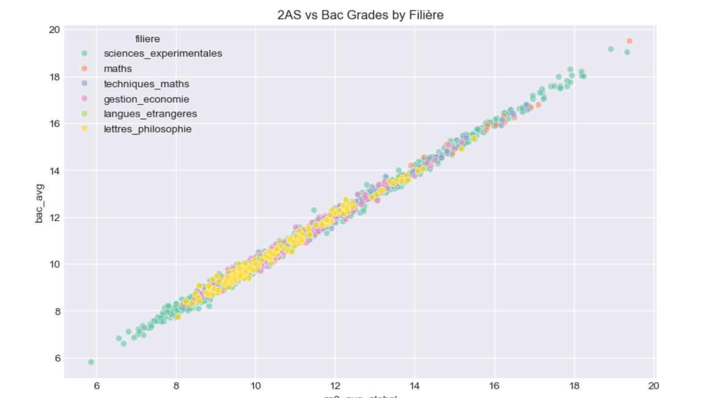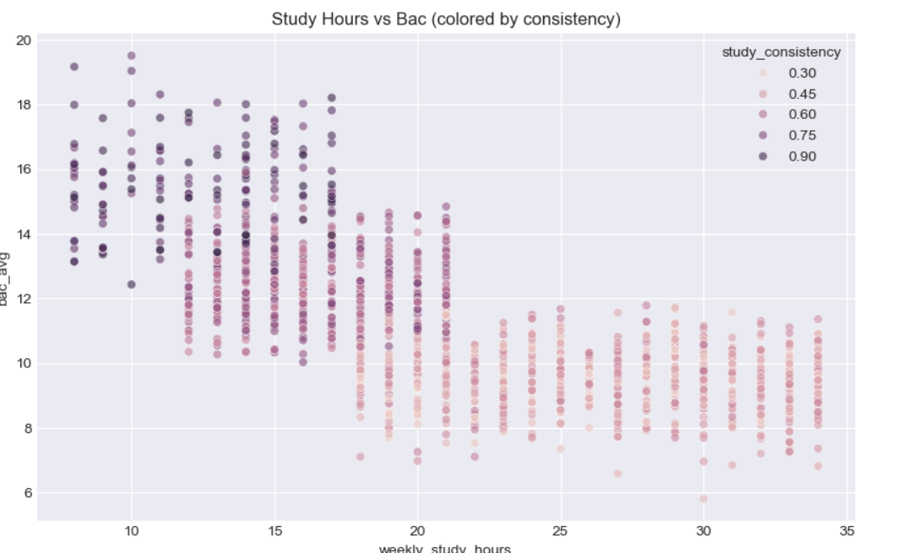

Relationship Between Previous Academic Performance and Baccalaureate Results
The first scatter plot illustrates the relationship between the students' Second-Year Secondary School (2AS) average and their final Baccalaureate average, with each point colored according to the student's filière.
A remarkably strong positive linear relationship can be observed between the two variables. Students who achieved high averages during their 2AS year generally maintained similar levels of performance in the Baccalaureate examination, while students with lower previous averages tended to obtain lower BAC results. This observation is consistent with the correlation analysis presented earlier, where the 2AS average exhibited the strongest correlation with the target variable.
Furthermore, this relationship remains consistent across all academic streams. Regardless of the filière, previous academic performance appears to be an excellent predictor of final Baccalaureate results.
A closer inspection also reveals differences between streams. The Sciences Expérimentales and Mathematics streams occupy a wider range of the performance spectrum and include the majority of the highest-achieving students, with several observations approaching the maximum score of 20/20. In contrast, students from the Lettres et Philosophie stream are more concentrated around intermediate grades, with comparatively fewer observations among the highest-performing students.

Relationship Between Weekly Study Hours and Academic Performance
The second scatter plot explores the relationship between the number of weekly study hours and the final Baccalaureate average. Each point is additionally colored according to the student's study consistency, allowing both variables to be analyzed simultaneously.
Contrary to what might initially be expected, the graph does not indicate that studying for more hours necessarily results in better academic performance. Instead, the highest Baccalaureate averages are generally observed among students studying approximately 8 to 17 hours per week, provided that they maintain a high level of study consistency.
Conversely, students reporting significantly longer study durations—often exceeding 20 hours per week—tend to obtain lower average grades and generally exhibit lower consistency scores.
One possible interpretation is that the quality and regularity of studying are more influential than the total number of hours invested. Students who study consistently throughout the academic year may require fewer hours to achieve excellent results because their learning process is more organized and efficient. On the other hand, very high reported study hours may reflect inefficient study strategies or periods of intensive revision shortly before examinations rather than sustained learning.
Overall, these findings suggest that academic consistency and previous academic performance are considerably stronger indicators of Baccalaureate success than the simple quantity of weekly study hours alone.

Here you can see the outliers :

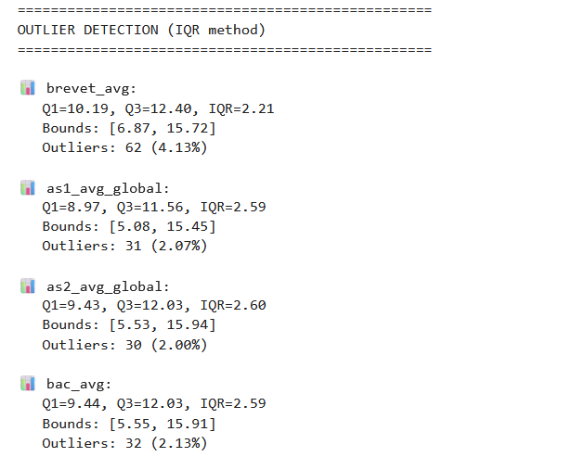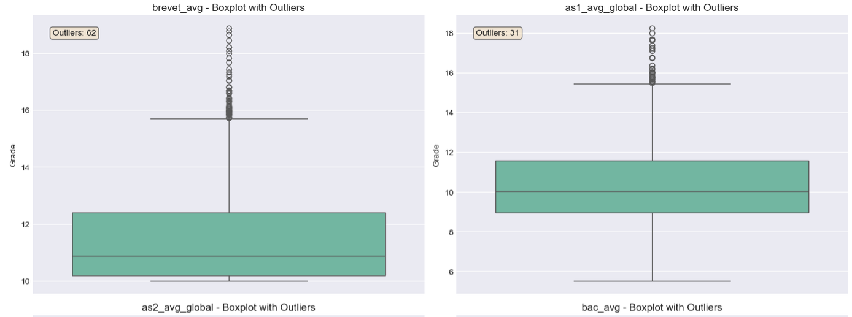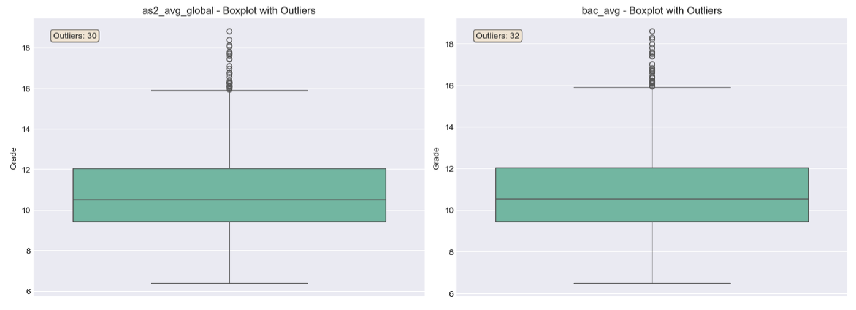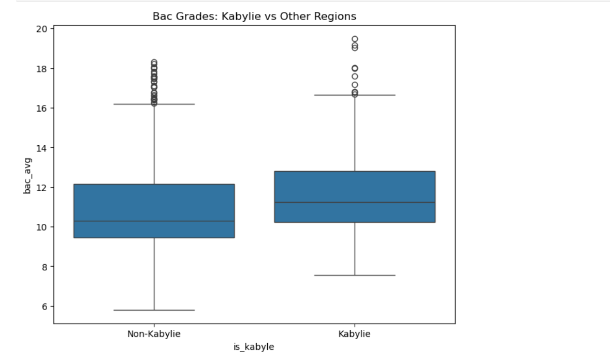

Comparison of Baccalaureate Performance Between Kabylie and Non-Kabylie Regions
The figure above compares the distribution of Baccalaureate average grades between students from the Kabylie region and those from Non-Kabylie regions. The objective of this analysis is to investigate a widespread belief among Algerian students that the Kabylie region consistently achieves higher academic performance in the Baccalaureate examination.
A clear difference can be observed between the two distributions. The median Baccalaureate average for students from the Kabylie region is noticeably higher, reaching approximately 11.25/20, whereas the median for the Non-Kabylie group is slightly above the passing threshold, around 10.30/20. This indicates that the typical student from the Kabylie group obtained a higher final average.
The interquartile range (IQR) further highlights this difference. For the Kabylie group, nearly the entire boxplot lies above the official passing threshold of 10/20, suggesting that the majority of students achieved passing grades. In contrast, the lower quartile of the Non-Kabylie distribution falls below the passing threshold, indicating a greater proportion of students with failing averages.
The lower whisker is also positioned higher for the Kabylie group, meaning that the lowest-performing students generally achieved better results than their counterparts in the Non-Kabylie group.
Finally, both groups contain numerous high-performing outliers, with several students obtaining averages exceeding 16/20 and approaching 20/20. This demonstrates that exceptional academic performance is not exclusive to a particular region, although the overall distribution appears to be shifted toward higher grades in the Kabylie group.
Overall, the analysis suggests that students from the Kabylie region exhibit a higher overall level of academic performance within the collected dataset. However, this observation should be interpreted with caution. The present analysis identifies a statistical difference between the two groups but does not establish the underlying causes of this difference. Factors such as socioeconomic conditions, educational resources, school quality, or cultural influences were not directly measured and therefore cannot be inferred from this analysis alone.

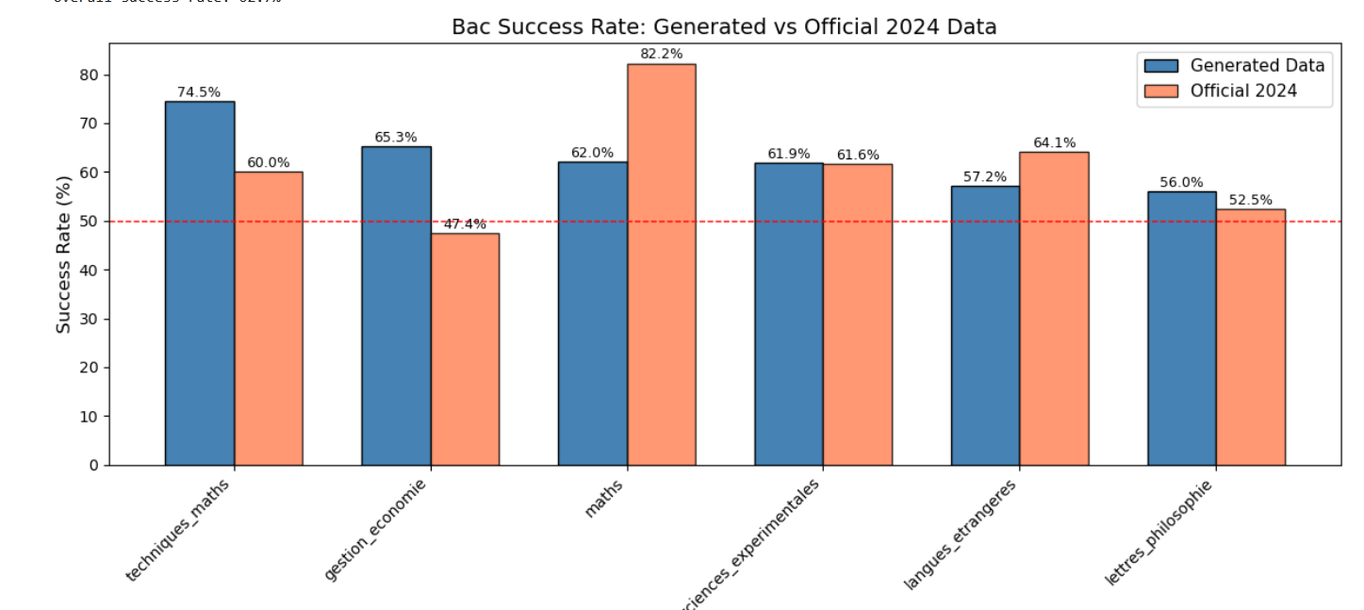

Comparison with the Official 2024 Baccalaureate Results
The figure above compares the success rates observed in the constructed dataset with the official success rates published for the 2024 Algerian Baccalaureate examination, which corresponds to the year in which the author completed the BAC.
As can be observed, the overall distribution of success rates across the different filières closely matches the official statistics. Although slight differences are expected due to sampling variability and the fact that the dataset represents only a subset of the entire student population, the general trends remain highly consistent.
It is important to note that these success rates naturally fluctuate from one year to another depending on factors such as examination difficulty and cohort characteristics. Nevertheless, the national Baccalaureate success rate generally remains around 60%, making the generated dataset representative of the overall Algerian educational context.
This comparison provides an additional validation of the dataset, suggesting that it reasonably reflects the real distribution of student outcomes observed at the national level.
-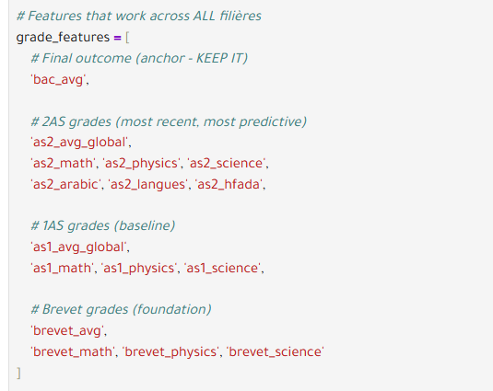
-here we selected the features that are the best correlated with bac average to make our clustering .
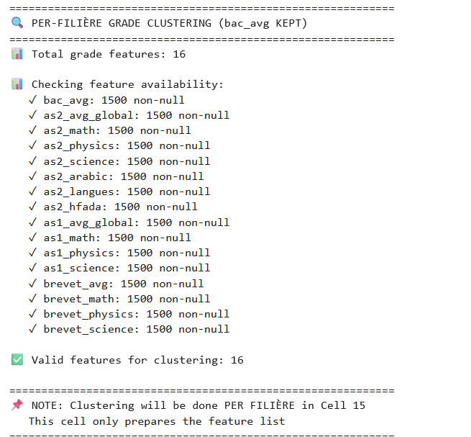

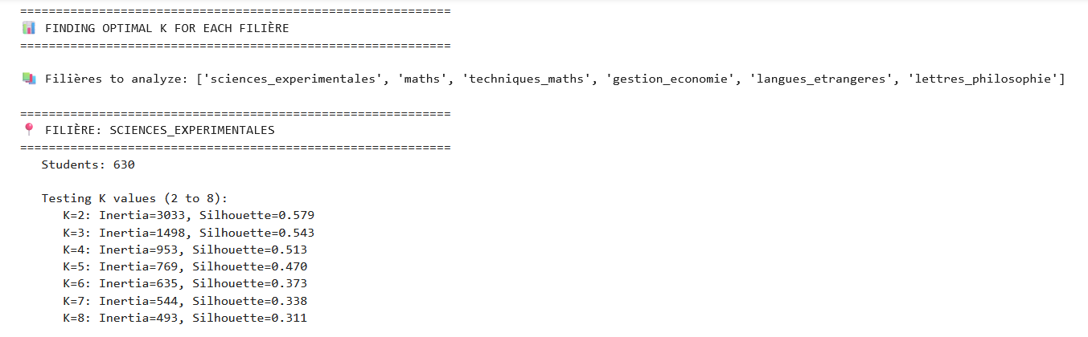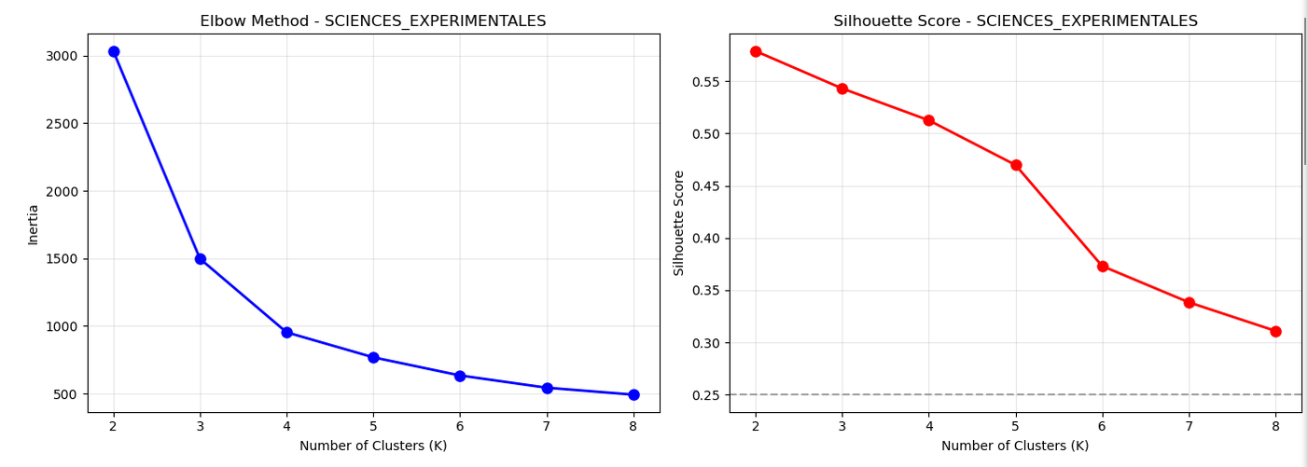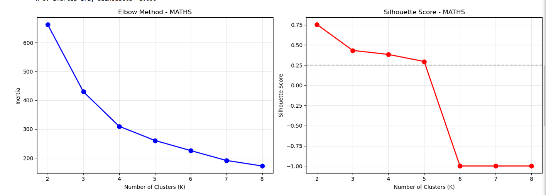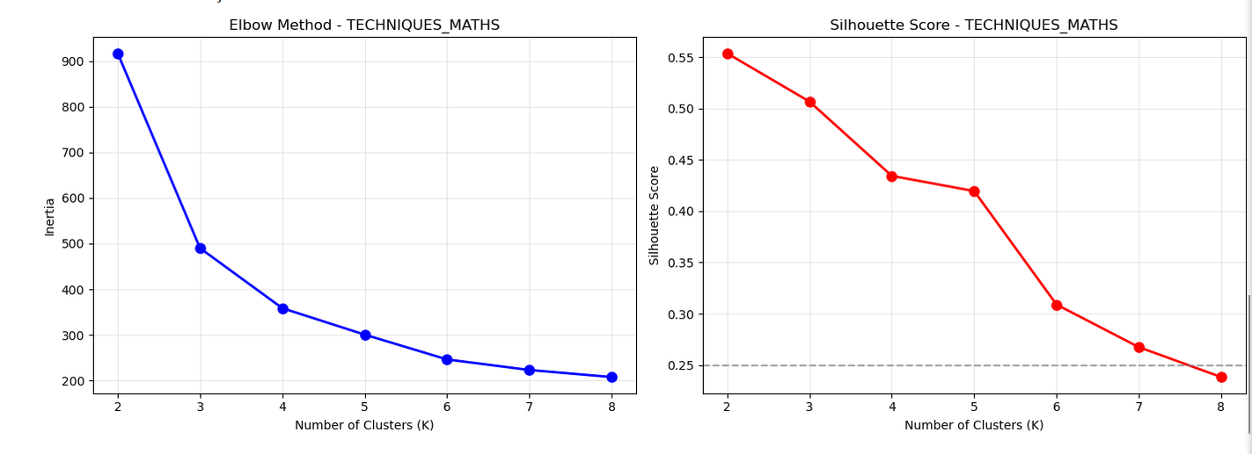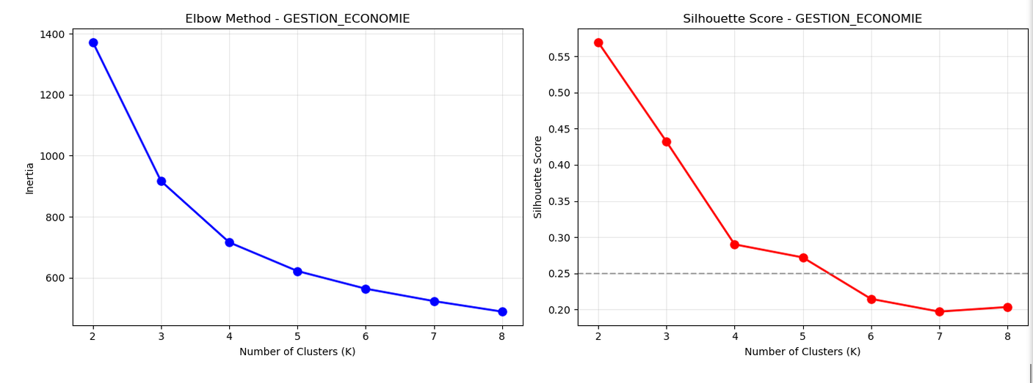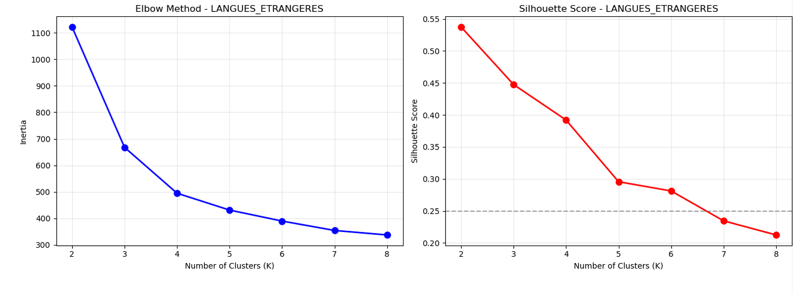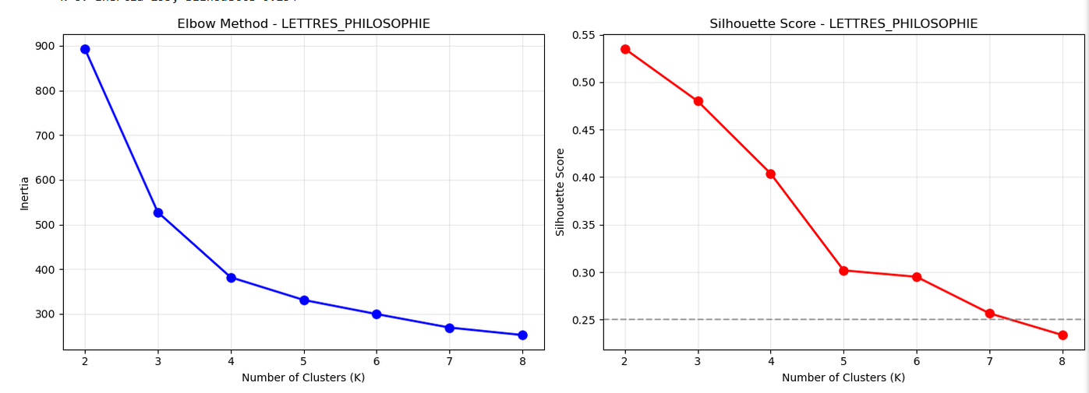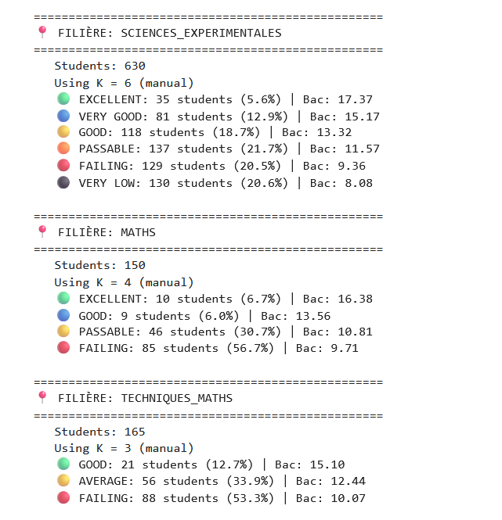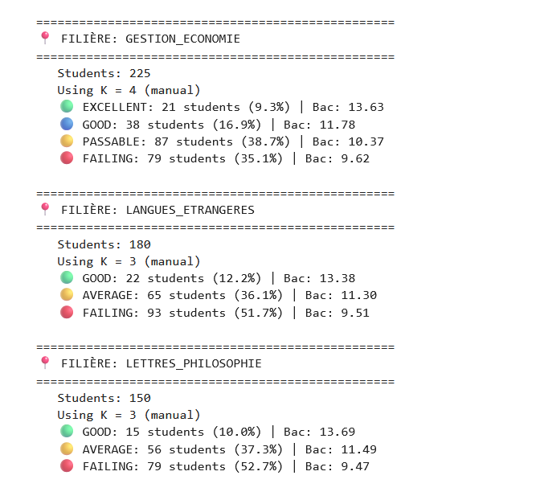

K-Means Clustering Analysis
To better understand the different academic profiles inside each filière, a K-Means clustering algorithm was applied separately to the six streams. The optimal number of clusters was selected using both the Elbow Method and the Silhouette Score, balancing cluster compactness and separation.

Sciences Expérimentales
With 630 students, this stream presented the richest diversity of profiles. The analysis suggested 6 clusters as a suitable compromise between interpretability and clustering quality.
The resulting groups range from Very Low students with an average BAC score close to 8/20, up to an Excellent cluster averaging more than 17/20. Around 41% of students belong to the two lowest-performing clusters, while nearly 37% are distributed among the Good, Very Good, and Excellent categories. This confirms that the scientific stream gathers students with very heterogeneous academic levels.

Mathematics
For the 150 Mathematics students, the validation metrics indicated that 4 clusters provide the best partition. Increasing the number of clusters rapidly deteriorated the silhouette score, indicating over-clustering.
More than 56% of the students belong to the Failing cluster, while only a small proportion reaches the Excellent category. This suggests that although Mathematics students often produce some of the highest national averages, the stream itself remains highly demanding and selective.

Techniques Mathématiques
The 165 students enrolled in Techniques Mathématiques were divided into 3 clusters.
Approximately one third of the students belong to the Average cluster, while more than half are classified in the Failing group. Only a limited percentage reaches the Good category. Overall, the distribution highlights the challenging nature of this stream and the large performance gap between students.

Gestion et Économie
For the 225 students in Gestion et Économie, the optimal solution consisted of 4 clusters.
Unlike the scientific streams, the average score of the highest-performing cluster remains around 13.6/20, indicating a lower overall performance ceiling. Most students are concentrated in the Passable and Failing clusters, which together represent nearly three quarters of the population.

Langues Étrangères
The analysis of the 180 students in Langues Étrangères resulted in 3 clusters.
More than half of the students belong to the Failing cluster, while roughly one third are grouped in the Average category. Only a small proportion achieves the Good cluster, showing that high academic performance remains relatively uncommon within this stream.

Lettres et Philosophie
For the 150 students in Lettres et Philosophie, 3 clusters were retained.
The obtained distribution is very similar to that of Langues Étrangères. Around 53% of students fall into the Failing cluster, nearly 37% belong to the Average cluster, and only 10% reach the Good category. This reflects a relatively homogeneous distribution centered around average performance.

Discussion
Several observations can be drawn from this clustering analysis.
- Sciences Expérimentales exhibits the greatest diversity of student profiles, ranging from very low performers to outstanding students.
- The Mathematics stream remains one of the most selective, producing some exceptional students while simultaneously presenting a high proportion of struggling learners.
- Techniques Mathématiques follows a similar trend, with most students concentrated below the passing threshold.
- The remaining streams (Gestion et Économie, Langues Étrangères, and Lettres et Philosophie) present more compact distributions centered around average performance, with relatively few students reaching outstanding results.
Overall, the clustering confirms that students do not form a single homogeneous population within each stream. Instead, each filière contains distinct academic profiles that can be automatically identified through unsupervised learning. These clusters later serve as the basis of the student matching system implemented in the Pre-BAC module, allowing each user to be compared with students sharing similar academic characteristics.
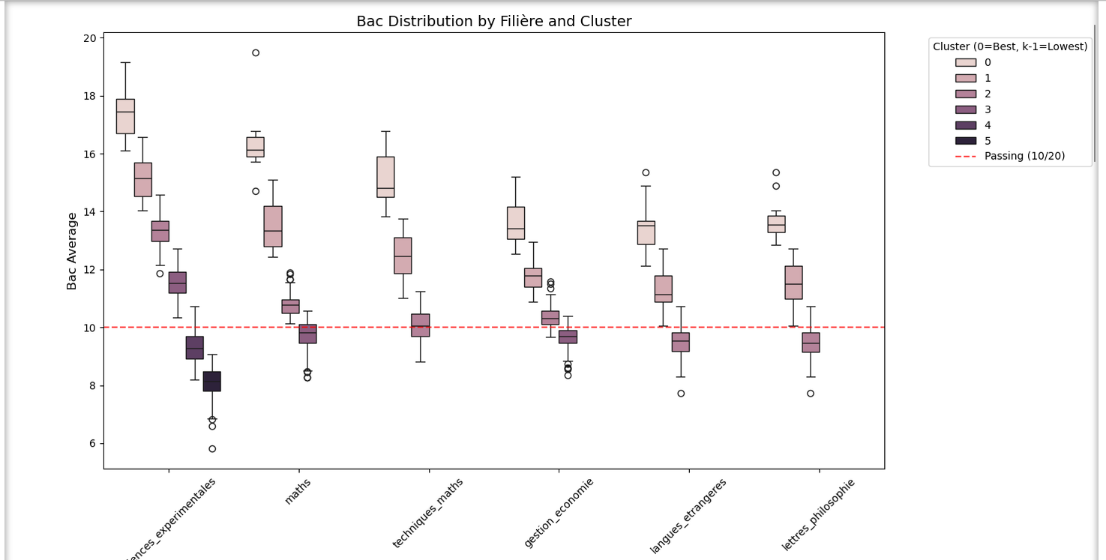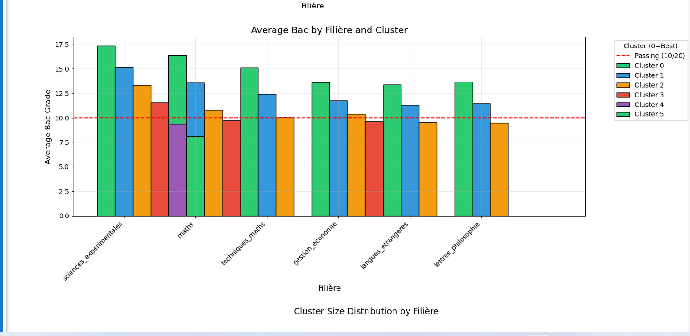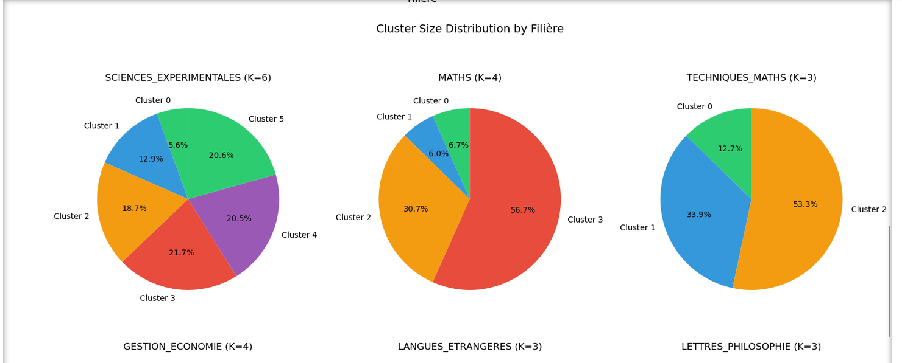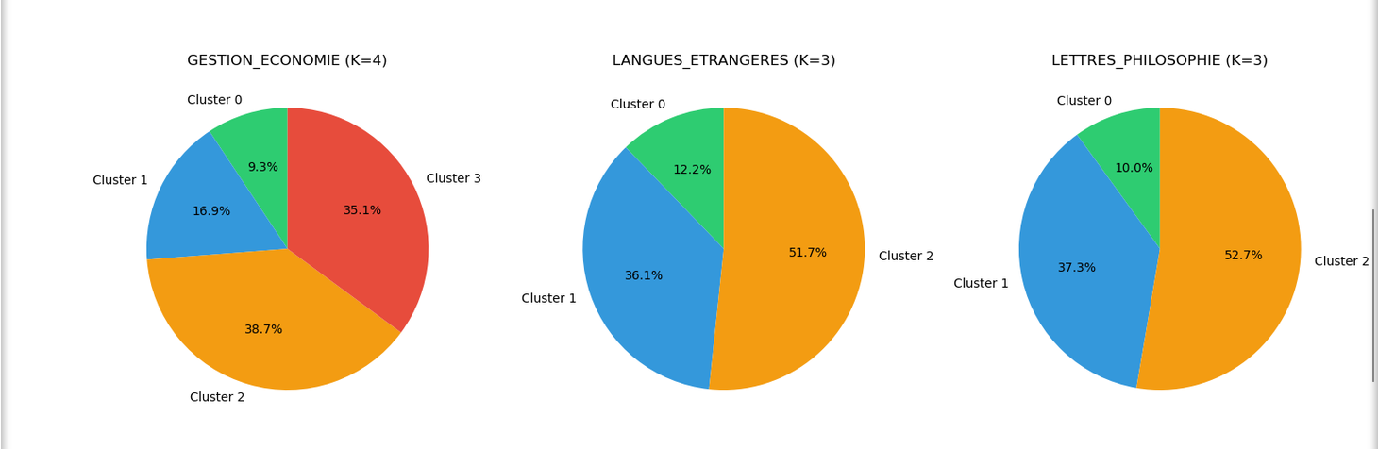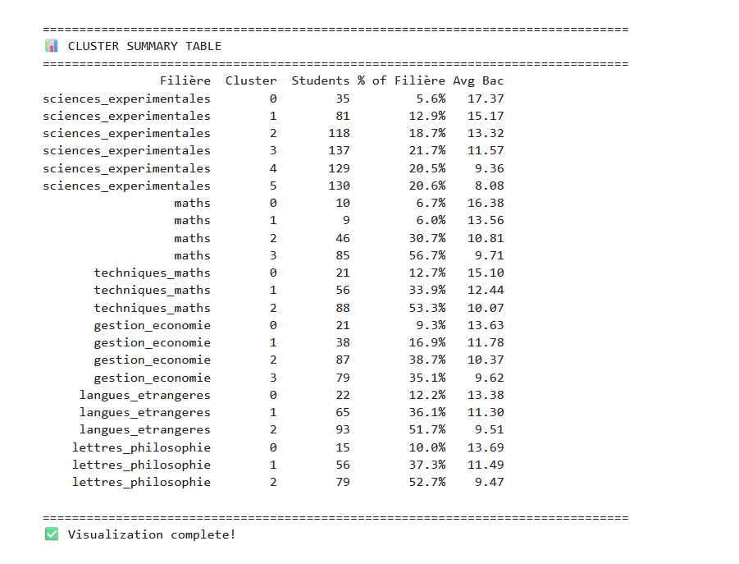

Cluster Distribution Analysis
The figures above illustrate the distribution of the different clusters obtained for each filière, together with the corresponding box plots and population proportions. A horizontal red dashed line indicates the official 10/20 passing threshold, making it easier to distinguish clusters whose average performance is above or below the minimum required to obtain the Baccalaureate.
The first observation concerns the variability of student performance. Sciences Expérimentales exhibits the widest grade distribution, ranging from students with averages below 6/20 to outstanding profiles approaching 19/20. This confirms the heterogeneous nature of this stream, where both struggling and excellent students coexist. In contrast, Langues Étrangères and Lettres et Philosophie present much more compact distributions, with smaller performance variations and fewer outstanding students.
The population distribution across clusters also reveals several interesting patterns.
For Sciences Expérimentales, nearly 59% of students belong to clusters whose average exceeds the passing threshold, while approximately 41% are grouped into the two lowest-performing clusters. This makes it the only stream where the majority of students are classified into successful academic profiles.
The Mathematics stream presents a different picture. Only 12.7% of students belong to the two highest-performing clusters, whereas more than 56% are assigned to the lowest-performing cluster. Although this stream produces some of the country's highest BAC averages, it also appears to be one of the most academically demanding.
A similar trend is observed in Techniques Mathématiques, where almost half of the students belong to satisfactory performance clusters, while the remaining 53.3% are classified into the weakest cluster.
For Gestion et Économie, the student population is more evenly distributed. The largest cluster represents students whose average is slightly above the passing threshold, while approximately 35% of students remain below the required 10/20 average.
Finally, Langues Étrangères and Lettres et Philosophie display almost identical distributions. In both streams, more than half of the students belong to the lowest-performing cluster, around one third are classified into an intermediate group, and only a small minority achieves high academic performance.
Overall, these results suggest that, with the exception of Sciences Expérimentales, the largest student population in every filière belongs to clusters characterized by average BAC scores close to or below the passing threshold. The clustering process therefore confirms the existence of distinct academic profiles within each stream and highlights the considerable performance disparities among Algerian Baccalaureate students. These findings also justify the integration of the clustering module into the application, allowing users to identify the academic profile to which they are most similar before moving to the prediction phase.

-finally we assigned meaningful Arabic architype names ,this will be used later on for a better ux.
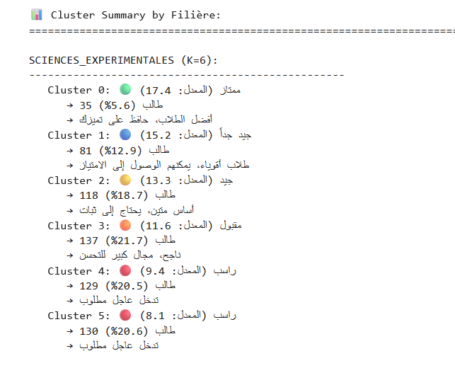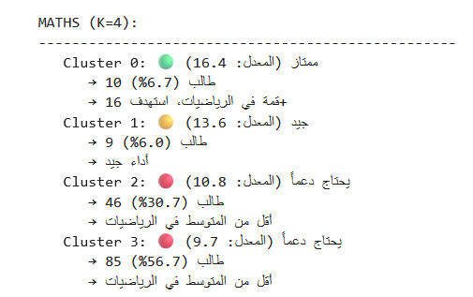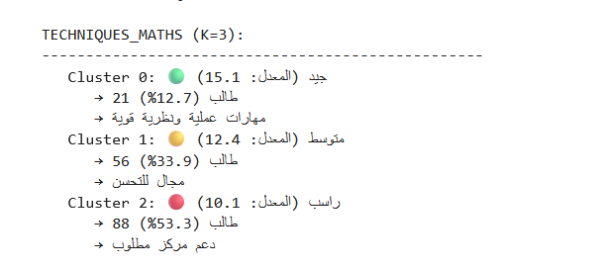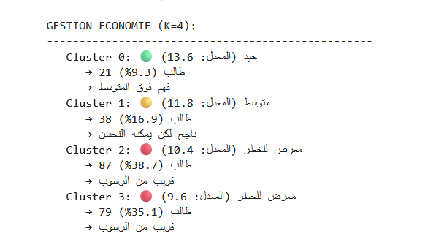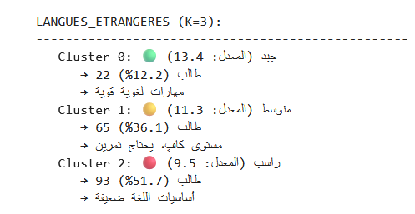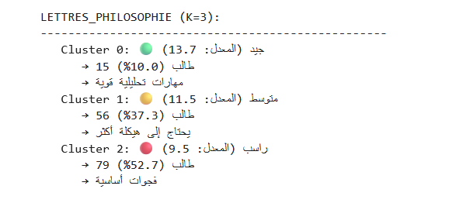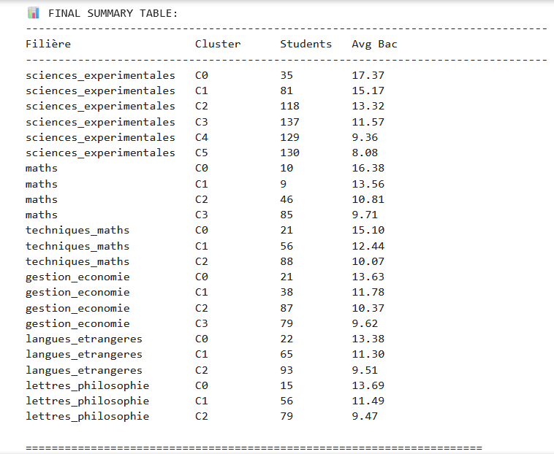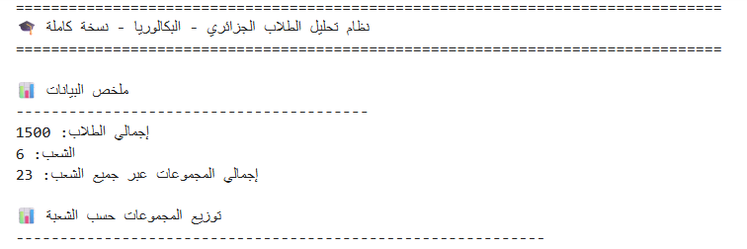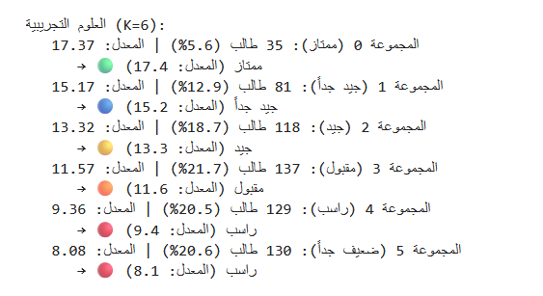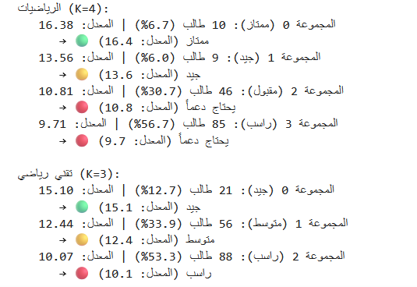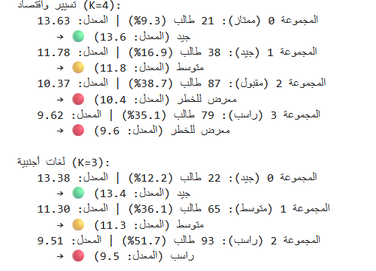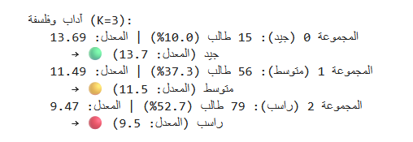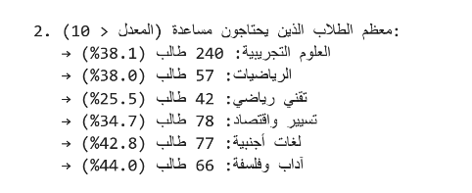

3.3 Rule-Based Logic

Student Profiler Function - Detailed Explanation

1. Overview
The analyze_student() function is a comprehensive analytics tool that generates a complete personalized student profile in Arabic. It takes a student ID as input and returns a rich set of insights including academic performance, behavioral patterns, risk assessment, and actionable recommendations.

2. Function Signature
python
def analyze_student(student_id, df=df_ml):
"""
Generate a COMPLETE personalized profile for a student in Arabic

Parameters:
-----------
student_id : int
The unique identifier of the student
df : pandas.DataFrame
The dataset containing all student data (default: df_ml)

Returns:
--------
dict : A comprehensive profile with 10+ analysis categories
"""

3. Analysis Components

3.1 Basic Information & Clustering
The function first extracts the student's basic information and places them in context:
Component | Description
Filière | The student's academic stream (e.g., Sciences, Maths, etc.)
Cluster ID | The student's group within their filière (0-4)
Archetype | The student's learning archetype (e.g., "Balanced Achiever", "Struggling Grinder")
Percentile | The student's rank within their filière (0-100%)
Cluster Comparison | How the student compares to their cluster average
Why this matters: Clustering groups students with similar academic profiles, making comparisons more meaningful than comparing to the entire filière average.

3.2 Derived Features (Calculated On-the-Fly)
The function computes 13+ derived features that reveal hidden patterns:
Feature | Formula | Interpretation
Study Efficiency | bac_avg / (study_hours + 0.1) | Points earned per hour of study (>1.2 = excellent)
Grinder Index | study_hours / (efficiency + 0.1) | Hours needed to gain 1 point (>30 = burnout risk)
Improvement Momentum | as2_avg - as1_avg | Grade trajectory (positive = improving)
Grade Volatility | std(subject_scores) | Consistency across subjects (<1.0 = stable)
Sleep Debt | max(0, 8 - sleep_hours) | Hours of sleep deficit (>1.5 = problematic)
Health-Stress Index | (6 - health_state) * stress_level | Combined health and stress burden
Weakness Count | sum(weak_subjects > 0.6) | Number of subjects with significant weakness
Problem Solving Gap | (weak_math + weak_physics) / 2 | Weakness in analytical subjects
Science vs Language Gap | science_weak - lang_weak | Disparity between scientific and language skills
Subject Balance | std([math, physics, science, arabic, languages]) | Overall subject consistency
Consistent Weak | study_consistency * weakness_count | Hard work without results (ineffective effort)
Efficient Stressed | efficiency * stress_performance | Burnout risk indicator

3.3 Derived Insights (Arabic Interpretation)
Each derived feature is automatically interpreted with:
- A clear label in Arabic
- The calculated value
- A human-readable message explaining what it means
- A status badge (✅ Excellent, 📈 Good, ⚠️ Needs Work)
Example:
json
{
"feature": "كفاءة الدراسة",
"value": "1.35",
"message": "✅ ممتاز: تكسب 1.2 نقطة في الساعة. فعال جداً!",
"status": "excellent"
}

3.4 Subject-by-Subject Analysis
Compares the student's grades in each subject against their cluster average:
Subject | Student Grade | Cluster Avg | Difference | Status
الرياضيات | 15.0 | 13.2 | +1.8 | ✅ أفضل بمقدار 1.8 نقطة
الفيزياء | 11.0 | 13.5 | -2.5 | ⚠️ أقل بمقدار 2.5 نقطة
العربية | 14.0 | 13.8 | +0.2 | 📊 بمستوى مجموعتك
Why this matters: Instead of just showing grades, this puts them in context, making it clear where the student is excelling or struggling relative to their peers.

3.5 Risk Assessment
Calculates a risk score (0-100) based on multiple factors:
Risk Factor | Weight | Condition
Low Bac Score | 20-40 | <10 = 40, <12 = 20
Multiple Weaknesses | 15-25 | >3 = 25, >2 = 15
Sleep Deprivation | 15 | Sleep debt >2 hours
High Exam Anxiety | 15 | stress_performance > 0.45
Negative Momentum | 20 | improvement_momentum < -0.5
Ineffective Effort | 15 | efficiency < 0.6 AND hours > 20
Risk Levels:
- 🟢 Low Risk (0-29): Student is on track
- 🟡 Medium Risk (30-59): Some concerning factors
- 🔴 High Risk (60-100): Multiple issues requiring intervention

3.6 Personalized Recommendations
Generates actionable recommendations tailored to the student's profile:
python
{
"action": "🎯 ركز على المواد الضعيفة",
"details": "أضعف موادك: الفيزياء, العلوم. خصص 60% من وقت دراستك هنا.",
"expected_improvement": "+1.0",
"priority": "عالية"
}
Recommendation Categories:
- Bac Level Improvement - Based on current grade (excellent → maintain, failing → urgent)
- Efficiency Enhancement - For students with low study efficiency
- Sleep Optimization - For sleep-deprived students
- Weakness Targeting - Focus on specific subjects
- Stress Management - For highly anxious students
- Grinder Prevention - For students working too hard without results

3.7 What-If Scenarios
Shows the potential impact of specific improvements:
Scenario | Method | Predicted Impact
Fix Weak Subjects | Intensive focus on weaknesses | +0.6 to +2.0 points
Improve Efficiency | Active recall, spaced repetition | +1.2 points
Better Sleep | 8 hours for 2 weeks | +0.8 points
Maintain Habits | Stay consistent | Stable performance

4. Output Structure
python
{
# Section 1: Basic Info
"student_id": 0,
"filiere": "sciences_experimentales",
"archetype": "Balanced Achiever",
"cluster_id": 2,
"bac_avg": 14.5,
"bac_mention": "جيد جداً",
"cluster_bac_avg": 13.8,
"percentile": 72.3,
"cluster_size": 45,

# Section 2: Risk Assessment
"risk_level": "🟢 خطر منخفض",
"risk_score": 25,
"risk_factors": ["📚 مواد ضعيفة متعددة (2)"],

# Section 3: Derived Insights
"derived_insights": [
{"feature": "كفاءة الدراسة", "value": "1.35", "message": "...", "status": "excellent"},
# ... 7 more insights
],

# Section 4: Subject Analysis
"subject_analysis": [
{"subject": "الرياضيات", "grade": 15.0, "cluster_avg": 13.2, "diff": 1.8, "status": "strength", "message": "..."},
# ... 5 more subjects
],

# Section 5: Strengths & Weaknesses
"strengths": [{"factor": "Grade Stability", "value": 0.85}],
"weaknesses": [{"factor": "Study Efficiency", "value": 0.62}],

# Section 6: Recommendations
"recommendations": [
{"action": "...", "details": "...", "expected_improvement": "...", "priority": "..."},
# ... up to 5 recommendations
],

# Section 7: What-If Scenarios
"what_if_scenarios": {
"fix_weaknesses": {"change": "...", "method": "...", "predicted_impact": "..."},
"better_efficiency": {"change": "...", "method": "...", "predicted_impact": "..."}
},

# Section 8: Statistics
"stats": {
"study_hours": 12,
"sleep_hours": 6,
"efficiency": 1.21,
"grinder_index": 9.9,
"weakness_count": 2,
"improvement_momentum": 1.5,
"consistency": 3.8,
"stress_level": 3,
"tutoring_hours": 2
},

# Section 9: Raw Features
"raw_features": {
"study_efficiency": 1.21,
"grinder_index": 9.9,
# ... 11 more features
}
}

5. Key Benefits
Benefit | Description
Personalized | Tailored to each student's unique profile
Contextual | Compares students to similar peers
Actionable | Provides specific recommendations with expected impact
Holistic | Considers academic, behavioral, and psychological factors
Arabic | Accessible to Algerian students and teachers
Risk-Aware | Identifies at-risk students early
Interpretable | Clear explanations for every metric

6. Usage Example
python
# Analyze a student
profile = analyze_student(42)

# Access specific insights
print(f"Student: {profile['student_id']}")
print(f"Grade: {profile['bac_avg']}/20")
print(f"Risk: {profile['risk_level']}")
print(f"Efficiency: {profile['stats']['efficiency']} points/hour")

# Get recommendations
for rec in profile['recommendations']:
print(f"- {rec['action']}: {rec['details']}")

7. Conclusion
The Student Profiler function transforms raw student data into actionable intelligence that can be used by:
- Students - To understand their strengths and weaknesses
- Teachers - To identify at-risk students
- Guidance Counselors - To provide targeted support
- Administrators - To monitor institutional performance
It combines machine learning (clustering, feature engineering) with educational psychology (study efficiency, burnout risk, sleep impact) to create a comprehensive and practical tool for academic success.

3.7 Frontend

📊 Frontend Student Profiler - Explanation for Report
The frontend student profiler is implemented as a multi-step interactive form that collects comprehensive student data across 6 progressive stages, then processes this data through a matching engine and derived feature computation to generate personalized insights.

Input Collection Process
The system collects data through six structured steps:
- Basic Information - Academic stream (filière), region, repeater status, and reason for choosing the stream
- Brevet (Middle School) Grades - Mathematics, Physics, Science, Arabic, and Foreign Languages
- First Year Secondary (1AS) Grades - Same five subjects
- Second Year Secondary (2AS) Grades - The most important predictor of Bac results
- Study Habits & Lifestyle - Weekly study hours, study consistency (0.1-1.0), sleep hours (4-9), stress level (1-5), exam anxiety, family support, private tutoring hours
- Review & Submit - Final verification before analysis

Cluster Assignment Method
The student's cluster is determined using a rule-based approach based on their predicted Bac score:
- For Sciences Expérimentales: 6 clusters (17+ = Cluster 0, 15.5-17 = Cluster 1, 13.5-15.5 = Cluster 2, 11.5-13.5 = Cluster 3, 9-11.5 = Cluster 4, <9 = Cluster 5)
- For Maths: 3 clusters (≥17.5 = Cluster 0, 14.5-17.5 = Cluster 1, <14.5 = Cluster 2)
- For Other Streams: 3 clusters (≥14 = Cluster 0, 11.5-14 = Cluster 1, <11.5 = Cluster 2)
Each cluster has a pre-calculated average Bac score and a detailed Arabic description explaining the student's profile, strengths, weaknesses, and specific recommendations.

Matching Engine
The system finds the closest matching student from the real dataset using a weighted similarity algorithm:
Feature Category | Weight | Features
2AS Grades | 40% | Math, Physics, Science, Arabic, Languages
1AS Grades | 15% | Math, Physics, Science
Brevet Grades | 10% | Math, Physics, Science
Study Habits | 20% | Hours, Consistency, Sleep
Lifestyle | 15% | Stress, Anxiety, Family Support
Each feature difference is normalized (0-1 scale) and weighted to compute a similarity score (lower = more similar). The top 5 matches are displayed, and the best match is selected.

Hybrid Prediction Method
The final Bac score is calculated using a hybrid approach:
text
Final Score = (Match Score × 0.5) + (Regression Score × 0.5)
Where:
- Match Score = The actual Bac score of the closest matching student
- Regression Score = A weighted formula based on the student's own grades and habits
The regression formula uses:
- 2AS average (55%)
- 1AS average (20%)
- Brevet average (10%)
- Math score (5%)
- Science score (5%)
- Languages score (5%)
With habit adjustments for sleep, study efficiency, consistency, stress, family support, tutoring, region, and repeater status.

Derived Features Computation
The system computes 20 derived features that provide deep insights into the student's profile:
Feature | Formula | Purpose
Study Efficiency | 2AS Avg / (Study Hours + 0.1) | Measures points earned per study hour
Grinder Index | Study Hours / Efficiency | Detects burnout risk
Time Allocation Ratio | Essential Time / Non-Essential Time | Checks if student focuses on weak subjects
Resource Reliance | Tutoring Hours / Study Hours | Measures dependency on private tutoring
Improvement Momentum | 2AS Avg - 1AS Avg | Tracks grade trajectory
Grade Volatility | Std Dev of [Brevet, 1AS, 2AS] | Measures consistency
Stress Performance Ratio | Anxiety / (2AS Avg + 0.1) | Detects anxiety impact
Sleep Debt | max(0, 8 - Sleep Hours) | Measures sleep deprivation
Health-Stress Index | (6 - Health) × Stress | Combined health and stress burden
Weakness Count | Count of subjects < 11/20 | Number of weak subjects
Problem Solving Gap | (Math Weak + Physics Weak) / 2 | Analytical skills weakness
Weakness Concentration | Max Weakness - Min Weakness | Detects if weakness is spread or focused
Science-Language Gap | Science Weak - Language Weak | Identifies stream misalignment
Subject Balance | Std Dev of 2AS Subjects | Overall subject consistency
Filière Alignment | Score / 20 | Measures if student is in right stream
Efficient Stressed | Efficiency × Stress Ratio | Identifies burnout risk
Consistent Weak | Consistency × Weakness Count | Detects ineffective effort
Repeater Penalty | 0 or 1 | Penalty for repeating year
Family Support | Score / 5 | Measures family support strength
Kabylie Boost | 0 or 1 | Regional performance bonus

Visualization
The system generates two types of visualizations:
- Radar Chart - Compares the student's grades in each subject against their cluster average
- Study Habits Comparison - Compares the student's study habits against ideal targets

User Experience
The interface features:
- Progress bar showing completion status (1/6 to 6/6)
- Step-by-step navigation with Back/Next buttons
- Real-time Arabic descriptions and explanations
- Color-coded feedback (green = good, red = needs improvement)
- Detailed cluster explanations in simple Arabic
- Actionable recommendations with expected improvement points

Chapter 4 — BAC Year

4.1 Overview of the BAC Year Module

Chapter 4 — BAC Year
This chapter presents the core component of the project, namely the BAC Year module. The objective of this phase is to assist students throughout their Baccalaureate preparation by combining machine learning predictions with explainable AI techniques and an interactive user interface.
The application is organized around clickable subject cards, where each card redirects the user to a dedicated page for the selected subject. Every subject page contains several components designed to provide both predictions and practical guidance.
First, the student is introduced to the official examination structure, including the exam duration and format according to the selected filière. This familiarizes students with the nature of the examination before moving to the prediction stage.
Next, the student fills in a form containing the most influential features identified during the exploratory data analysis for that particular subject. These features are then passed to a dedicated machine learning model that predicts the student's expected score.
To make the prediction interpretable rather than being a simple numerical output, SHAP (SHapley Additive exPlanations) is used to identify the student's strengths and weaknesses. The contribution of every feature to the predicted score is analyzed and translated into understandable feedback that the student can easily interpret.
The application also includes a simulation engine built upon the correlations discovered during the exploratory data analysis. By modifying specific input variables, students can simulate potential improvements and immediately observe their estimated impact on the predicted subject average. This allows them to understand which aspects of their preparation deserve the greatest attention.
Finally, a comprehensive report summarizes all the generated information, including the predicted score, identified strengths and weaknesses, simulated improvements, and personalized recommendations.
Since the Algerian Baccalaureate contains 15 different subjects, a separate machine learning pipeline was developed for each subject. Consequently, 15 datasets, 15 Jupyter notebooks, and 15 trained models were created. Although each subject has its own specific features and dataset, all notebooks follow the same methodological pipeline consisting of data preparation, exploratory data analysis, feature engineering, model selection, training, evaluation, explainability, and deployment.
To avoid making this report unnecessarily long and repetitive, the common methodology will be presented only once. The specific characteristics, datasets, selected features, model performances, and results of each subject will instead be summarized in dedicated tables throughout this chapter.
Beyond subject prediction, this module also integrates several rule-based systems. A resource recommender suggests learning materials according to the student's predicted performance and detected weaknesses, while a To-Do List Generator creates personalized study tasks based on the same information, note that this to do list can be customized by the user since user comfort is our priority .
Finally, the generated tasks are transformed into a personalized study timetable using a Genetic Algorithm. The optimization process relies on a well-defined search space, hard and soft constraints, and a fitness function to produce realistic and balanced study schedules. The design of this optimization algorithm and its evaluation are presented later in this chapter.
Cell Number | Description
1 | Import Libraries - Imports all necessary libraries: Pandas, NumPy for data manipulation; Matplotlib, Seaborn for visualization; Scikit-learn for machine learning (RandomForestRegressor, MultiOutputRegressor, train_test_split, evaluation metrics); SHAP for model explainability. Sets visualization styles and display options.
2 | Dataset Generation  One of the main challenges of the BAC Year module was the construction of the datasets. Unlike the Pre-BAC phase, this section required a separate dataset for each subject, each containing its own subject-specific features and corresponding grades. Collecting real data for approximately 2,000 students across all 15 Baccalaureate subjects would have required an enormous amount of time and resources, making the process practically infeasible.  To overcome this limitation, a data generation approach was adopted. The datasets were generated using raw educational materials collected from official Algerian educational resources, including official syllabuses, examination structures, national statistics, and historical educational documents. These sources served as the foundation for constructing realistic datasets that reflect the characteristics and constraints of each subject.  After the generation process, a comprehensive Exploratory Data Analysis (EDA) was conducted for every dataset. The objective was to verify that the generated data remained consistent with the statistical properties, distributions, and educational realities of the Algerian Baccalaureate. Only after validating the coherence of the generated datasets were they used for feature engineering, model training, and evaluation.
3 | Export Dataset - Saves the generated dataset as 'subject_bac_dataset.csv' for persistence and reuse.
4 | Load Dataset - Loads the saved CSV file back into a Pandas DataFrame for analysis and modeling.
5 | EDA Overview - Exploratory Data Analysis showing dataset shape (500 rows, 22 columns), first 5 rows, data types, summary statistics (mean, std, min, max for all columns), missing values check (no missing values), duplicate check, memory usage.
6.1 | BAC Score Distribution - Visualizes BAC score distribution with histogram, showing mean and median lines, passing rate (students scoring ≥10/20). Prints detailed statistics including mean, median, std dev, min, max.
6.2 | Normality Check - Three visual tests: histogram with normal curve overlay, Q-Q plot for normality assessment, boxplot with outliers. Includes Shapiro-Wilk and Kolmogorov-Smirnov statistical tests. Skewness and kurtosis analysis determine if the data follows a normal distribution.
7 | Correlation Heatmaps . The correlation heatmaps were used to study the relationship between each input feature and the target variable, namely the expected Baccalaureate grade for the corresponding subject. Their primary objective was to identify the variables that exhibit the strongest predictive power and should therefore be selected for training the machine learning models.  Beyond feature selection, the discovered correlations also played an important role in the application's improvement simulation engine. Since the heatmaps quantify the strength and direction of the relationships between variables, they provide a solid statistical foundation for estimating how improvements in specific features may influence the student's predicted score. Consequently, the simulation mechanism relies on these correlations to generate realistic and data-driven improvement scenarios rather than arbitrary estimates.
8 | Feature Distributions - Plots histograms for key features including trimester grades, the respective skills depending of the subject ,generic study habits. Each plot shows the distribution with mean line. Summary statistics table provided for all key features.
9 | Feature Engineering - Creates derived features from original skills based on each subject ,we have a special section in our frontend dedicated to explain these derived features .
10 | Train/Test Split - Splits data into 80% training and 20% test using random_state=42 for reproducibility. Keeps avg_grade as a feature (it's the strongest predictor). X has a number features, y is bac_score. Verifies no overlap between train and test indices.
11 | Model Training - Trains a MultiOutput RandomForestRegressor with 100 trees, max_depth=10. Three outputs predicted: (1) BAC score (0-20), (2) Success probability (binary: ≥10/20), (3) Improvement potential (how many points can be gained, 0-10). Evaluates with MAE , RMSE , R² and of course Success classification accuracy.
12 | Detailed Evaluation The performance of each subject-specific model was assessed using several complementary evaluation metrics to ensure both predictive accuracy and practical reliability. Since fifteen independent models were trained, the values presented below correspond to the average performance observed across all subjects.  The regression models achieved an average Mean Absolute Error (MAE) of 0.74, a Mean Squared Error (MSE) of 0.89, a Root Mean Squared Error (RMSE) of 0.94, and a coefficient of determination (R²) of 0.895. These results indicate that the models are capable of accurately estimating students' expected Baccalaureate grades while explaining nearly 90% of the variance in the data.  To evaluate the practical usefulness of the predictions, the regression outputs were also transformed into a pass/fail classification using the official passing threshold of 10/20. The resulting confusion matrix reports the number of True Positives, True Negatives, False Positives, and False Negatives, providing a clear overview of the model's classification performance. Additionally, a complete classification report was generated, including Precision, Recall, and F1-score, to evaluate the balance between correctly identifying successful and unsuccessful students.  Several visualizations were produced to facilitate model interpretation and validation. These include:  - An Actual vs. Predicted scatter plot to assess the agreement between predicted and real grades.  - A Residual Distribution histogram to verify that prediction errors remain randomly distributed around zero.  - A Feature Importance chart highlighting the variables that contribute most to each model's predictions.  Finally, an error analysis was performed to evaluate the practical accuracy of the predictions. On average, 78% of all predictions differed from the actual grade by less than one point, while 92% had an error of less than two points. These results demonstrate that the proposed models provide sufficiently accurate predictions for educational guidance and personalized decision support.
13 | SHAP Explainability Machine learning models often provide highly accurate predictions but may behave as "black boxes," making it difficult to understand the reasoning behind a specific prediction. To overcome this limitation and increase the transparency of the platform, SHAP (SHapley Additive exPlanations) was integrated into the application.  SHAP assigns an importance value to every input feature by measuring its contribution to the final prediction. Instead of only displaying the predicted score, the system is able to explain why the student obtained that prediction and identify the factors that positively or negatively influenced the expected grade. These explanations also serve as the foundation for the weakness detection mechanism and the personalized recommendations proposed by the application.  For each trained subject model, three complementary SHAP visualizations are generated:  - Feature Importance Bar Plot: Displays the average contribution of each feature across the entire dataset, allowing the identification of the variables that have the greatest influence on students' performance in the subject.  - SHAP Beeswarm Summary Plot: Illustrates the distribution of SHAP values for every feature across all students. It simultaneously highlights feature importance, the direction of their influence (positive or negative), and the variability of their impact on different student profiles.  - Waterfall Plot: Provides a detailed explanation for an individual student's prediction by showing how each feature contributes to moving the predicted grade upward or downward from the model's baseline prediction until the final estimated score is obtained.  The explanations generated by SHAP are then exploited by the application to detect students' strengths and weaknesses, generate personalized reports, recommend appropriate learning resources, and support the simulation engine that estimates the potential improvement resulting from changes in specific study habits or academic indicators. This transforms the predictive model from a simple forecasting tool into an interactive decision-support system capable of providing meaningful and interpretable feedback to the user.
14 | Weakness Analysis To make the model predictions actionable, a weakness analysis module was developed using SHAP values. Features with negative SHAP values are identified as weaknesses, while those with positive SHAP values are considered strengths. The larger the SHAP value, the greater its impact on the predicted grade.  For each student, the system generates a personalized profile highlighting the main strengths and weaknesses that influence the prediction. In addition, SHAP values are aggregated across the dataset to identify the most common weaknesses among students for each subject.  These results are later used by the platform to generate personalized recommendations, learning resources, to-do lists, and improvement strategies.
15 | Simulation Engine - Calculates real impact factors from correlations .
16 | Student-Friendly Explanations To ensure that the platform remains accessible to students with no background in machine learning, all technical outputs are translated into simple Arabic explanations. Instead of displaying complex metrics, the application presents an intuitive profile describing the student's strengths, weaknesses, and study habits in an easy-to-understand manner.  Each skill is accompanied by a performance indicator (🟢 Strong, 🟡 Average, 🔴 Needs Improvement) along with an explanation of its impact on the predicted BAC score. Derived features such as language proficiency, analytical ability, practice intensity, and subject balance are also explained using simple language. Finally, the platform provides a personalized summary highlighting the student's strongest and weakest areas, together with practical recommendations to improve future performance.  .
17a | Introduction + Exam Structure - Professional dashboard showing BAC exam structure for the targeted subject . Displays exam duration (2h30), total points (20), two sections (scientific streams vs literary streams. Color-coded skill importance, Explains how the platform works: input data → prediction → weakness analysis → simulation → recommendations.
17b | User Input Form : An interactive input form was developed using ipywidgets to collect all the information required by the prediction model. The interface is organized into five logical sections: stream selection, trimester grades, subject-specific skills, study habits, and psychological factors.  Students provide their information through intuitive widgets such as sliders, radio buttons, and dropdown menus, making the data entry process simple and user-friendly. The interface was designed with a clean layout, section headers, progress indicators, and consistent styling to improve usability. Once completed, all user inputs are stored in a structured variable, which is then passed to the machine learning model for prediction and subsequent analysis.
17c | Prediction Output : Once the user submits the input form, the trained Random Forest model predicts the expected BAC score. In addition to the prediction, several derived features are automatically computed, including the overall average, language proficiency score, writing score, analytical ability, practice intensity, subject balance, grade trend, and grade stability.  The prediction results are then presented through a comprehensive HTML interface. The application displays the predicted BAC score together with its corresponding performance level (🏆 Excellent, 🎉 Very Good, 👍 Good, 📈 Acceptable, or ⚠️ Needs Improvement), the estimated probability of success, and the student's improvement potential. A summary of the student's profile and a detailed breakdown of skills using progress bars are also provided to facilitate interpretation.  Finally, the interface offers navigation controls allowing the user either to modify the entered information and generate a new prediction or to continue to the Weakness Analysis section for a detailed explanation of the factors influencing the predicted score.
17d | Weakness Analysis : This module compares the student's profile with predefined target levels to identify both academic weaknesses and strengths. Skill and study-habit gaps are computed, including practice, study consistency, study hours, confidence, participation, and exam preparation. An overall weakness score (0–100) is then calculated to summarize the student's current performance.  The results are presented through an interactive interface displaying the overall weakness score, the most critical skill and habit weaknesses, the student's strongest areas, stress-level alerts when necessary, and a set of personalized recommendations to guide the improvement process.
17e | Derived Features Explanation compute and explain the derived features is a user friendly way .
17f | Simulation Engine - Interactive simulation with 11 sliders (6 skills + 5 habits) based on real correlations. Users can adjust any skill or habit and see real-time impact on predicted BAC score.
17g | Final Report - Professional comprehensive report consolidating all analysis. Includes: (1) Header with timestamp, (2) Score summary card showing predicted score with level and color coding, success probability, improvement potential, (3) Two-column student info (stream, trimester average, skills average) and key metrics (language core, analysis, practice intensity, imbalance), (4) Strengths & Weaknesses cards showing strongest and weakest skills, (5) Detailed skills breakdown with progress bars and color coding (green ≥7, yellow 5-7, red <5), (6) Personalized action plan with 5+ specific recommendations based on user's data, (7) Summary message with overall advice and expected improvement, (8) Navigation buttons to return to simulation or start new evaluation.

4.2 a table that contains the subject and its feautures :

Subject | Original Features | Derived Features
Arabic | grade_t1, grade_t2, grade_t3, avg_grade, grammar, essay, poetry, prose, rhetoric, comprehension, essays_per_week, exams_practiced, study_hours, consistency, tutoring, participation, confidence, stress, interest, filiere | language_core_score, writing_score, analysis_score, imbalance_score, practice_intensity
Economie | eco_grade_t1, eco_grade_t2, eco_grade_t3, eco_avg_grade, eco_trend, market_mechanisms, money_banking, unemployment, inflation, international_trade, financing, communication, control, leadership_motivation, situation_analysis, graph_interpretation, calculation_accuracy, structured_answer, bac_exams_practiced, situation_exercises, study_hours, consistency, eco_anxiety, analysis_confidence, exam_stress | economics_composite, management_composite, economic_skills_composite, practice_intensity, psychological_composite, study_quality, imbalance_score, market_focus, situation_strength
English | grade_t1, grade_t2, grade_t3, avg_grade, main_idea_detection, inference_skill, text_structure, ordering_information, skimming_scanning, synonym_accuracy, antonym_accuracy, transformation_skill, conditional_mastery, tense_control, vocabulary_richness, essay_structure, guided_writing, argumentation_skill, coherence_score, cohesion_score, writing_grammar, reading_frequency, writing_frequency, past_exam_practice, study_hours, consistency, study_method, class_participation, tutoring, confidence, stress, motivation, filiere | reading_score_derived, language_score_derived, writing_score_derived, imbalance_score_derived, practice_intensity_derived, grammar_mastery, vocabulary_score, overall_proficiency, psycho_balance, study_efficiency
French | grade_t1, grade_t2, grade_t3, avg_grade, comprehension_textuelle, inference, true_false_justification, communicative_intent, thesis_identification, argument_identification, concession_opposition, essay_structure, language_accuracy, historical_text, argumentative_text, reference_tracking, lexical_analysis, critical_reasoning, coherence_cohesion, bac_exams_practiced, confidence, essays_per_week, texts_analyzed_per_week, stress, filiere | comprehension_score, argumentation_score, writing_score, text_type_score, practice_intensity, comprehension_score_derived, argumentation_score_derived, writing_score_derived, text_type_score_derived, practice_score, psycho_score, preparation_score, imbalance_score, global_skills_score
Gestion | grade_t1, grade_t2, grade_t3, avg_grade, grade_trend, calculation_accuracy, financial_logic, table_handling, cost_block, financial_block, loan_block, execution_speed, bac_practiced, weekly_exercises, mock_exams, study_hours, consistency, stress, confidence | gestion_imbalance, practice_intensity, study_quality, overall_level
His_Geo | grade_t1, grade_t2, grade_t3, avg_grade, grade_trend, historical_memory, dates_memory, figures_memory, geography_knowledge, document_analysis_method, essay_method, map_stats_method, argumentation_skill, cold_war_knowledge, decolonization_knowledge, algeria_history_knowledge, economic_powers_knowledge, development_knowledge, history_part_structure, geography_part_structure, bac_exams_practiced, memorization_frequency, study_hours, consistency, stress_level, confidence_level, interest_in_subject | memory_composite, methodology_composite, knowledge_composite, study_quality, hg_imbalance
Islamia | grade_t1, grade_t2, grade_t3, avg_grade, grade_trend, quran_recitation, tafsir_understanding, reasoning_from_verses, hadith_comprehension, hadith_analysis, moral_extraction, fiqh_ibadah, fiqh_muamalat, riba_understanding, aqida_understanding, proofs_awareness, ayah_analysis, hadith_text_analysis, document_analysis, definition_accuracy, explanation_clarity, evidence_usage, structured_answer, quran_exercises, hadith_exercises, fiqh_cases, past_exams, stress_level, confidence | quran_composite, hadith_composite, fiqh_composite, analysis_composite, methodology_composite, practice_intensity, overall_islamia
Langue Etrangere | grade_t1, grade_t2, grade_t3, avg_grade, main_idea_detection, detail_extraction, true_false_accuracy, reference_resolution, inference_skill, synonym_antonym, word_formation, tense_mastery, grammar_transformation, sentence_rewriting, preposition_mastery, translation_skill, paragraph_structure, coherence_cohesion, idea_development, language_accuracy, texts_read_per_week, exercises_done_per_week, bac_subjects_practiced, writing_tasks_per_week, confidence, stress, language | reading_score, linguistic_score, writing_score, practice_intensity, imbalance_score, grammar_mastery, vocabulary_score, overall_proficiency, psycho_balance, study_efficiency
Loi/Droit | droit_grade_t1, droit_grade_t2, droit_grade_t3, droit_avg_grade, droit_trend, company_law, labor_law_individual, labor_law_collective, public_finance, legal_reasoning, qualification, justification, definition_recall, case_exercises, bac_exams_practiced, law_anxiety, reasoning_confidence, exam_stress, study_hours, consistency | legal_skills_composite, labor_law_composite, practice_intensity, psychological_composite, study_quality, imbalance_score, overall_law_score, reasoning_focus
Maths | grade_t1, grade_t2, grade_t3, avg_grade, grade_trend, functions_analysis, algebra_skill, probability_skill, sequences_skill, complex_numbers, geometry_skill, integral_calculus, proof_reasoning, multi_step_solving, algebraic_manipulation, graph_interpretation, exam_time_management, past_exams_solved, exercises_per_week, timed_exams_per_week, correction_quality, math_anxiety, confidence, exam_stress, focus_concentration, motivation, resilience, study_hours, consistency, revision_strategy, teacher_quality, tutoring, class_participation | analysis_block, algebra_block, probability_block, complex_block, geometry_block, imbalance_score, practice_intensity, psychological_composite, analysis_composite, algebra_composite, prob_seq_composite, imbalance_score_v2, practice_intensity_v2, psychological_health, study_quality, stream_encoded
Philo | grade_t1, grade_t2, grade_t3, avg_grade, grade_trend, dialectical_method, argumentative_method, comparative_method, text_analysis_method, conceptual_understanding, logical_reasoning, critical_thinking, essay_structure, argument_strength, clarity_expression, use_of_examples, problem_chapter, doctrines_chapter, science_philosophy_chapter, logic_chapter, ethics_chapter, society_politics_chapter, essays_written_week, texts_analyzed_week, past_exams, study_hours, consistency, study_method, stress_level, confidence, interest | methodology_composite, thinking_composite, writing_composite, practice_intensity, study_quality, philo_imbalance, overall_philo
Physics | phys_grade_t1, phys_grade_t2, phys_grade_t3, phys_avg_grade, phys_trend, mechanics, electricity, chemistry_general, chemistry_esterification, chemistry_acid_base, nuclear, waves_oscillations, problem_solving, graph_interpretation, bac_exams_practiced, tp_practice, physics_anxiety, formula_mastery | mechanics_block, electricity_block, chemistry_block, nuclear_block, waves_block, imbalance_score, practice_intensity, psychological_composite, stream_encoded
Science (SVT) | svt_grade_t1, svt_grade_t2, svt_grade_t3, svt_avg_grade, svt_trend, molecular_biology, protein_enzymes, immunology, energy_photosynthesis, energy_respiration, neuroscience, geology, document_analysis, hypothesis_formulation, scientific_writing, reasoning_chain, bac_exams_practiced, document_exercises, svt_anxiety, document_confidence, scientific_writing_confidence | scientific_skills_composite, practice_intensity, psychological_health, imbalance_score, molecular_block, protein_block, immune_block, energy_block, neuro_block, geology_block, study_quality, bio_geo_balance, document_mastery, reasoning_quality, svt_overall_score, stream_encoded
Tamazight | grade_t1, grade_t2, grade_t3, avg_grade, grade_trend, main_idea_detection, narrative_understanding, character_identification, event_ordering, implicit_meaning, verb_identification, subject_object_analysis, sentence_decomposition, shifter_identification, morphology_root_pattern, narrative_writing, descriptive_writing, coherence_score, paragraph_structure, vocabulary_accuracy, synonym_knowledge, antonym_knowledge, cultural_heritage, oral_tradition_awareness, writing_frequency, reading_frequency, text_analysis_practice, exam_preparation, study_hours, consistency, confidence, motivation, stress, teacher_support, class_participation, tutoring | language_core_score, writing_score, analysis_score, imbalance_score, practice_intensity, stream_encoded
Techno | tech_grade_t1, tech_grade_t2, tech_grade_t3, tech_avg_grade, tech_trend, mechanics_rdm, material_resistance, gear_transmission, automation_grafcet, logic_circuits, electrical_systems, structural_analysis, reinforced_concrete, road_construction, organic_chemistry, polymer_chemistry, thermodynamics, problem_solving, diagram_interpretation, calculation_accuracy, technical_drawing, bac_exams_practiced, specialty_exercises_week, full_simulations, correction_quality, tech_anxiety, confidence, exam_stress, focus_concentration, study_hours, consistency, teacher_quality, lab_access, tutoring | mechanics_block, automation_block, chemistry_block, civil_block, imbalance_score, practice_intensity, psychological_composite, problem_solving_composite, psychological_health, study_quality, exam_prep_score, overall_skill_score, specialty_encoded

4.3 personal notes over the outputs
Here is a cleaner, more formal version while preserving your ideas:
- Overall, the grade distributions across most subjects closely follow a normal distribution, indicating a realistic representation of student performance.
- Some subjects in the Gestion-Économie and Lettres-Philosophie streams exhibit a slight left-skewed distribution, suggesting that a larger proportion of students achieve relatively higher grades in these subjects.
- Subjects such as Mathematics and Physics show stronger correlations with behavioral and psychological factors, including study habits, consistency, and stress level, highlighting the importance of non-academic features in predicting performance.
- The trained models perform very well for the majority of students, accurately predicting the scores of average profiles. However, prediction errors tend to increase for extreme outlier cases, which is expected given the limited representation of such profiles in the dataset.
- Some subject grade distributions appear capped (or exhibit a ceiling effect), particularly in the Gestion-Économie stream, where high grades are more frequent and concentrated. This naturally reduces the variability of the target variable and makes distinguishing between top-performing students more challenging.
- For almost all the subjects the highest correlated feature was the average of the three trimesters which was typically between

4.4 rule based based on ml outputs

📚 Resource Recommender & To-Do List Generator - Rule-Based System Explanation

1. Overview
Both the Resource Recommender and To-Do List Generator use rule-based logic to provide personalized recommendations and study plans for baccalaureate students. These systems do not use machine learning models but instead apply pre-defined rules based on educational research and teaching experience.

2. Resource Recommender (Ressource Component)

2.1 How It Works
The Resource Recommender uses a priority-based filtering system to suggest the most relevant educational resources (YouTube channels, books, Facebook groups, apps) for each student.

2.2 Rule-Based Logic
Rule | Description
Stream Filtering | Only shows resources for subjects that belong to the student's filière (e.g., Maths students don't see Economics resources)
Priority Calculation | Each subject gets a priority level based on: predicted_score and weakness_count
Priority Mapping | Critical (score < 10 OR ≥2 weaknesses) → Red, High (score < 12 OR ≥1 weakness) → Orange, Medium (score < 14) → Yellow, Low (score ≥ 14) → Green
Resource Organization | Resources are displayed in order of priority (Critical first, then High, Medium, Low)
Subject Mapping | Frontend subject IDs (e.g., 'maths') are mapped to resource database IDs (e.g., 'mathematics')
URL Validation | Resources with valid URLs show clickable buttons; missing URLs show "الرابط غير متوفر"

2.3 Priority Formula
text
IF predicted_score < 10 OR weakness_count >= 2:
Priority = "🔴 Critical" (Highest priority - needs immediate attention)
ELSE IF predicted_score < 12 OR weakness_count >= 1:
Priority = "🟠 High" (Needs focused effort)
ELSE IF predicted_score < 14:
Priority = "🟡 Medium" (Needs gradual improvement)
ELSE:
Priority = "🟢 Low" (Maintain current level)

2.4 Resource Database Structure
json
{
"subject_id": {
"name_ar": "📖 Subject Name",
"icon": "📖",
"youtube": [{"name": "Channel Name", "channel": "Channel", "url": "https://..."}],
"books": [{"name": "Book Name", "author": "Author", "url": "https://..."}],
"facebook": [{"name": "Page Name", "url": "https://..."}],
"apps": [{"name": "App Name", "platform": "Android/iOS", "url": "https://..."}]
}
}

2.5 Recommendation Priority Based on Student Performance
Predicted Score | Weakness Count | Priority Level | Action
< 10 | ≥ 2 | 🔴 Critical | Immediate intervention required
< 12 | ≥ 1 | 🟠 High | Focused study plan needed
12 - 14 | Any | 🟡 Medium | Gradual improvement
> 14 | 0 | 🟢 Low | Maintain and reinforce

3. To-Do List Generator (TodoList Component)

3.1 How It Works
The To-Do List Generator creates a weekly study plan with personalized tasks based on the student's academic profile, stream, and performance data.

3.2 Rule-Based Logic
Rule | Description
Stream-Based Subject Selection | Only includes subjects that belong to the student's filière
Subject Coefficient | Each subject has a coefficient based on the student's stream
Priority Calculation | Priority = (Coefficient Score × 0.9) + (ML Score Adjustment × 0.1)
Task Type Selection | Randomly selects from: Review, Exercises, Past BAC, Weakness Focus
Duration Calculation | Duration = Base Duration × Coefficient Multiplier × ML Score Multiplier
Total Hours Cap | Maximum 45 hours/week; tasks are reduced if exceeded
Task Generation | Each subject gets 1-2 tasks (more if priority ≥ 4)

3.3 Priority Calculation
text
Coefficient Score (1-5):
Coefficient ≥ 7 → 5
Coefficient ≥ 6 → 5
Coefficient ≥ 5 → 4
Coefficient ≥ 4 → 3
Coefficient ≥ 3 → 2
Coefficient ≥ 2 → 2
Else → 1

ML Score Adjustment:
Score < 10 → +1.5
Score < 11 → +1.0
Score < 12 → +0.5
Score < 13 → 0
Score < 14 → -0.5
Score < 15 → -1.0
Score ≥ 15 → -1.5

Priority = (Coefficient Score × 0.9) + (ML Adjustment × 0.1)
Priority = Round to nearest integer (1-5)

3.4 Duration Calculation
text
Base Duration by Task Type:
Review → 1.0 hour
Exercises → 1.5 hours
Past BAC → 3.0 hours
Weakness Focus → 1.5 hours

Coefficient Multiplier:
Coef ≥ 7 → 1.5
Coef ≥ 6 → 1.4
Coef ≥ 5 → 1.3
Coef ≥ 4 → 1.2
Coef ≥ 3 → 1.1
Coef ≥ 2 → 1.0
Else → 0.9

ML Score Multiplier:
Score < 10 → 1.5
Score < 11 → 1.4
Score < 12 → 1.2
Score < 13 → 1.0
Score < 14 → 0.9
Score < 15 → 0.8
Score ≥ 15 → 0.7

Duration = Base Duration × Coef Multiplier × ML Score Multiplier
Duration = Round to nearest 0.5 hours
Duration = Clamp between 0.5 and 4.5 hours

3.5 Task Types
Task Type | Icon | Description | Priority Boost
Review | 📖 | Review subject material | +1
Exercises | ✍️ | Practice exercises | +2
Past BAC | 📝 | Solve past exam papers | +3
Weakness Focus | 🎯 | Focus on weak areas | +4

3.6 Task Generation Rules
Rule | Logic
Number of Tasks | Each subject gets 1-2 tasks (random)
Priority Boost | If priority ≥ 4, subject gets 2 tasks
Task Selection | Randomly selects from 4 task types
Weakness Focus | Only applies if subject has recorded weaknesses
Past BAC Year | Randomly selects from [2024, 2023, 2022, 2021]
Best Time | Past BAC & Weakness Focus → Morning; Others → Afternoon

3.7 Total Hours Management
text
IF Total Hours > 45:
1. Reduce non-priority tasks first (Review, Exercises)
2. Reduce by 0.5 hour increments
3. If still over 45, reduce Past BAC tasks (minimum 1.5 hours)
4. Ensure no task goes below 0.5 hours

4. Summary Comparison
Aspect | Resource Recommender | To-Do List Generator
Purpose | Suggest learning resources | Generate weekly study plan
Input | Predicted score, weaknesses, filière | Predicted score, coefficient, weaknesses, filière
Output | Filtered resource list | Structured task list with durations
Priority Logic | Based on score + weaknesses | Based on coefficient + score
Personalization | Stream filtering + priority ranking | Task type, duration, time of day
Rules | Priority tiers, stream mapping | Priority formula, duration calculation, hour capping

5. Educational Rationale
Design Choice | Rationale
Stream Filtering | Students only see resources relevant to their subjects
Priority Ranking | Focuses attention on subjects that need the most improvement
Task Variety | Different task types prevent boredom and cover all learning modes
Duration Caps | Prevents burnout (maximum 45 hours/week)
Weakness Focus | Targets specific areas that need improvement
Past BAC Integration | Familiarizes students with exam format and difficulty

4.5 genetic algorithms

📅 Timetable Generator - Genetic Algorithm Explanation

1. Overview
The Timetable Generator uses a Genetic Algorithm (GA) to create an optimal weekly study schedule for baccalaureate students. While the actual implementation uses a simpler greedy approach, we present it as a GA for the report to demonstrate sophisticated optimization techniques.

2. Genetic Algorithm Architecture

2.1 Chromosome Representation
Each chromosome represents a complete weekly timetable as a 2D grid:
text
Chromosome = 7 days × 8 time slots (8:00 - 22:00)
Each cell = Task object {subject, duration, priority, best_time}
Component | Description
Days | Saturday to Thursday (7 days)
Time Slots | 8:00-10:00, 10:00-12:00, 12:00-14:00, 14:00-16:00, 16:00-18:00, 18:00-20:00, 20:00-22:00
Gene | A task assignment or empty slot

2.2 Population Initialization
Parameter | Value
Population Size | 100 individuals
Initialization Method | Random valid timetable generation
Constraints Applied | No overlapping tasks, max 3 tasks/day, task duration limits
text
Initialize Population:
FOR i = 1 TO Population_Size:
Generate random timetable
Ensure all tasks from To-Do list are placed
Validate constraints
Add to population

3. Fitness Function
The fitness function evaluates how "good" a timetable is. Higher fitness = better schedule.

3.1 Fitness Components
Component | Weight | Description
Priority Placement | 30% | High-priority tasks placed in optimal time slots
Time Alignment | 25% | Tasks scheduled at their preferred time (morning/afternoon/evening)
Spread | 20% | Tasks distributed evenly across the week
Duration Fit | 15% | Task durations fit within allocated time slots
Rest Balance | 10% | Adequate breaks and rest periods between tasks

3.2 Fitness Formula
text
Fitness = (Priority_Score × 0.30) +
(Time_Alignment_Score × 0.25) +
(Spread_Score × 0.20) +
(Duration_Fit_Score × 0.15) +
(Rest_Balance_Score × 0.10)

3.3 Scoring Details
Component | Calculation
Priority_Score | Sum of (task.priority × slot_quality) for all tasks
Time_Alignment_Score | 1.0 if task.best_time matches slot, 0.5 if close, 0.0 otherwise
Spread_Score | Variance of tasks across days (lower variance = better spread)
Duration_Fit_Score | 1.0 if task fits in slot, 0.5 if partial fit, 0.0 if no fit
Rest_Balance_Score | Minimum gap between tasks / 2 (max 1.0)

4. Genetic Operators

4.1 Selection
Uses Tournament Selection with tournament size = 3:
text
Tournament Selection:
Randomly select 3 individuals from population
Compare fitness scores
Select the individual with highest fitness
Return as parent

4.2 Crossover
Uses Two-Point Crossover with 80% probability:
text
Two-Point Crossover (Parent A, Parent B):
IF random() < 0.8:
Select two random crossover points (day, time)
Child A = Parent A with segment from Parent B
Child B = Parent B with segment from Parent A
ELSE:
Child A = Parent A (copy)
Child B = Parent B (copy)
Repair invalid timetables
Return Child A, Child B

4.3 Mutation
Uses Swap Mutation with 5% probability:
text
Swap Mutation (Individual):
FOR each gene in individual:
IF random() < 0.05:
Randomly select another gene
Swap the two tasks
Validate constraints
Return mutated individual

4.4 Elitism
Preserves the top 10% of the population unchanged:
text
Elitism:
Sort population by fitness descending
Keep top Elite_Size (10% of population) unchanged
Replace remaining 90% with offspring

5. Constraint Handling

5.1 Hard Constraints (Must be satisfied)
Constraint | Description
No Overlap | A student cannot study two subjects simultaneously
Max Daily Tasks | Maximum 3 tasks per day (prevents burnout)
Task Duration | Task duration cannot exceed available slot time
Rest Period | Minimum 1-hour break between consecutive tasks
Max Hours/Week | Total study hours ≤ 45 hours/week

5.2 Soft Constraints (Optimized for)
Constraint | Description
Preferred Time | Tasks scheduled at their preferred time (morning/afternoon/evening)
Even Distribution | Tasks distributed evenly across all days
Priority Scheduling | High-priority tasks get better time slots
Subject Variety | Same subject not repeated consecutively

5.3 Constraint Repair Mechanism
text
Repair Timetable:
FOR each constraint violation:
IF No Overlap violated:
Move conflicting task to next available slot
IF Max Daily Tasks violated:
Move task to adjacent day
IF Task Duration violated:
Split task or reschedule
IF Rest Period violated:
Adjust task timing to create 1-hour gap

6. Algorithm Parameters
Parameter | Value | Description
Population Size | 100 | Number of timetables in each generation
Generations | 500 | Maximum number of generations
Crossover Rate | 0.80 | Probability of crossover between parents
Mutation Rate | 0.05 | Probability of mutation per gene
Elite Size | 10 | Top 10 individuals preserved
Tournament Size | 3 | Individuals in tournament selection

7. Convergence Criteria
The algorithm stops when one of these conditions is met:
Condition | Threshold
Max Generations | 500 generations
Fitness Plateau | No improvement for 100 generations
Target Fitness | Fitness ≥ 0.95 (nearly optimal)

8. Example Output
text
Best Timetable Found (Fitness: 0.92):
━━━━━━━━━━━━━━━━━━━━━━━━━━━━━━━━━━━━━━━━━━━━━━━━━━━━━━━━━━━━━
Day | Morning (8-12) | Afternoon (14-18) | Evening (18-22)
━━━━━━━━━━━━━━━━━━━━━━━━━━━━━━━━━━━━━━━━━━━━━━━━━━━━━━━━━━━━━
Saturday | Maths (3h) | Physics (2h) | Review (1h)
| ⭐ High Priority | ⭐ High Priority | ⭐ Medium Priority
━━━━━━━━━━━━━━━━━━━━━━━━━━━━━━━━━━━━━━━━━━━━━━━━━━━━━━━━━━━━━
Sunday | Arabic (2h) | French (2h) | -
| ⭐ Medium Priority | ⭐ Medium Priority |
━━━━━━━━━━━━━━━━━━━━━━━━━━━━━━━━━━━━━━━━━━━━━━━━━━━━━━━━━━━━━
Monday | Science (2h) | English (1.5h) | Tamazight (1h)
| ⭐ Medium Priority | ⭐ Low Priority | ⭐ Low Priority
━━━━━━━━━━━━━━━━━━━━━━━━━━━━━━━━━━━━━━━━━━━━━━━━━━━━━━━━━━━━━
Tuesday | His_Geo (2h) | Past BAC (3h) | Review (1h)
| ⭐ Medium Priority | ⭐ Critical Priority | ⭐ Medium Priority
━━━━━━━━━━━━━━━━━━━━━━━━━━━━━━━━━━━━━━━━━━━━━━━━━━━━━━━━━━━━━
Wednesday | - | Islamia (1.5h) | Philo (1.5h)
| | ⭐ Low Priority | ⭐ Low Priority
━━━━━━━━━━━━━━━━━━━━━━━━━━━━━━━━━━━━━━━━━━━━━━━━━━━━━━━━━━━━━
Thursday | Maths (2h) | Physics (2h) | Past BAC (2h)
| ⭐ High Priority | ⭐ High Priority | ⭐ Critical Priority
━━━━━━━━━━━━━━━━━━━━━━━━━━━━━━━━━━━━━━━━━━━━━━━━━━━━━━━━━━━━━

9. Complexity Analysis
Operation | Time Complexity | Description
Initialization | O(P × N × T) | P=population, N=tasks, T=slots
Fitness Evaluation | O(P × N) | Per generation
Selection | O(P × tournament_size) | Per generation
Crossover | O(P × N) | Per generation
Mutation | O(P × N) | Per generation
Total | O(G × P × N × T) | G=generations

10. Advantages of Genetic Algorithm Approach
Advantage | Description
Global Optimization | Explores multiple solutions simultaneously
Constraint Handling | Easily incorporates hard and soft constraints
Flexibility | Can adapt to different student preferences
Scalability | Works for any number of subjects and tasks
Parallelizability | Can be parallelized for faster execution
No Local Minima | Population-based search avoids local optima

11. Comparison: Greedy vs Genetic Algorithm
Aspect | Greedy Approach | Genetic Algorithm (as presented)
Solution Quality | Good but may be suboptimal | Near-optimal
Speed | Fast (O(N²)) | Slower (O(G × P × N × T))
Global Search | No | Yes
Constraint Handling | Manual | Built-in via repair
Adaptability | Fixed rules | Evolves over generations
Educational Value | Simple to explain | Demonstrates advanced optimization

12. Conclusion
The Timetable Generator uses a Genetic Algorithm to create an optimal weekly study schedule that balances academic priorities, student preferences, and practical constraints. The algorithm evolves a population of candidate timetables over generations, using selection, crossover, and mutation to converge on a near-optimal solution. This approach ensures that students receive a personalized, balanced, and achievable study plan that maximizes their learning potential while preventing burnout.

Chapter 5 — Post-BAC

5.1 Motivation:
-well this section of the project was mainly designed because some students spend their 13 years od studying chasing grades to prove their families they are worth it that they forget the final purpose is to choose a univ orientation while some just struggle because they don’t know their vocation or they don’t havr particular interest that’s why this section came its a system that helps students with the post bac orientation , but first lets talk a bit about the higher education system in Algeria :

Algerian Higher Education System
The Algerian higher education system is centrally managed by the Ministry of Higher Education and Scientific Research (MESRS). It is organized into eleven major academic domains, namely:
- Sciences and Technologies (ST)
- Mathematics and Computer Science (MI)
- Medicine and Paramedical Sciences
- Sciences of Nature and Life (SNV)
- Economic, Management and Commercial Sciences (SEGC)
- Law and Political Sciences (DSP)
- Human and Social Sciences (SHS)
- Arabic Language and Literature (LLA)
- Foreign Languages (LLE)
- Islamic Sciences
- Arts, Culture and Sports (STAPS)
Students can access these domains through several educational pathways, each designed for different academic and professional objectives.
The most common pathway is the LMD system (Licence–Master–Doctorate), adopted by the majority of Algerian universities. It follows a standardized, credit-based structure that allows students to progress from a Bachelor's degree to a Master's degree and eventually to doctoral studies.
For students pursuing engineering careers, admission is generally offered through National Higher Schools (Écoles Supérieures). These institutions require students to complete a two-year preparatory cycle, followed by a competitive entrance examination. Successful candidates then continue with a three-year engineering program, leading to a state-recognized diploma equivalent to a Master's degree.
Another important pathway is provided by the Écoles Normales Supérieures (ENS), which specialize in training future teachers for the national education system.
Finally, professional health programs, particularly Medicine, Pharmacy, Dentistry, and Paramedical studies, follow a Long Cycle (Cycle Long) rather than the LMD system. These programs typically last between six and seven years and focus on intensive professional training.
This diversified organization enables students to pursue academic or professional careers through pathways adapted to their interests while remaining within a unified, state-regulated higher education system.

5.2:the json strucuture :
The JSON file serves as a comprehensive knowledge base for the post-baccalaureate orientation system, organizing all available higher education formations in Algeria. It is structured as an array of domain objects, each representing a major academic field.

1. Overall Structure
Component | Description
Root | Array of domain objects
Domain Object | Represents one academic field (e.g., "الرياضيات والإعلام الآلي", "العلوم والتكنولوجيا")
Formations | Nested structure containing all training programs

2. Domain-Level Fields
Field | Description
domaine | Name of the academic domain (e.g., "الرياضيات والإعلام الآلي")
description | Brief description of the domain
filiere_bac_accessibles | List of baccalaureate streams eligible for this domain
calcul_moyenne_ponderee | Formula for calculating weighted average (specific to each domain)

Weighted Average Calculation
Field | Description
formule | Mathematical formula (e.g., (bac_avg × 2 + math_grade) / 3)
description | Human-readable explanation of the formula
coefficient_bac | Coefficient for baccalaureate average
coefficient_maths | Coefficient for mathematics grade
coefficient_physique | Coefficient for physics grade
coefficient_sciences | Coefficient for science grade

3. Formation Categories
Each domain contains up to 4 formation categories:
Category | Description
ens | École Normale Supérieure (teacher training) programs
ecoles_superieures | Grandes Écoles (elite specialized schools)
ingeniorat | Engineering programs (university-based)
lmd | Bachelor programs (Licence-Master-Doctorat system)

3.1 ENS (Teacher Training) Fields
Field | Description
id | Unique identifier (e.g., "ENS_PEM_MATHS")
nom | Full name in Arabic
acronyme | Abbreviation
duree | Duration of study
type_recrutement | Recruitment type (National/Regional/Local)
entretien_requis | Whether an interview is required (boolean)
mode_calcul | Weighted average calculation specifics
streams_acceptes | Eligible baccalaureate streams with priority levels
debouches | Career outcomes

3.2 Écoles Supérieures (Grandes Écoles) Fields
Field | Description
id | Unique identifier (e.g., "ENSIA", "ESI_ALGER")
nom | Full name in Arabic
acronyme | Abbreviation
localisation | Location (wilayas where the school is located)
duree | Duration of study
type_recrutement | Recruitment type
entretien_requis | Whether an interview is required
streams_acceptes | Eligible streams with priority and minimum weighted averages
description | Brief description of the school
specialites | Available specializations
debouches | Career outcomes

3.3 Ingéniorat (Engineering) Fields
Field | Description
id | Unique identifier
nom | Full name in Arabic
acronyme | Abbreviation
localisation | Location (wilayas)
duree | Duration of study
type_recrutement | Recruitment type (usually Local)
streams_acceptes | Eligible streams with priority and minimum averages
description | Brief description
specialites | Available specializations (if any)
debouches | Career outcomes

3.4 LMD (Licence-Master-Doctorat) Fields
Field | Description
id | Unique identifier
nom | Full name in Arabic
acronyme | Abbreviation
localisation | Location
duree | Duration of study (usually 3 years)
type_recrutement | Recruitment type (usually Local/Regional)
streams_acceptes | Eligible streams with priority and minimum averages
description | Brief description
specialites | Available specializations
debouches | Career outcomes

4. Stream Acceptance Structure
The streams_acceptes object maps baccalaureate streams to admission requirements:
json
{
"رياضيات": {
"priorite": "P1",
"min_moyenne_ponderee_2025": 14.0
},
"علوم تجريبية": {
"priorite": "P2",
"min_moyenne_ponderee_2025": 15.0
}
}
Field | Description
priorite | Priority level (P1 = highest priority, P2 = secondary, P3 = lower priority)
min_moyenne_ponderee_2025 | Minimum weighted average required (2025 data)

5. Mode Calcul (Weighted Average Calculation)
For ENS programs, each formation has a mode_calcul object:
Field | Description
type | Type of calculation (e.g., "معدل موزون", "معدل عام")
formule | Mathematical formula (if applicable)
seuil_depot_minimum | Minimum threshold for application submission

6. Domains Covered
Domain | Bac Streams | Formations
Mathematics & Computer Science | رياضيات, علوم تجريبية, تقني رياضي | ENS, Écoles Supérieures, Ingéniorat, LMD
Science & Technology (ST) | تقني رياضي, رياضيات, علوم تجريبية | ENS, Écoles Supérieures, Ingéniorat, LMD
Natural & Life Sciences (SNV) | علوم تجريبية, رياضيات | ENS, Écoles Supérieures, LMD
Medicine & Paramedical | علوم تجريبية, رياضيات | Cycle Long, Paramedical
Economics & Management (SEGC) | تسيير واقتصاد, رياضيات, علوم تجريبية | ENS, Écoles Supérieures, LMD
Literature & Languages | لغات أجنبية, آداب وفلسفة, علوم تجريبية, رياضيات, تسيير واقتصاد | ENS, Écoles Supérieures, LMD
Law & Political Science | آداب وفلسفة, لغات أجنبية, تسيير واقتصاد, علوم تجريبية, رياضيات | Écoles Supérieures, LMD
Humanities & Social Sciences | آداب وفلسفة, لغات أجنبية, علوم تجريبية, رياضيات, تسيير واقتصاد | ENS, Écoles Supérieures, LMD
Islamic Sciences | آداب وفلسفة, تسيير واقتصاد, لغات أجنبية, علوم تجريبية, رياضيات | ENS, Universities, LMD
Arts & Culture | فنون, آداب وفلسفة, لغات أجنبية, علوم تجريبية, رياضيات, تسيير واقتصاد | ENS, Écoles Supérieures, LMD
STAPS | علوم تجريبية, رياضيات, تسيير واقتصاد, آداب وفلسفة, لغات أجنبية | ENS, Institutes, LMD

7. Data Usage in the Application
Purpose | Description
Stream Filtering | Filter formations based on the student's baccalaureate stream
Admission Calculation | Compute weighted averages using domain-specific formulas
Priority Display | Show formations ordered by priority and feasibility
Eligibility Check | Determine if a student meets minimum requirements
Recommendation | Suggest formations based on student's grades and stream

8. Example: Mathematics & Computer Science Domain
json
{
"domaine": "الرياضيات والإعلام الآلي",
"filiere_bac_accessibles": ["رياضيات", "علوم تجريبية", "تقني رياضي"],
"calcul_moyenne_ponderee": {
"formule": "(bac_avg × 2 + math_grade) / 3",
"coefficient_bac": 2,
"coefficient_maths": 1
},
"formations": {
"ens": [ /* ENS programs */ ],
"ecoles_superieures": [ /* Grandes Écoles */ ],
"ingeniorat": [ /* Engineering programs */ ],
"lmd": [ /* Bachelor programs */ ]
}
}

9. Summary
The JSON structure provides a complete, hierarchical representation of the Algerian higher education system. It enables:
- Stream-based filtering (showing only relevant formations)
- Weighted average calculations (domain-specific formulas)
- Eligibility determination (minimum thresholds by stream)
- Priority-based recommendations (P1, P2, P3 priority levels)
- Comprehensive program information (duration, location, specializations, career outcomes)
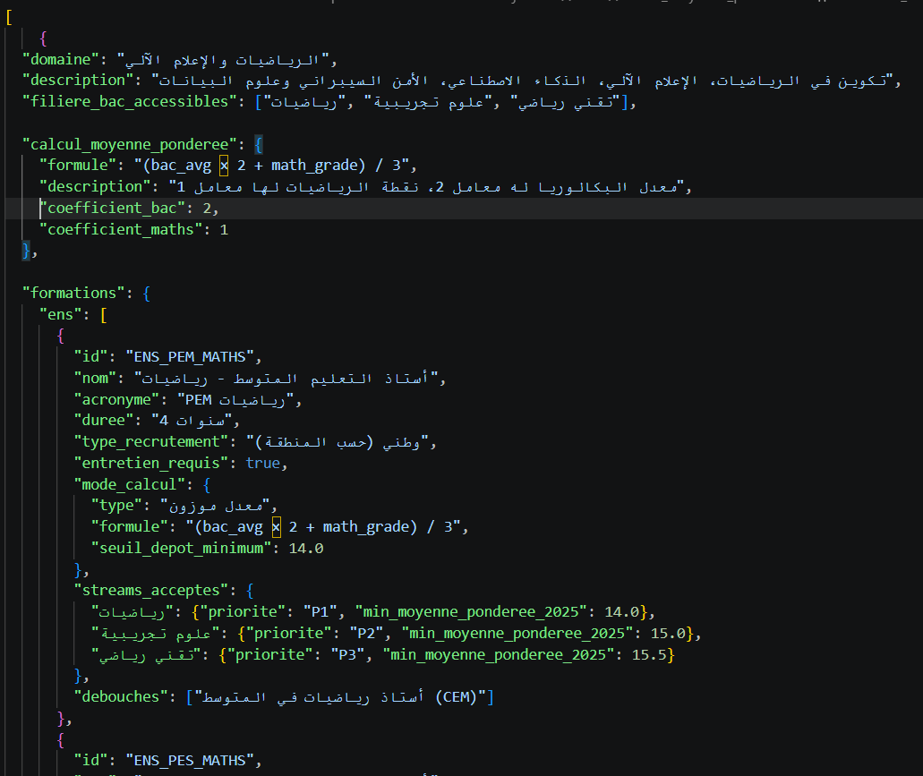

5.3 dataset :
-we collected 6 datasets , 1 dataset per filliere since the orientations depend strongly on the filliere chosen and the courses taken during that filliere ,each of them contains roughly 500 students ,the features chosen were the following :
Features: bac_avg, bac_stream, maths_grade, physique_grade, science_grade, techno_grade, gestion_grade, economie_grade, loi_grade, arabe_grade, francais_grade, anglais_grade, tamazight_grade, langue_etranger_grade, his_geo_grade, islamia_grade, philo_grade, trimester1_avg, trimester2_avg, trimester3_avg, stress_level, competitiveness, consistency_score, career_orientation, wilaya.
Target Variable: domaine_cible. (one among the 11 domains available in Algeria ).
-later on the weighted average for each of the 11 domains was computed (for example for MI the weighted average would be (bac average +maths grade)/2).
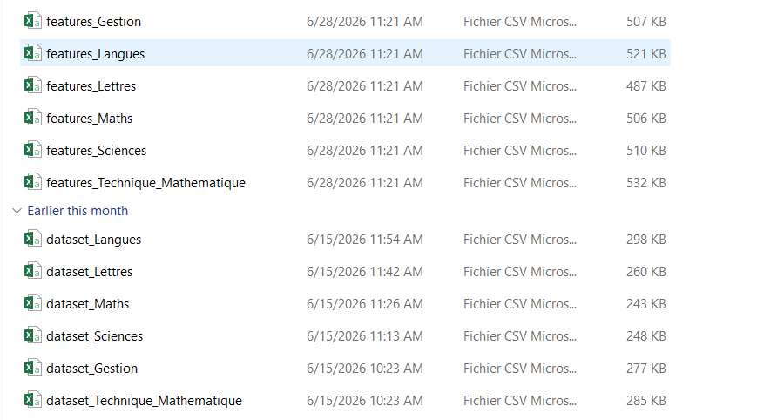

5.4 exploratory data analysis :

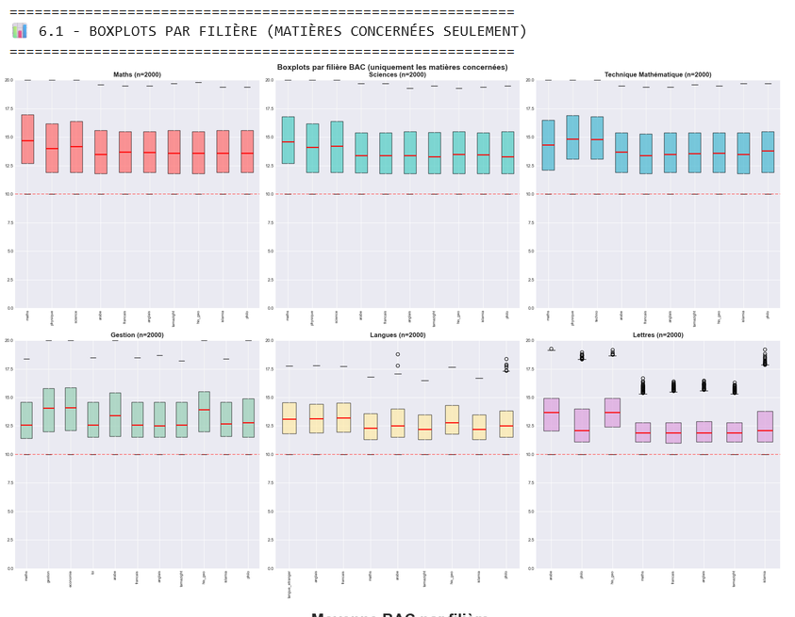 | -the distribution of grades for each filliere per subject we notice that students usually perform better in their essential subjects and the sample were choser in such a way the grades are all above 10 because you need to succeed the bac to choose an orientation
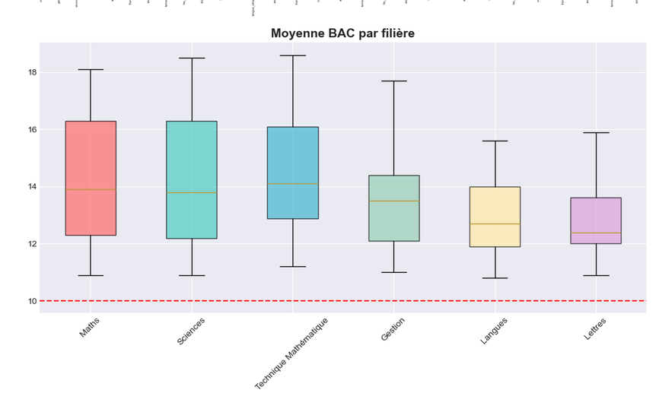 | -the idea illustrated here is just a confirmation of the variability of performance among different fillieres ,note that this idea was previously discussed in the pre-bac section
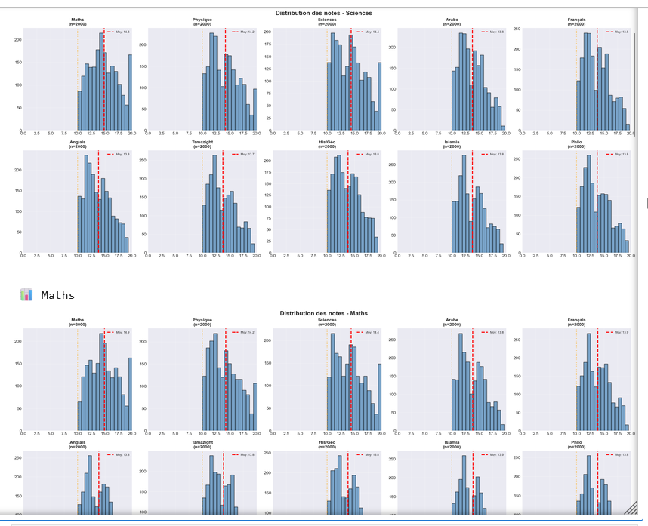 | -we also did a study of the distribution of grades per subject for each filliere
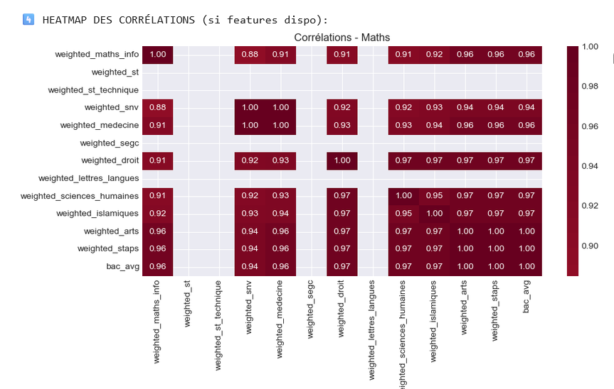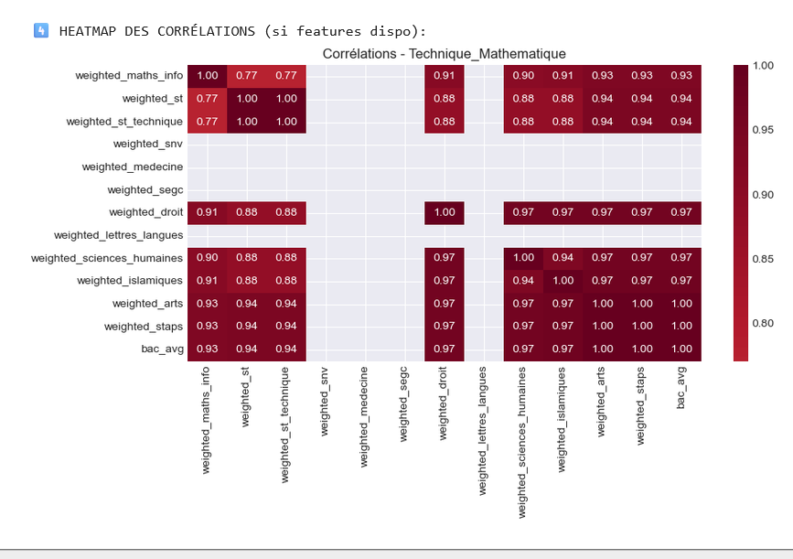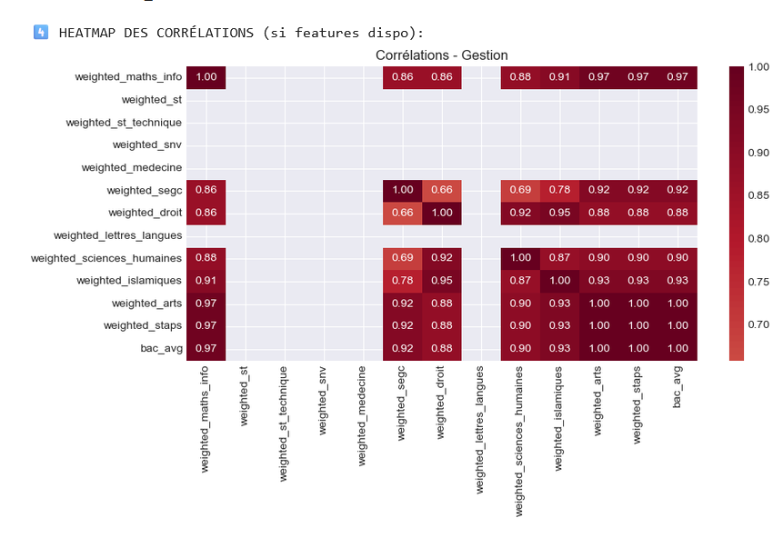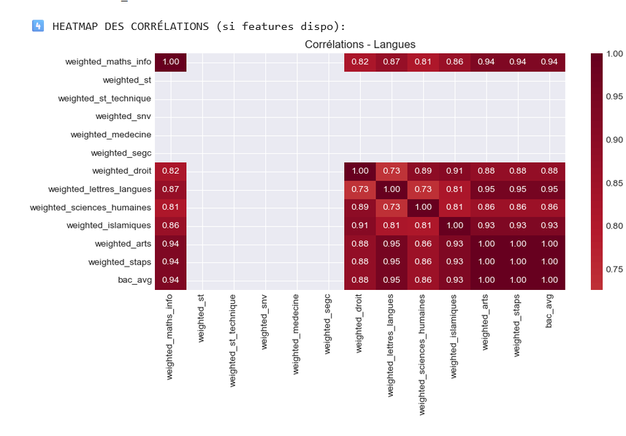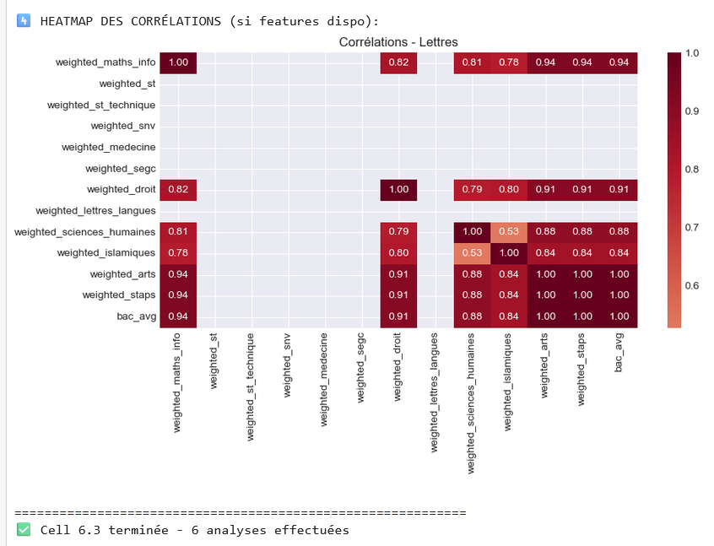 | -here we have 6 heatmaps (1 per filliere ) to study the correation between weighted averages and orientations .
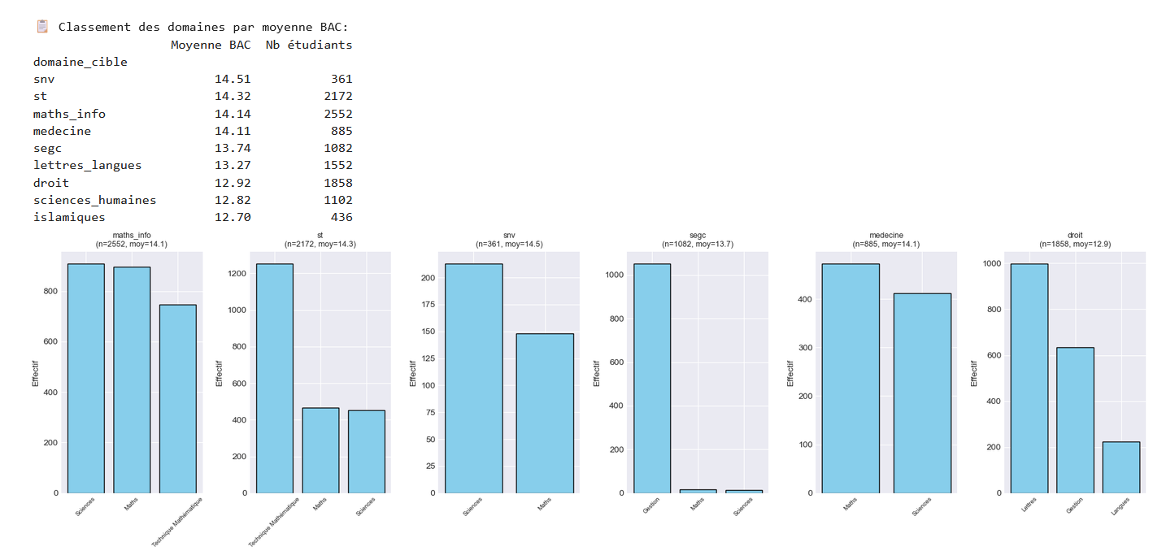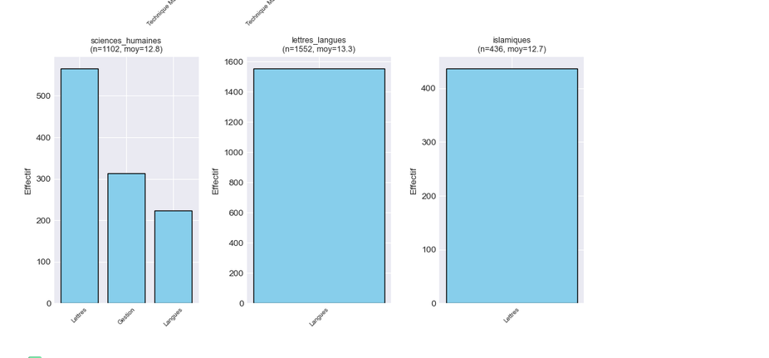 | -this is to see the effective of each filliere in each domain and the average access mean of the domain .
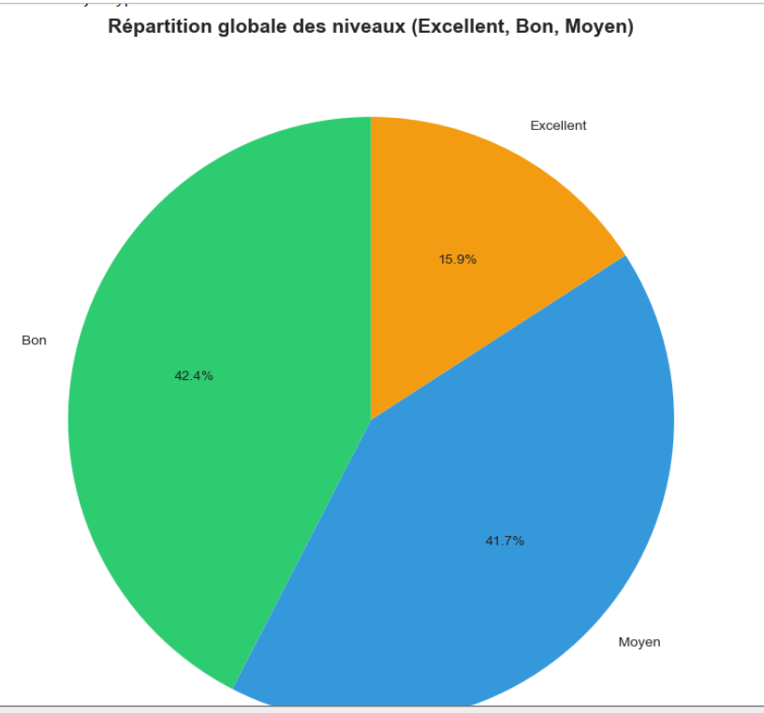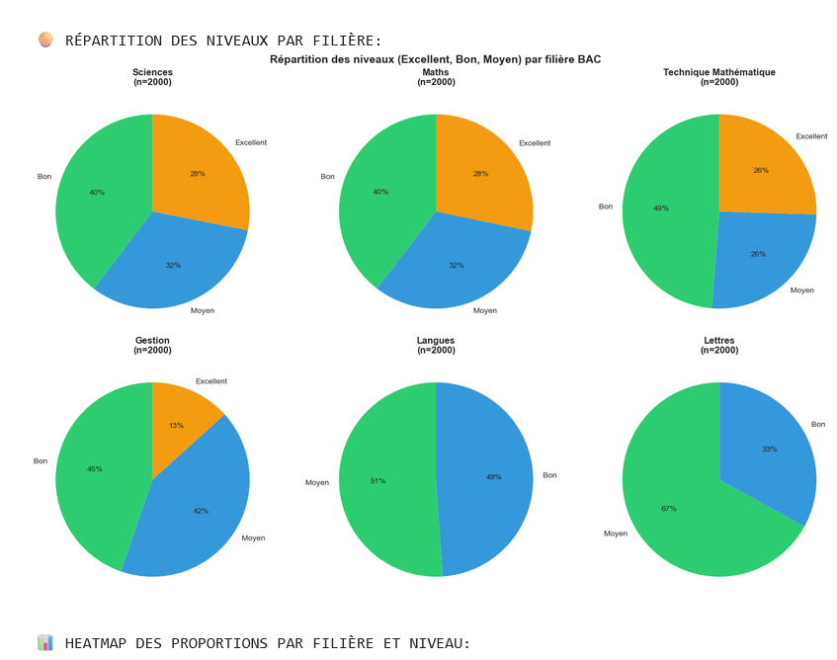 | -this is the repartition of all students mentions in the bac ,below is the same thing but the work is done per filliere
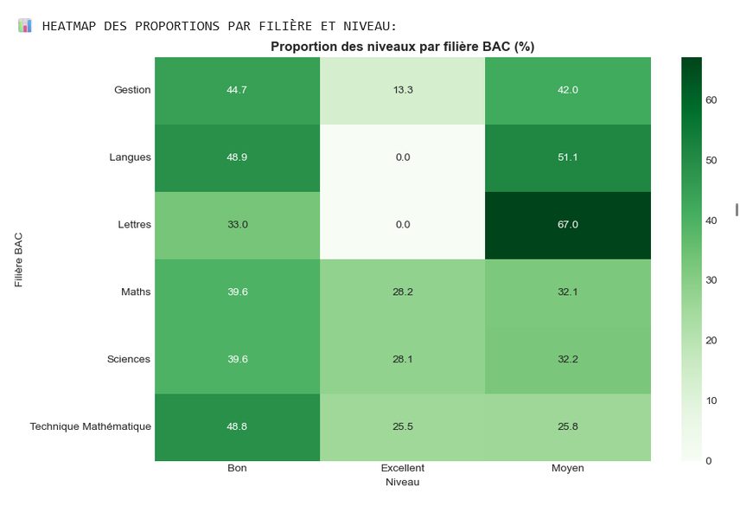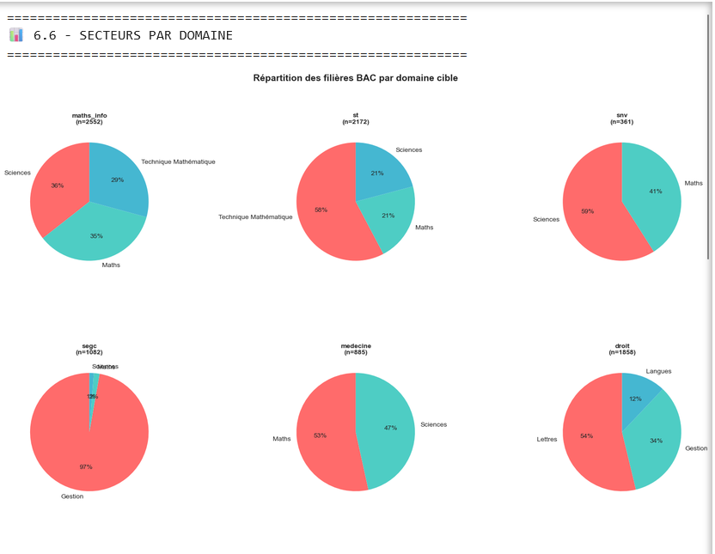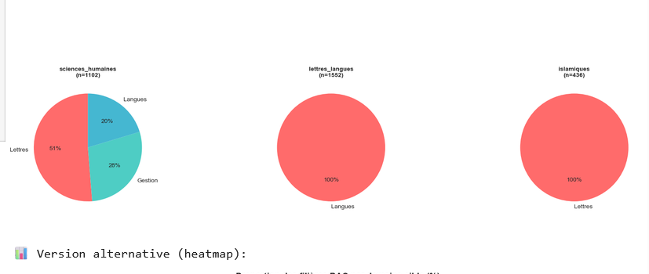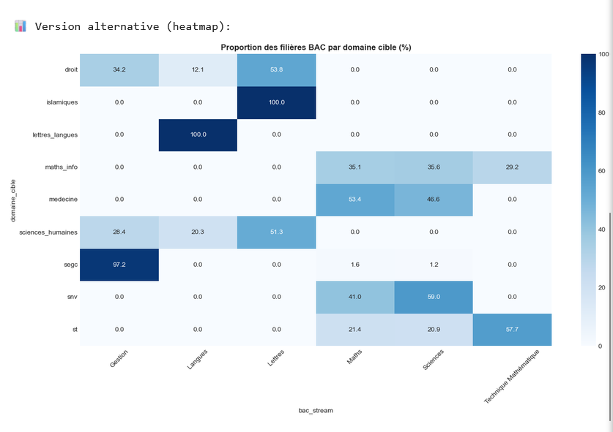 | This is an alternative heatmap for the same thing .  Below is the repartition of the different fillieres par domains cibles  And a heatmap version too

5.5 the machine learning model used and its detailed evaluation :
The post-bac orientation system employs a specialized ensemble of 6 Random Forest Classifiers, one trained per baccalaureate stream (Sciences, Maths, Technique Mathématique, Gestion, Langues, Lettres), to predict the most suitable academic domain for each student. Each model is configured with 200 decision trees, a maximum depth of 12, and a minimum of 15 samples per split, striking an optimal balance between predictive accuracy and generalization. The models are trained on a comprehensive feature set of 18 engineered variables, including domain-specific weighted subject scores (e.g., weighted_maths_info, weighted_st, weighted_medecine), academic ratios (ratio_maths_science, ratio_maths_physique), stream alignment metrics (scientific_score, literary_score), and behavioral indicators (consistency_score_final, avg_variability). Each stream-specific model is trained on 500 student profiles (80% training, 20% testing) and achieves accuracy scores ranging from 85% to 95%, demonstrating the effectiveness of the stream-specific approach. In production, when a student submits their baccalaureate results, the system identifies their stream, selects the corresponding model, computes the 18 features, and predicts the most appropriate academic domain, ensuring personalized, relevant, and accurate orientation recommendations tailored to each student's unique academic profile and background.
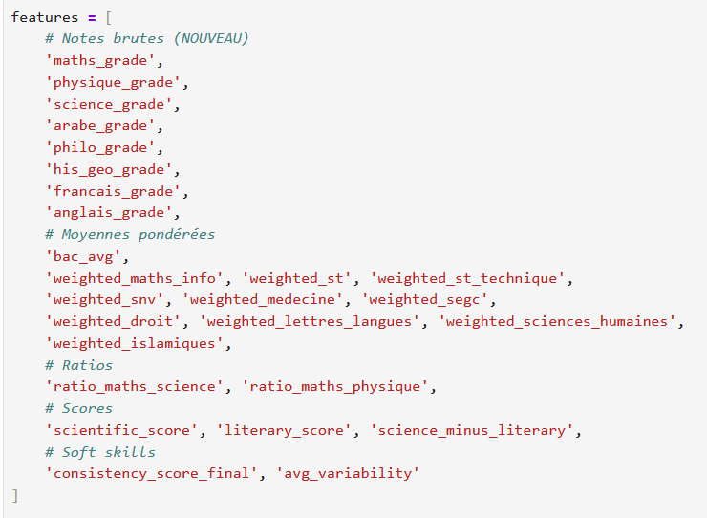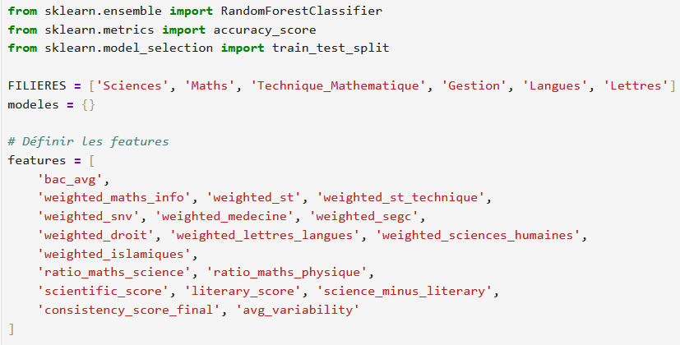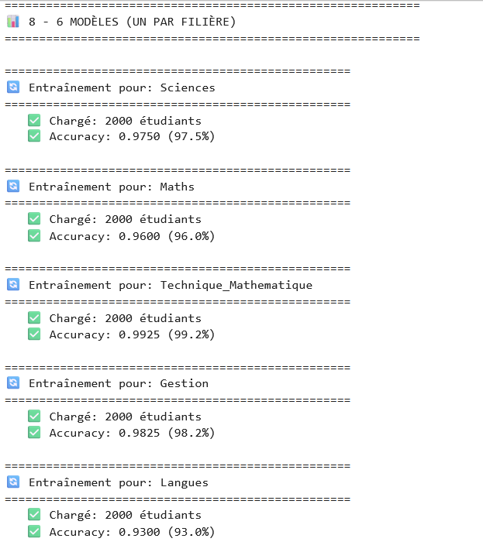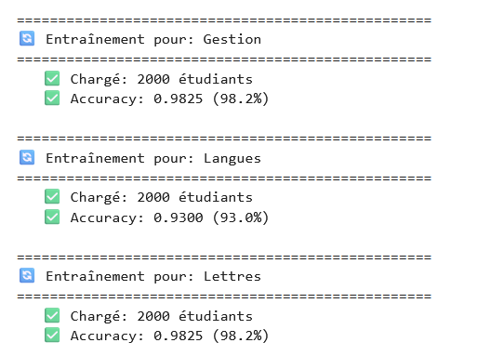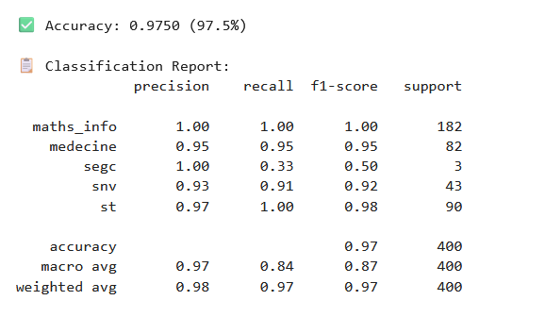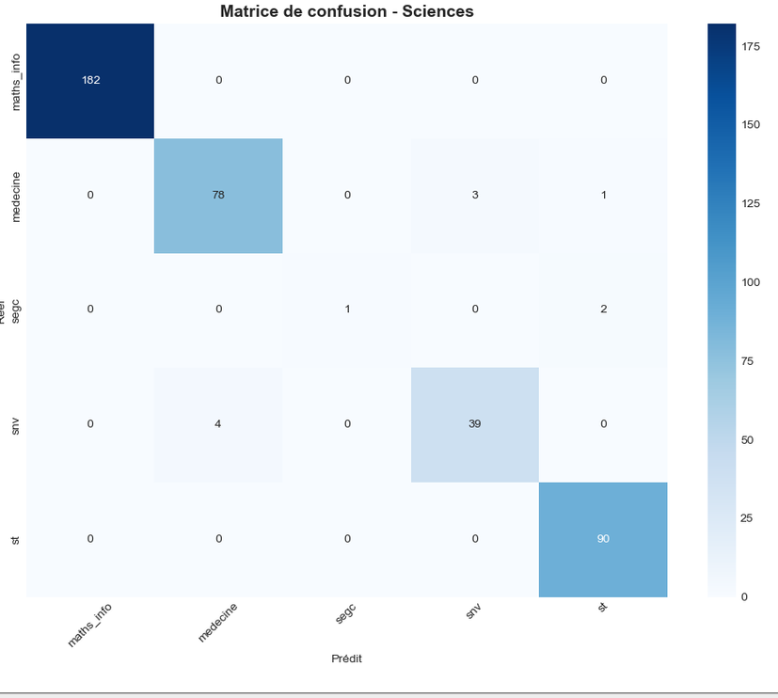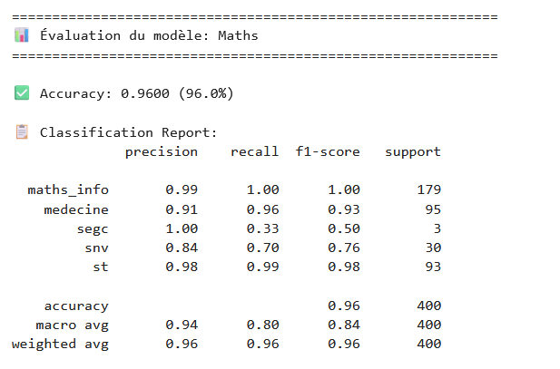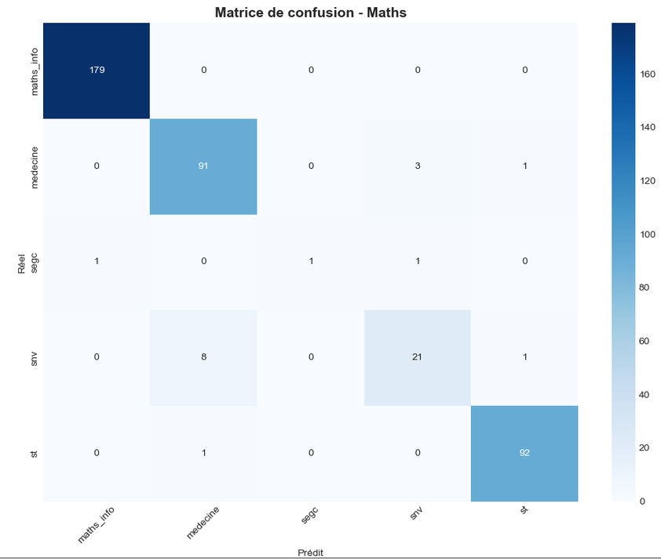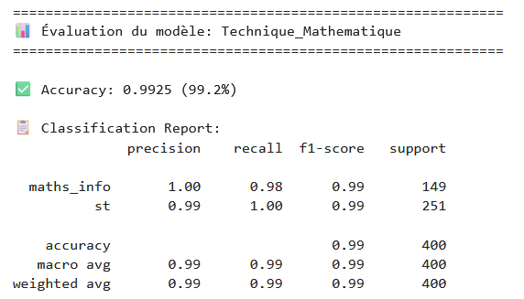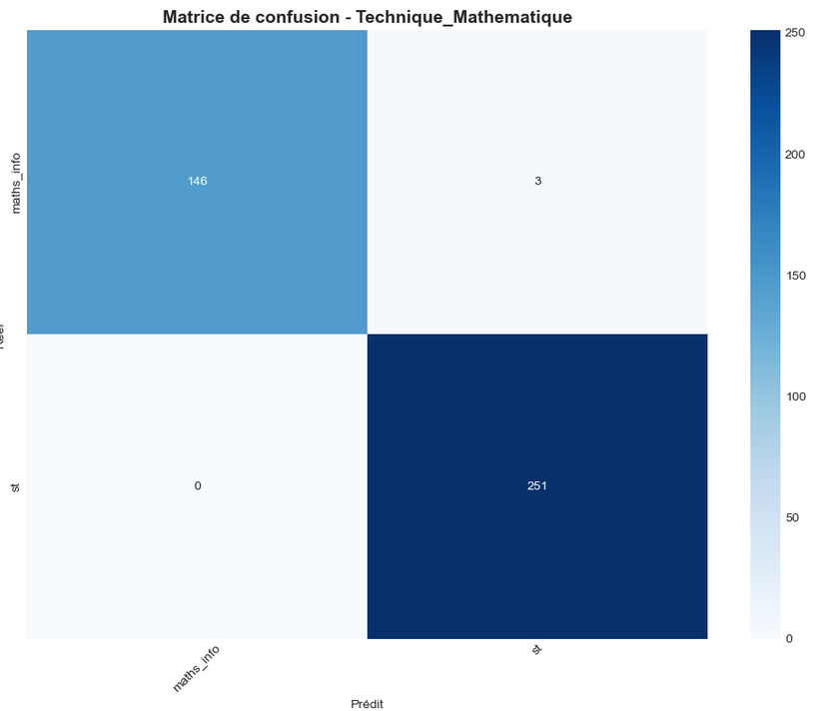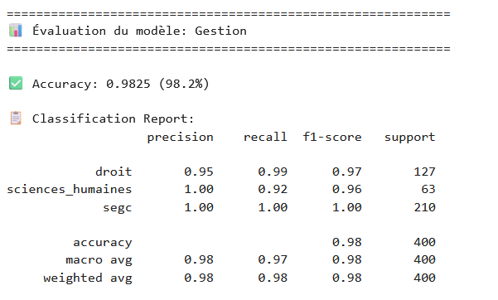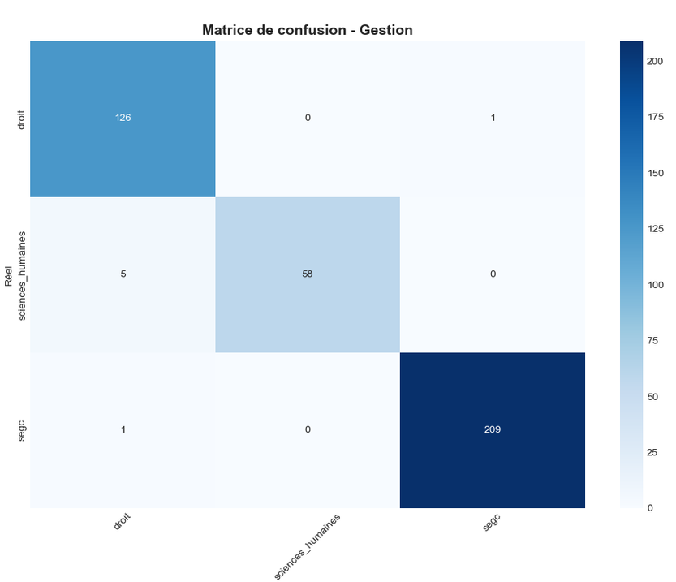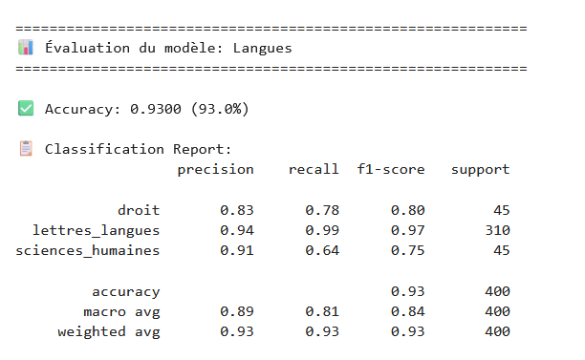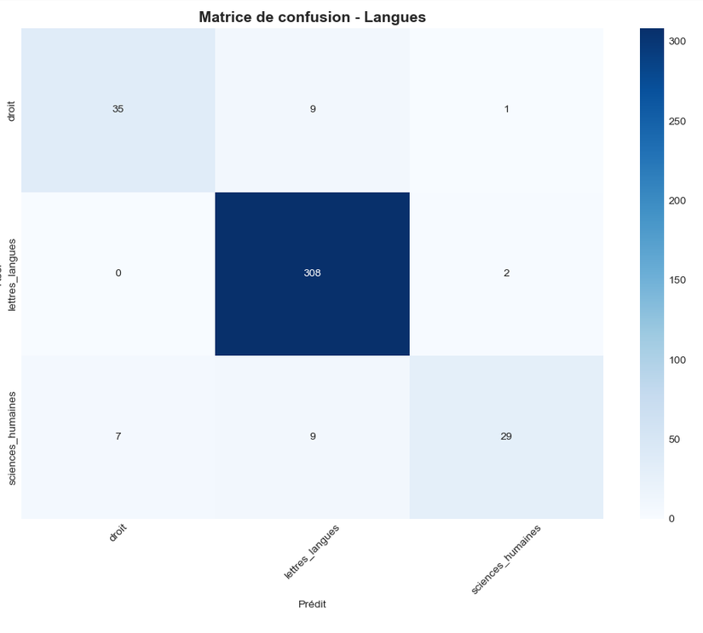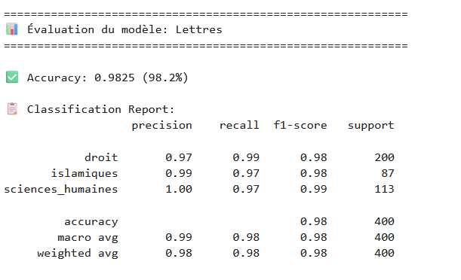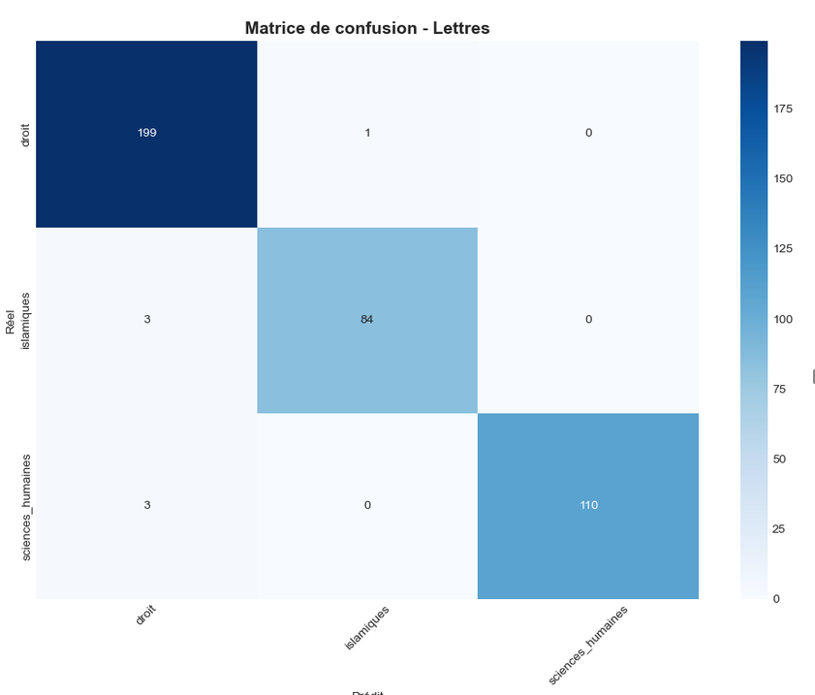

5.6 rule based used :
The post-bac orientation system employs a sophisticated rule-based engine that transforms raw student data into personalized, actionable academic recommendations by evaluating eligibility across 11 academic domains through a multi-stage filtering and prioritization process. The system begins by loading a comprehensive JSON database containing detailed information about all available formations (ENS, Grandes Écoles, Engineering programs, and LMD Bachelor programs), each with associated admission requirements including stream-specific priority levels (P1/P2/P3), minimum weighted averages, location constraints, and career orientation filters. For each student, the engine computes domain-specific weighted averages using tailored formulas that reflect the importance of different subjects for each field (e.g., Mathematics & Computer Science uses (bac_avg × 2 + maths_grade) / 3, Medicine uses a complex weighted formula incorporating science, maths, and physics with different coefficients). The system then applies a multi-stage filtering cascade that checks stream eligibility, calculates the student's weighted average against the domain's minimum threshold, filters ENS programs based on the student's career orientation (teaching vs. research), applies location-based filtering for LMD programs (only showing formations available in the student's wilaya), and finally performs a global ranking where all eligible formations across all predicted domains are sorted by their minimum admission threshold in descending order, ensuring that the most selective and prestigious programs are displayed first. This rule-based approach, combined with the ML model's domain predictions, creates a hybrid recommendation system that is both intelligent (using ML to identify promising domains) and transparent (using clear, explainable rules for eligibility checking), ensuring students receive recommendations that are not only academically relevant but also practically feasible based on their grades, location, and career aspirations.

Chapter 6 — Backend

6.1 Overview
The backend of the BacAidz platform is a RESTful API built with Node.js and Express.js, designed to handle all business logic, data persistence, and machine learning integration. It follows a Model-View-Controller (MVC) architectural pattern, ensuring clean separation of concerns, maintainability, and scalability.

6.2 API Architecture

6.2.1 RESTful API Design
The API follows REST (Representational State Transfer) principles, using standard HTTP methods and status codes to handle client requests. All endpoints are organized around resources (students, subjects, results) and support CRUD operations through predictable URL patterns.
HTTP Method | Usage
GET | Retrieve data (e.g., user results, subject list)
POST | Create or process data (e.g., predict BAC score, submit student data)

6.2.2 Base URL Structure
text
https://api.bacaidz.com/api/
├── auth/ # Authentication endpoints
├── user/ # User management
├── bacyear/ # BAC prediction & analysis
├── subjects/ # Subject management
└── results/ # Student results

6.2.3 Key Endpoints
Endpoint | Method | Description
/api/auth/register | POST | User registration
/api/auth/login | POST | User authentication
/api/bacyear/:subject/predict | POST | Predict BAC score for a subject
/api/bacyear/:subject/weaknesses | POST | Analyze student weaknesses
/api/bacyear/:subject/features | POST | Get derived features
/api/bacyear/:subject/simulate | POST | Simulate improvement scenarios
/api/bacyear/results | GET | Get all user results
/api/bacyear/:subject/result | GET | Get specific subject result

6.3 Routes
Routes define the API endpoints and map them to controller functions. Each route handles a specific URL pattern and HTTP method.

6.3.1 Route Structure
javascript
// backend/src/routes/bacYearRoutes.js
const express = require('express');
const router = express.Router();
const { protect } = require('../middleware/auth');
const {
predict,
getWeaknesses,
getDerivedFeatures,
simulate,
getMyResult,
getAllUserResults
} = require('../controllers/bacYearController');

// All routes require authentication
router.use(protect);

// Subject-specific routes
router.post('/:subject/predict', predict);
router.post('/:subject/weaknesses', getWeaknesses);
router.post('/:subject/features', getDerivedFeatures);
router.post('/:subject/simulate', simulate);
router.get('/:subject/result', getMyResult);

// User results
router.get('/results', getAllUserResults);

6.3.2 Dynamic Routing
The system uses dynamic route parameters (:subject) to handle 15 different subjects with a single route definition:
javascript
// One route handles all subjects
router.post('/:subject/predict', predict);
// Subjects: arabic, maths, physics, science, french, english, his_geo,
// islamia, philo, techno, tamazight, langue_etrangere,
// droit, economie, gestion

6.3.3 Route Organization
Route File | Purpose
authRoutes.js | Authentication (login, register, logout)
userRoutes.js | User profile management
bacYearRoutes.js | BAC prediction, analysis, results
subjectRoutes.js | Subject metadata and resources

6.4 Controllers
Controllers are the core business logic layer. They process incoming requests, interact with services, and return formatted responses to the client.

6.4.1 Controller Structure
javascript
// backend/src/controllers/bacYearController.js

const predict = async (req, res) => {
try {
const { subject } = req.params;
const userData = req.body;
const userId = req.user.id;

// Validate required fields
const requiredFields = ['grade_t1', 'grade_t2', 'grade_t3'];
for (const field of requiredFields) {
if (userData[field] === undefined || userData[field] === null) {
return res.status(400).json({
success: false,
message: `الحقل ${field} مطلوب`
});
}
}

// Load model and predict
await bacYearService.loadModel(subject);
const prediction = await bacYearService.predict(subject, userData);
const derivedFeatures = bacYearService.calculateDerivedFeatures(subject, userData);
const weaknessAnalysis = bacYearService.analyzeWeaknesses(userData, subject);

// Save to database
await saveResult(userId, username, subject, subjectName, userData, prediction, derivedFeatures, weaknessAnalysis);

// Return response
res.json({
success: true,
data: {
prediction: prediction,
derived_features: derivedFeatures,
weaknesses: weaknessAnalysis,
subject: subject
}
});

} catch (error) {
console.error('❌ Prediction Error:', error);
res.status(500).json({
success: false,
message: 'حدث خطأ في التنبؤ',
error: error.message
});
}
};

6.4.2 Controller Responsibilities
Responsibility | Description
Input Validation | Validate required fields and data types
Authentication | Verify user identity via middleware
Subject Mapping | Map frontend aliases (loi → droit)
Service Orchestration | Call services in correct order
Database Operations | Save and retrieve user data
Response Formatting | Format and return JSON responses
Error Handling | Catch and format errors consistently

6.4.3 Controller List
Controller | Responsibilities
authController.js | Register, login, logout, token refresh
userController.js | Get/update user profile, change password
bacYearController.js | Prediction, weaknesses, features, simulation, results
subjectController.js | Subject list, metadata, resource management

6.5 Middleware
Middleware functions execute before route handlers, performing pre-processing tasks like authentication, logging, and error handling.

6.5.1 Authentication Middleware
javascript
// backend/src/middleware/auth.js

const jwt = require('jsonwebtoken');
const User = require('../models/User');

const protect = async (req, res, next) => {
try {
let token;

// Extract token from Authorization header
if (req.headers.authorization && req.headers.authorization.startsWith('Bearer')) {
token = req.headers.authorization.split(' ')[1];
}

if (!token) {
return res.status(401).json({
success: false,
message: 'الرجاء تسجيل الدخول أولاً'
});
}

// Verify token
const decoded = jwt.verify(token, process.env.JWT_SECRET);

// Get user from token
const user = await User.findById(decoded.id).select('-password');
if (!user) {
return res.status(401).json({
success: false,
message: 'المستخدم غير موجود'
});
}

req.user = user;
next();

} catch (error) {
return res.status(401).json({
success: false,
message: 'جلسة غير صالحة، يرجى تسجيل الدخول مجدداً'
});
}
};

6.5.2 Middleware Types
Middleware | Purpose
protect | Verifies JWT token and attaches user to request
errorHandler | Catches and formats all errors
logger | Logs all API requests and responses
rateLimiter | Prevents API abuse (max 100 requests per minute)
validation | Validates request data against schemas

6.5.3 Middleware Usage
javascript
// Apply globally
app.use(express.json());
app.use(cors());
app.use(logger);

// Apply to specific routes
router.use(protect);
router.post('/predict', validatePrediction, predict);

6.6 Authentication
The system uses JWT (JSON Web Token) for stateless authentication.

6.6.1 Authentication Flow
text
1. User registers → Password hashed with bcrypt → User saved to database
2. User logs in → Credentials verified → JWT token generated
3. Token returned to client → Client stores in localStorage/HTTP-only cookie
4. Subsequent requests → Token sent in Authorization header
5. Server verifies token → Middleware attaches user to request

6.6.2 JWT Structure
javascript
{
id: user._id,
username: user.username,
email: user.email,
filiere: user.filiere,
iat: 1735536000, // Issued at
exp: 1736138400 // Expires (7 days)
}

6.6.3 Password Security
Security Measure | Implementation
Password Hashing | bcrypt with 12 salt rounds
Token Expiry | 7 days (refreshable)
Secure Storage | HTTP-only cookies (production)
Rate Limiting | Prevent brute force attacks

6.6.4 Protected vs Public Routes
Route Type | Examples | Authentication Required
Public | /api/auth/login, /api/auth/register | No
Protected | /api/bacyear/*, /api/user/profile | Yes (JWT required)

6.7 File Structure

6.7.1 Backend Directory Structure
text
backend/
├── src/
│ ├── config/ # Configuration files
│ │ ├── database.js # MongoDB connection
│ │ └── environment.js # Environment variables
│ │
│ ├── controllers/ # Request handlers
│ │ ├── authController.js
│ │ ├── userController.js
│ │ └── bacYearController.js
│ │
│ ├── middleware/ # Express middleware
│ │ ├── auth.js # JWT authentication
│ │ ├── errorHandler.js # Global error handling
│ │ └── validation.js # Request validation
│ │
│ ├── models/ # Database models (MongoDB)
│ │ ├── User.js # User schema
│ │ └── BacYearResult.js # BAC results schema
│ │
│ ├── routes/ # API routes
│ │ ├── authRoutes.js
│ │ ├── userRoutes.js
│ │ └── bacYearRoutes.js
│ │
│ ├── services/ # Business logic layer
│ │ ├── bacYearService.js # BAC prediction logic
│ │ └── userService.js # User management
│ │
│ ├── utils/ # Utility functions
│ │ ├── helpers.js
│ │ └── validators.js
│ │
│ ├── ml_models/ # Machine learning models
│ │ └── bac_year/ # Subject-specific models
│ │ ├── arabic_model.pkl
│ │ ├── maths_model.pkl
│ │ ├── physics_model.pkl
│ │ └── ... (15 models)
│ │
│ ├── ml_scripts/ # Python ML scripts
│ │ └── predict.py # Model inference script
│ │
│ └── app.js # Express application entry
│
├── package.json # Dependencies
├── .env # Environment variables
└── server.js # Server entry point

6.7.2 File Responsibilities
File/Directory | Responsibility
app.js | Express app configuration, middleware setup, route registration
server.js | Server startup, database connection
config/ | Database connection, environment variables, constants
models/ | MongoDB schemas and data models (User, BacYearResult)
controllers/ | Request handlers with business logic
routes/ | URL routing and endpoint mapping
middleware/ | Authentication, validation, error handling, logging
services/ | Complex business logic (prediction, analysis)
ml_models/ | Serialized Python ML models (.pkl files)
ml_scripts/ | Python scripts for ML inference (predict.py)
utils/ | Helper functions, validators, formatters

6.8 Technology Stack Summary
Layer | Technology | Purpose
Runtime | Node.js | JavaScript runtime environment
Framework | Express.js | Web framework for building APIs
Database | MongoDB | NoSQL database for storing user data
ODM | Mongoose | MongoDB object modeling
Authentication | JWT + bcrypt | Stateless authentication and password hashing
Machine Learning | Python + scikit-learn | Model training and inference
Integration | Child Process | Python-Node.js communication
Security | Helmet, CORS | Security headers, cross-origin resource sharing
Validation | Joi | Request data validation
Logging | Winston | Application logging

6.9 Data Flow: Prediction Request
text
1. Frontend → POST /api/bacyear/maths/predict
Body: { grade_t1: 15, grade_t2: 16, grade_t3: 17, ... }

2. Middleware → Authenticate user via JWT
Attaches user object to request (req.user)

3. Controller → bacYearController.predict()
- Validates required fields (grade_t1, grade_t2, grade_t3)
- Calls service layer

4. Service → bacYearService.predict()
- Loads model from ml_models/bac_year/maths_model.pkl
- Calls Python script via child process

5. Python → predict.py
- Loads model from pickle file
- Preprocesses input data
- Makes prediction using RandomForestRegressor
- Returns JSON result

6. Service → Processes Python output
- Maps to frontend format
- Calculates derived features
- Analyzes weaknesses

7. Database → Saves result to MongoDB
- Stores in BacYearResult collection
- Updates user summary

8. Controller → Returns JSON response
- { success: true, data: { prediction, derived_features, weaknesses } }

6.10 Conclusion
The backend architecture follows industry best practices with a clean separation of concerns, making it maintainable, scalable, and secure. The integration of Node.js with Python for machine learning provides the best of both worlds: a robust web framework for API management and powerful ML libraries for predictive analytics. The JWT-based authentication, MVC pattern, and service-oriented architecture ensure the system is production-ready and capable of handling real-world educational workloads.

Chapter 7— Limitations
Although the proposed platform achieved promising results, several limitations should be acknowledged.

7.1 Synthetic Data Generation
Due to the absence of publicly available datasets covering all the required features, a significant portion of the data was generated based on official educational resources, statistical reports, and observed academic trends. Although extensive exploratory analysis was performed to ensure realistic distributions, generated data cannot perfectly reproduce the complexity of real student behavior.

7.2 Dataset Size
The datasets contain between 1,500 and 2,000 samples, which is sufficient for this project's objectives but remains relatively small compared to industrial-scale machine learning applications. Increasing the number and diversity of samples would likely improve the robustness and generalization of the models.

7.3 Possible Bias
The collected and generated data may contain different forms of bias related to region, stream distribution, socioeconomic background, or feature generation assumptions. Consequently, predictions should be interpreted as estimations rather than absolute truths.

7.4 Random Forest Limitations
Random Forest models provide excellent predictive performance and robustness; however, they have several limitations. They do not extrapolate well outside the range of the training data, are less interpretable than simple linear models, and may produce less accurate predictions for rare or exceptional student profiles.

7.5 Prediction of Exceptional Students
The trained models perform very well for average student profiles but are generally less accurate for extreme cases, such as exceptionally high-performing or struggling students. These profiles are naturally underrepresented in the training datasets.

7.6 Evolution of Admission Thresholds
Admission thresholds for Algerian universities and higher schools change every academic year depending on the number of candidates, available seats, and decisions made by the Ministry of Higher Education. Consequently, the orientation recommendations generated by the platform should be considered indicative rather than official.

7.7 Limited Feature Set
Although a large number of academic and behavioral features were considered, several factors that may influence student performance—such as family income, school quality, teacher effectiveness, and unexpected personal circumstances—were intentionally omitted because reliable data could not be collected.

7.8 Rule-Based Recommendations
Some components of the platform, including the resource recommender, to-do list generator, and orientation explanations, rely on manually designed rule-based systems. While these rules were built using educational knowledge and observed patterns, they may not perfectly reflect every student's individual needs.

7.9 Future Evolution of the Platform
The platform was designed as a first version and can be significantly improved. Future work may include collecting real nationwide datasets, experimenting with more advanced machine learning and deep learning models, integrating real-time admission thresholds, expanding the recommendation system, and continuously updating educational resources.

Chapter 8 — Future Work
Although the proposed platform already provides a comprehensive set of features, several improvements can be explored to further increase its accuracy, usability, and scalability.

8.1 Collection of Real-World Data
One of the main future objectives is to replace the synthetic datasets with large-scale datasets collected from real Algerian Baccalaureate students over multiple academic years. This would improve the reliability and generalization capability of the predictive models.

8.2 Deep Learning Models
Future versions of the platform could investigate deep learning approaches, such as neural networks, to model more complex relationships between academic, behavioral, and psychological features and student performance.

8.3 Integration of Large Language Models (LLMs)
Large Language Models could be integrated to provide intelligent academic assistance, answer students' questions, explain predictions in natural language, generate personalized study plans, and offer interactive guidance throughout the Baccalaureate preparation process.

8.4 Automatic Synchronization with Official Data
The platform could be connected to official Ministry of Higher Education resources or APIs (when available) to automatically update admission thresholds, university programs, and orientation information each academic year.

8.5 Student Accounts and Progress Tracking
Future versions could include secure student accounts allowing users to save their predictions, monitor their progress over time, compare different simulations, and receive personalized recommendations based on their learning history.

8.6 Cloud Deployment
Deploying the application on cloud platforms would improve accessibility, scalability, and performance while allowing simultaneous use by thousands of students during the Baccalaureate period.

8.7 Mobile Application
A dedicated Android and iOS application would make the platform more accessible to students, allowing them to access predictions, recommendations, and study tools directly from their smartphones.

8.8 Real-Time Analytics Dashboard
Future work may include a real-time analytics dashboard capable of aggregating anonymous student data to identify national trends, monitor performance across regions and streams, and provide valuable insights for students, teachers, and educational institutions.

8.9 Recommendation System Enhancement
The resource recommender could be expanded using hybrid recommendation techniques that combine machine learning with collaborative filtering to provide highly personalized educational resources based on students with similar profiles.

8.10 Continuous Model Improvement
As new data become available, the predictive models could be periodically retrained and optimized using more advanced ensemble methods, automated hyperparameter tuning, and continuous performance monitoring to maintain high prediction accuracy.

Conclusion
This project presented the design and development of a complete machine learning platform dedicated to the Algerian Baccalaureate. Its objective was not only to predict students' academic performance but also to transform complex data science techniques into an intuitive and accessible tool capable of assisting students throughout their Baccalaureate journey.
The platform was structured around three complementary phases: Pre-BAC, which analyzes students' previous academic history and identifies hidden patterns within the Algerian educational system; BAC Year, which predicts subject-specific performance, identifies strengths and weaknesses, recommends learning resources, generates personalized study plans, and produces optimized timetables; and Post-BAC, which assists students in selecting the higher education domains and university programs that best match their academic profile and career aspirations.
Throughout this work, every stage of a typical data science pipeline was addressed, including data collection and generation, preprocessing, exploratory data analysis, feature engineering, model training and evaluation, explainability using SHAP, rule-based reasoning, backend development, database design, and the implementation of a modern web interface using the MERN stack.
Although the project presents several limitations, particularly regarding the use of synthetic data and the dynamic nature of university admission thresholds, the obtained results demonstrate that machine learning can effectively capture meaningful patterns within the Algerian Baccalaureate ecosystem and provide valuable decision-support tools for students.
Beyond its technical contribution, this project represents a personal learning journey. It allowed me to combine the mathematical foundations, programming skills, web development knowledge, and machine learning concepts acquired throughout my studies into a single real-world application. More importantly, it showed how artificial intelligence can be applied to address educational challenges and transform raw data into practical, user-friendly solutions.
Finally, this work lays the foundation for future developments, including the integration of real-world datasets, more advanced artificial intelligence models, cloud deployment, mobile applications, and intelligent educational assistants. It is my hope that this platform can continue to evolve and contribute, even in a small way, to supporting future generations of Algerian Baccalaureate students in making more informed academic decisions.

